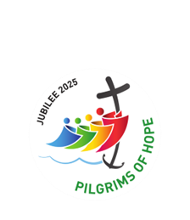
december 2025

He will be a joy and a delight to you,
and many will rejoice because of his birth.
Luke 1:14



To all legionaries and your families:

May the blessings of the Christ child and the peace of this Christmas season fill your homes with love and happiness.

Meaning of the Advent Wreath
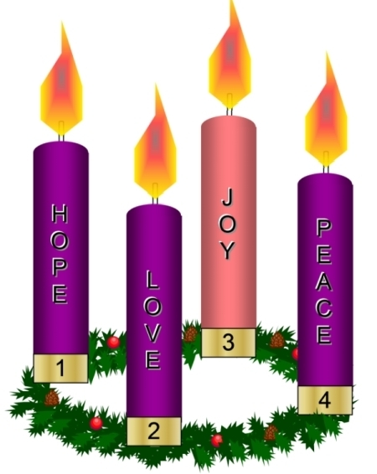
The 2nd Sunday of
Advent symbolizes
Faith with the Bethlehem Candle reminding us of Mary and Joseph’s journey to Bethlehem. We light the second purple candle.
The 1st Sunday of Advent symbolizes Hope with the ‘Prophet’s Candle’, reminding us that Jesus is coming.
We light the first purple candle.

The 4th Sunday of Advent symbolizes Peace with the Angel Candle reminding us of the message of the angels: “Peace on Earth, Good Will Towards men.” We light the third purple candle.
The 3rd Sunday of Advent symbolizes Joy with the Shepherds’ Candle reminding us of the Joy the world experienced at the coming birth of Jesus. We light the rose or pink candle.

Some Advent Wreaths also include a 5th white Christ candle, symbolizing purity, which is lit on Christmas Eve or Christmas Day. Many circular wreaths can incorporate a white candle by adding a pillar candle to the centre.

In each of the four weeks of Advent this year the prophet Isaiah will accompany us to dream of God’s abundant future materialising in the rubble of our lives and of the world.

Jesus made His own Isaiah’s words, presenting Himself as the fulfilment of the year of the Lord’s favour. (Pope Francis)
“The Spirit of the Lord is upon me, because He has anointed me to bring the good news to the poor. He has sent me to proclaim release to the captives and recovery of sight to the blind, to let the oppressed go free. To proclaim the year of the Lord’s favour.” Luke 4: 14-22


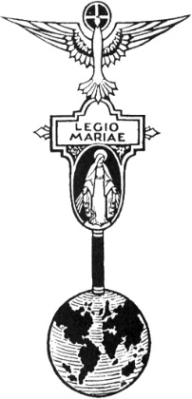
THE LEGION OF MARY
BULLETIN
December 2025
Comitium of Perth (Western Australia) Inc
36 Windsor St, East Perth 6000
Tel 93282726
Email: comitiumofperth@gmail.com
Website: https://www.legion-of-mary-comitium-of-perth-western-australia-inc.org
Facebook: Legion of Mary Perth Western

Australia

Dates to remember.
2nd Monday of the Month
Executive meeting
3rd Monday of the Month Comitium Meeting
2nd Saturday of the Month Rosary Making
EDC meeting 4th Monday
NDC meeting 4th Saturday
November 22nd
EVENTS for 2025
Dec 15 – Jan 12 Closed
EVENTS for 2026
17th Jan 2026 Officers’ Afternoon Tea and Training.
19th Jan Comitium Meeting
22nd March ACIES
16th May 1 Day Retreat
16th July Pilgrimage (provisional)
Sept 5-7th Rosary Bouquet
Sept 8th Nativity Mass
ALLOCUTIO: by Fr Doug Harris

ALL SOULS
November is the month of the Holy Souls in Purgatory. There is evidence in Scripture that there is purgatory. In the Old Testament, 2nd Macabees 12:46, says, “It is a holy and wholesome thing to pray for the dead …” The Jews believe in purgatory. For example, Jews recite a prayer called “Mourne’s Kaddish” for 11 months after the death of a person, so that their sins would be forgiven. Purgatory is not an invention of the Catholic Church.
In the New Testament Our Blessed Lord spoke about purgatory. For example: Our Blessed Lord said: “The sin against the Holy Spirit would not be forgiven in this life or in the next,” meaning that some sin is forgiven in the next life. In heaven there are no sins to forgive. In hell, the souls don’t want their sins to be forgiven. Therefore, there must be another place after death, where sins can be forgiven.
The only prayers that can help the souls in purgatory are the prayers of us who are still living on this earth. The souls in purgatory cannot do anything more through their own prayers to release themselves from purgatory. The Holy Souls are already praying and suffering as much as they can to be released.
For this reason, the holy souls plead for us to pray and make sacrifices for them. We need to give all our heart to prayers and sacrifices for the souls in purgatory.
The State of Purgatory:
St Augustine: “The time of purgatory will be more painful
than anything man can suffer in this present life.”
St Catherine of Genoa: “The souls in purgatory endure a pain which no tongue can describe, and no intelligence comprehend.”
It is generally understood that the souls in purgatory are not immersed in a physical fire but a fire different from anything known on earth. However, there are many reports of souls in purgatory being immersed in fire. For example: There was a French nun in purgatory who appeared to her nuns in their convent. She put her hands on a cupboard door leaving her handprint and fingerprint burnt into the door.
These stories and many others are verified and kept in the “museum of purgatory” in the Vatican.
The chief pain in purgatory is the pain of separation from God. At Judgment, the Holy Souls, have an experience of God’s love. To be deprived of His Love, after experiencing it, is an unimaginable pain.
Even though the pains in purgatory are great, the souls in purgatory are prepared to accept their pains because having experienced Our Blessed Lord at Judgment, they want to be in purgatory to repair or make up for their sins, and they are prepared to suffer any pain in order to be with Our Lord again and experience His Love.
When we pray for the souls in purgatory the souls in purgatory pray for us and their prayers are very, very powerful. Their prayers are powerful because their suffering is great.
For example, St Catherine of Bologna said that whatever favour she asked through the souls in purgatory she was granted immediately.
A French maid from a country town made a commitment to God to offer one mass per month for the holy souls. She earned little. On one occasion she travelled to Paris with her mistress. In Paris she fell ill and was hospitalised for a long period of time. So long, that her mistress went on ahead back to her home in the country. The maid, when well enough to leave hospital, had only one franc. She realized that she had not made her usual monthly offering. She went into a church and gave her franc to a priest for the mass offering. The maid did not know anyone in Paris and she had no money. In her distress a young man took her to a house and told her ask for work. A lady answered the door, and the maid told her about the young man who had sent her here to ask for work. The lady was amazed because only a few minutes earlier she had dismissed her maid and at a moment’s notice, so, it was impossible that anyone could have known that she was looking for another maid. “Impossible!” exclaimed the lady, “No young man, no one at all, could have known that I needed a maid.” “Madam,” the girl answered, “that’s the young man who told me.” She pointed to a picture on the wall. “Why child, that is my only son who has been dead for more than a year.” “Dead or not,” asserted the girl with deep conviction in her voice, “it was he who told me to come to you, he even led me to the door. See the scar over his eye. I would know him anywhere.” Then followed the full story of how she had mass offered with her last franc. Convinced of what the maid told her, the lady received her with open arms –not as a maid, but as a daughter, “You have sent my darling boy to heaven.”
The souls in purgatory look on us with remorse, if not despair, because those of us who live our faith only lukewarmly are making the same mistake that they made. St Catherine of Genoa, after Our Lord took her to purgatory and back said: “The souls in Purgatory, look down on us and say: “O wretched creatures, why are you so blindly attached to the things that pass? Why not make provision for the future?”
Sr Mary Gabriel appeared to her Religious Sisters from 1874 to 1890. She was in purgatory. She said: “Use every minute well, as each one is an opportunity to merit Heaven and escape Purgatory. Oh, if we had 5 minutes of the time you waste thinking about yourself what we would do for Him for whom we yearn so ardently.”
So, what should we do to release souls from purgatory?
As often as possible pray and make sacrifices. Also, offer all one’s daily trials or sufferings for these souls especially during the month of November.
Have a mass said for the souls in purgatory. Blessed Henry made an agreement with a friend that if one of them were to die the other would offer two masses a week for his soul. The other died first. Blessed Henry immediately commenced offering up two masses a week for his soul. After a long time when Blessed Henry felt that his friend had gone to heaven, Blessed Henry ceased the mass offerings. Later the friend appeared to Blessed Henry to tell him that he was still in purgatory. Blessed Henry told him that even though he had stopped the offerings at mass he had often prayed for his friend. The friend said the mass is the most powerful prayer for releasing souls out of purgatory. Blessed Henry then continued the practice of offering two masses a week for his friend. Soon after he was visited again by his friend, but this time he was in heaven.
Make a plenary indulgence.

Plenary Indulgence:
A Plenary Indulgence can be offered for oneself or for any intention. When offered for a soul in purgatory that soul may go to Heaven, depending on our faith.
How to gain a Plenary Indulgence on a particular day:
Holy Communion.
Sacrament of Reconciliation once every two weeks.
(Within 7 days before or after).
If one intends to gain a Plenary Indulgence almost every day a single monthly Sacramental Confession suffices.
Prayer for the Pope’s intentions, (i.e. An ‘Our Father.’)
A work:
(i) The Rosary (5 Decades) prayed with at least one other person or in the presence of the
Blessed Sacrament, or
(ii) The Stations or,
(iii) 30 minutes before the Blessed Sacrament or,
(iv) Visit the sick or the imprisoned, or the elderly, or the lonely or anyone in need or,
(v) Act of abstinence, almsgiving.
(vi) There are also other works. (On All Souls Day instead of a work, you only need to pray the Creed in the presence of the Blessed Sacrament.)
(vii) From November 1 to 8, visit a Cemetery.
Only one Plenary Indulgence can be granted per day. Therefore, we should do all we can to try to fulfill the conditions for a plenary indulgence each day.
We are now in a Jubilee Year (2025). Instead of the above “works” we can walk through a Church that has a Holy Door. The two closest are Highgate and the Cathedral. Also, we can gain this Plenary Indulgence per day in this Jubilee.
During November one Mass per day will be offered for the souls recorded in the Parish Remembrance Book. The cost for the entire month is $15.00. You may record as many people as you like for $15.00
The St Gertrude prayer:

The Church says that many, perhaps one thousand souls, will be released by this prayer:
‘Eternal Father, I offer You
The most precious blood of Your Divine Son, Jesus,
In union with the masses said throughout the world today,
For all the holy souls in purgatory,
For sinners everywhere, for sinners in the universal church,
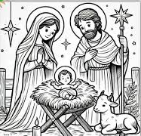
Those in my own home and within my own family.’
In the Name of the Father and of the Son and of the Holy Spirit.
Amen.

MESSAGE FROM THE PRESIDENT
December 2025

Dear Brothers and Sisters,
What an eventful year 2025 has been! It started with the appointment of a new Senatus Correspondent for WA, Sr Joan Davies. During visits to Melbourne this year, Sr Rosemary, Sr Bianca and I were privileged to spend valuable time with her. We have received wonderful support from several priests: Rev Fr Doug Harris and other Spiritual Directors have been constant supports to both Curiae and Praesidia; Rev Mons Thomas McDonald celebrated our ACIES and the Annual Mass for us at St Joachim’s parish, Rev Fr Stephen Truscott was presenter of the Half-Day of Reflection, and Rev Fr Grant Gorddard celebrated Mass during the Pilgrimage. Our grateful thanks go to them. Comitium was visited in March by Br Andrew Kong and Daniel Chin, Legionaries from Singapore, and in October by Sr Monica Chisela from Lusaka in Zambia. Meeting Legionaries from other countries enriches our understanding of the different challenges faced by Legionaries around the world.
Comitium has made upgrades to the air conditioners in the hall, and the office computer this year. These additions have helped to improve comfort for members during meetings, and convenience and efficiency for the Executive.
Unfortunately, I had to be away from Perth for several months, but all ran smoothly thanks to the dedicated work of the Executive of Comitium. Personally, I experienced the miraculous recovery of my son from strokes, and there have been several other remarkable healings amongst Legionaries, their families and friends. Thank you all for your prayers, which undoubtedly were a major contributor to these happy outcomes. Lastly, I thank Sr Christyne Williams for her work on the Executive and wish her well in the next stage of her life.
The Comitium Exec and I wish you all a Happy and Holy Christmas season and look forward to another productive year in 2026.

God bless and Mary guide you
Sr Sheelagh Tillotson
EXECUTIVE OFFICER ELECTIONS

*The office of Vice President is currently vacant and open to nominations. Any member wishing to nominate for this position please see Sr Sheelagh at the Comitium meeting to complete the necessary formalities.
*Sr Rosemary Bennett completed her first term as Assistant Treasurer in November. Sr Bennett has agreed to take on a second term so this position is now filled.
*Sr Bianca Casalengo completes her first term as Secretary in December. The position will be voted on at the December meeting..

NOVEMBER REPORT:
Annual Report “Our Lady of The Missions” Praesidium, Willetton.
Meeting Place: Sts. John & Paul Parish Hall Centre Willetton
Time: Thursdays at 2pm
President: Sr. Gracey John Britto
Vice President: Br. Jacob To
Secretary: Sr. Clara Gemmy
Treasurer: Sr. Ines Spiccia
Active members: 9, Auxiliary members : 44
Reporting from November 2024 to November 2025.
Works undertaken:
Members of ‘Our Lady of the Missions’ Praesidium meet weekly on Thursdays at 2 pm at Sts. John & Paul Parish centre. Nine active members make regular calls and visits to individuals, the elderly, sick and lonely at their homes or at their aged care premises. We pray, chat, play games and administer Holy Communion when requested. The residents at Brentwood Aged Care at 1a Aldridge Str, Aggarol Aged Care at Wilson, and different levels at Raffa aged care building look forward to the visits where members, pray, play games,
provide music, encourage their intake of food and drinks, sing-a-long and enjoy craft work.
Visits to a deceased auxiliary member’s husband at Salter Point Aged care is ongoing too.

Other members are actively supporting other parish activities, such as assisting in the piety stall every weekend, helping with hospitality, daily taking turns to lead the rosary prayers after mass and during the May and October months to lead or join the rosary prayers at the church grotto or at the special shrine prepared for our blessed Mother Mary in
the church.
One member is dedicated to rosary making.
Another is a sponsor to an RCIA candidate and together they attend the sessions on Tuesday evenings.
Two members help in cleaning the interior of their church when rostered.
Members also assist the elderly parishioners with grocery shopping or accompanying
them to their medical appointments when their transport is not available.
At Comitium level, members have attended the Annual ACIES, participated in the Annual day pilgrimage held at Schoenstatt Shrine, Talus Drive and the 48 hour rosary bouquet for our Blessed Mother’s birthday.
Office bearers take turns to attend the third Monday monthly Comitium meetings held at Venerable Edel
Quin Centre from 12 noon to 2pm. Members are rostered to man Venerable Edel Quin Centre from 11am to
1pm on 1st Wednesdays of every month. We are closely connected with our auxiliary members. A successful auxiliary get together was organised on Saturday 25 October 2025 at Sts. John &amp; Paul Hall
Centre. As usual elderly members were driven to and from for the function. It was memorable and
gratifying.
Active and auxiliary members attended the Annual Mass commemorating the life of Servant of God, Frank
Duff and all departed Legionaries on Sat 8 November 2025 at St. Joachim’s Parish, Victoria Park.
Our Lady of the Mission’s praesidium held their Annual Mass for deceased legionaries at 9am at Sts. John
&amp; Paul Parish on Tuesday 11 November 2025. Members look forward to the Annual General Reunion at
2pm held at Venerable Edel Quin Centre on 6 December 2025.
The plans for the future would be to recruit members to evangelise and encourage those interested to be
either active or auxiliary members. Praesidium believes in promoting the Rosary devotion in homes and as
part of the prayers for the repose at wakes when requested.


SPECIALS PRAYERS:

Prayers for the Sick: Louise Allen, Robert Walker, Marie Neale, Albert Codilla, Mimia Gee, Jasmin West. Kaye Ramshaw, Veronica Bogoni, Tony Spiccia.

Repose of the Souls: Yolanda Rayney, Sr Joan Evans PBVM,
Rev Fr Brian Ahearn, Monica Ahern, Ada Grinell (anniversary)

Special Intentions: Peggy Knowles on the occasion of her 90th birthday, Rev Fr Brian Limbourne’s 70th birthday, Sr Christyne for her years of service on the Comitium executive.

Healing Intentions of Servant of God Frank Duff: Sr Penny Fernandez, Rev Sr Teresa Tran, Sr Karen Daly.
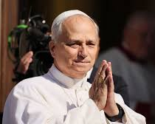
HOLY FATHER’S PRAYER INTENTION

During December, the Holy Father wants us to pray for Christians in areas of conflict
Let us pray that Christians living in areas of war or conflict, especially in the Middle East, might be seeds of peace, reconciliation,
and hope.

Reports to Comitium:
December | January 2026
NONE | VIETNAMESE CURIA

Visits to Praesidia:
December | January 2026
THORNLIE: MARIA ANNUNCIATA | NONE

COMITIUM CONTACT DETAILS

Web address:
https://www.legion-of-mary-comitium-of-perth-western-australia-inc.org

comitiumofperth@gmail.com

Spiritual Director | Fr Doug Harris | glendaloug@perthcatholic.org.au
President | Sheelagh Tillotson | 0468 928 319
Vice President
Secretary | Bianca-Maria Casalengo | 0415 405 368
Treasurer | Katie Bennett | 0488 547 817
Assistant Secretary | Cynthia Gauci | 0430 776 648
Assistant  Treasurer | Rosemary Bennett | 0421 580 783

Highlights of 2025
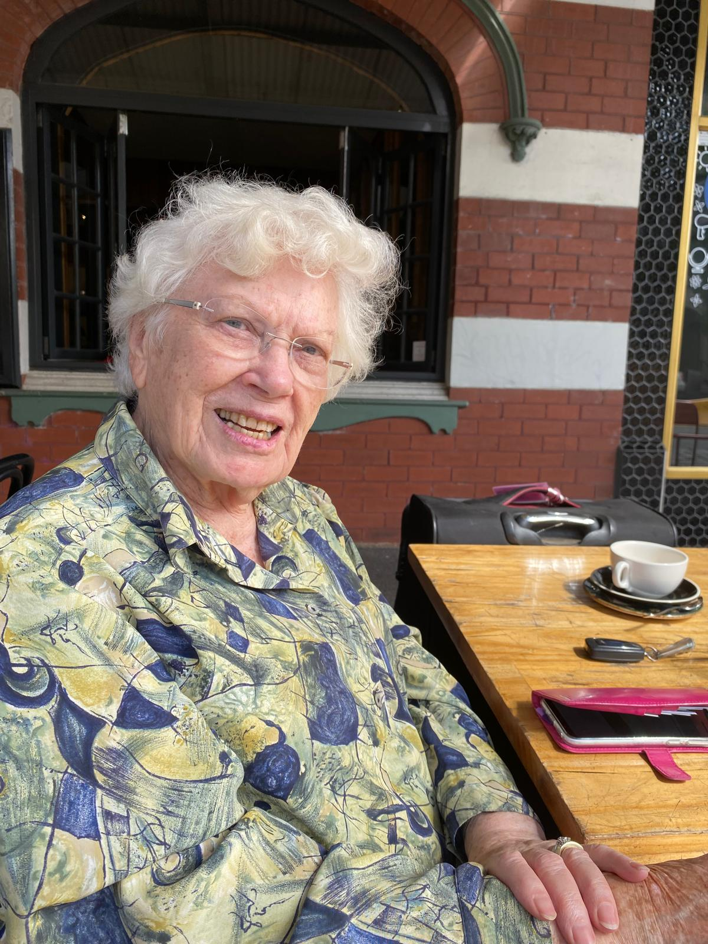 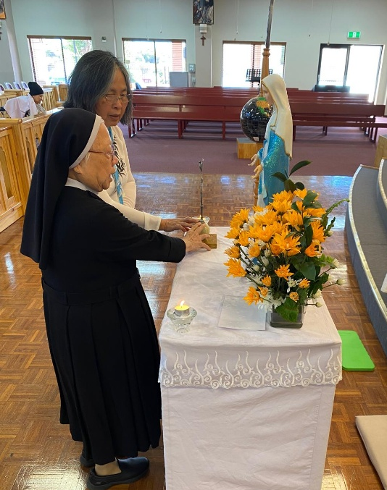 Sr Joan Davies became our Sr Theresa Tran, of the Vietnamese Curia,
Senatus Correspondent who has experienced improvement in her health since we invoked the Frank Duff prayer.

Events
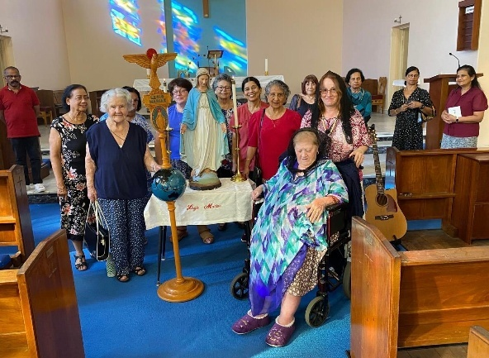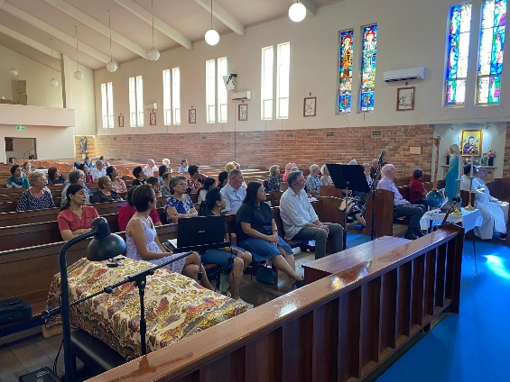
Comitium ACIES
in March at
St Joachim’s parish

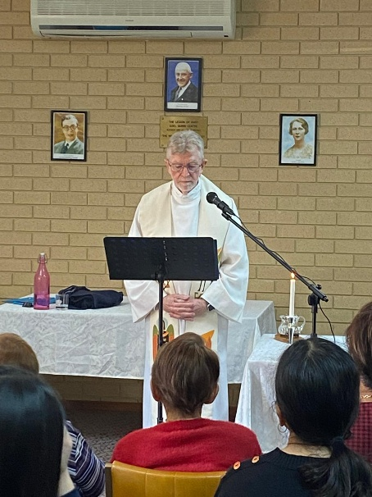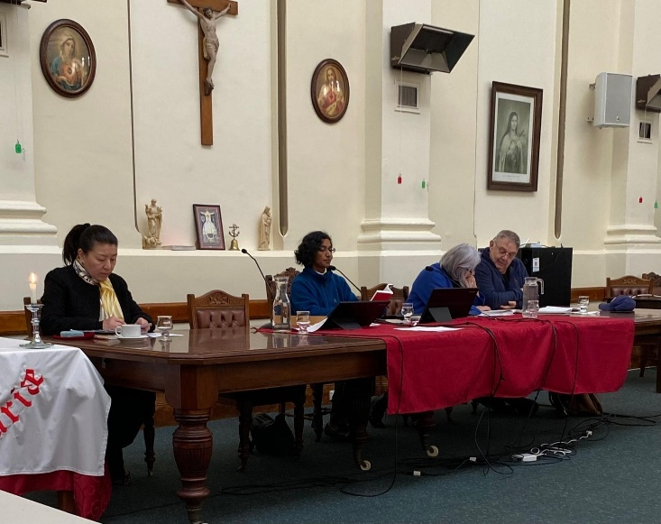
Half-day of Reflection in May Visits to Senatus meetings in June, July and October

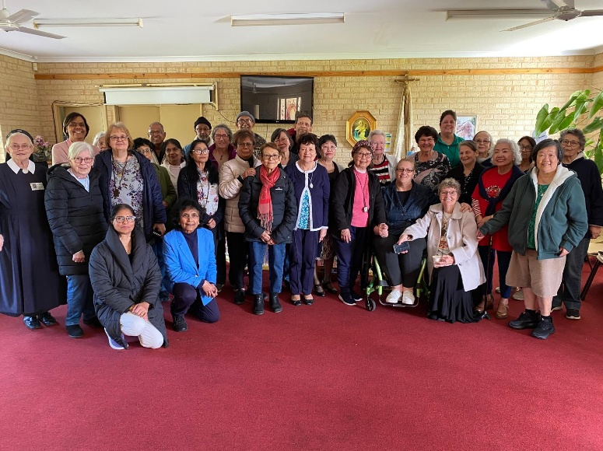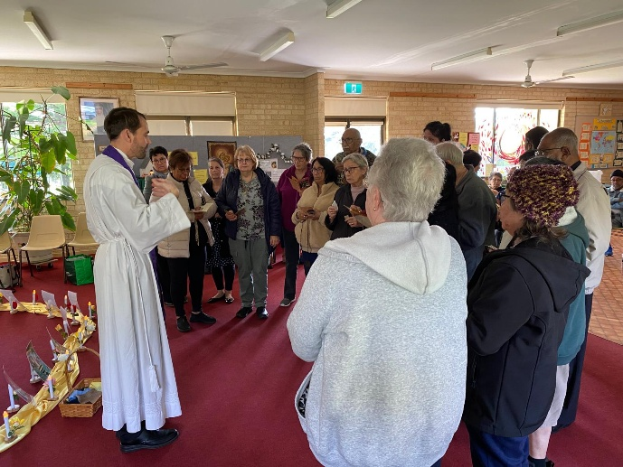
Pilgrimage participants at the Schoenstatt Shrine. Fr Grant talks to pilgrims

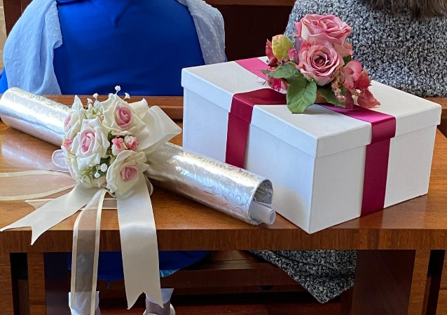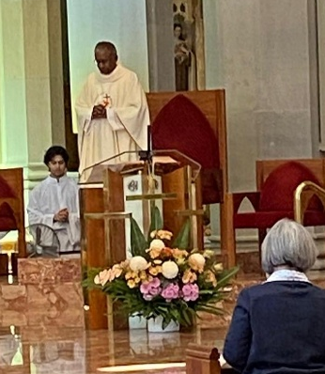
Rosary Bouquet, and Nativity Mass celebrated at St Mary’s Cathedral by Fr Sean Fernandez in September.

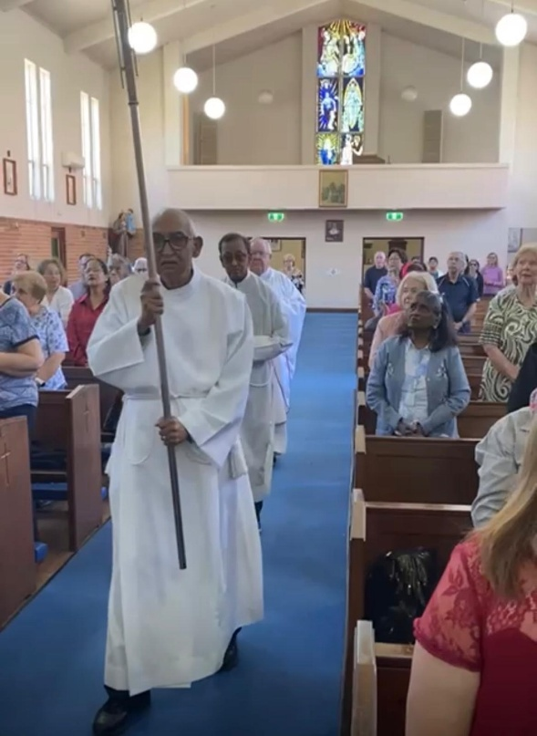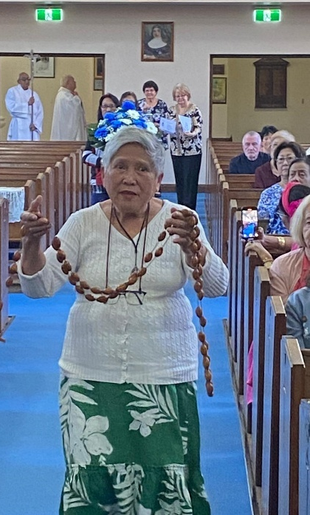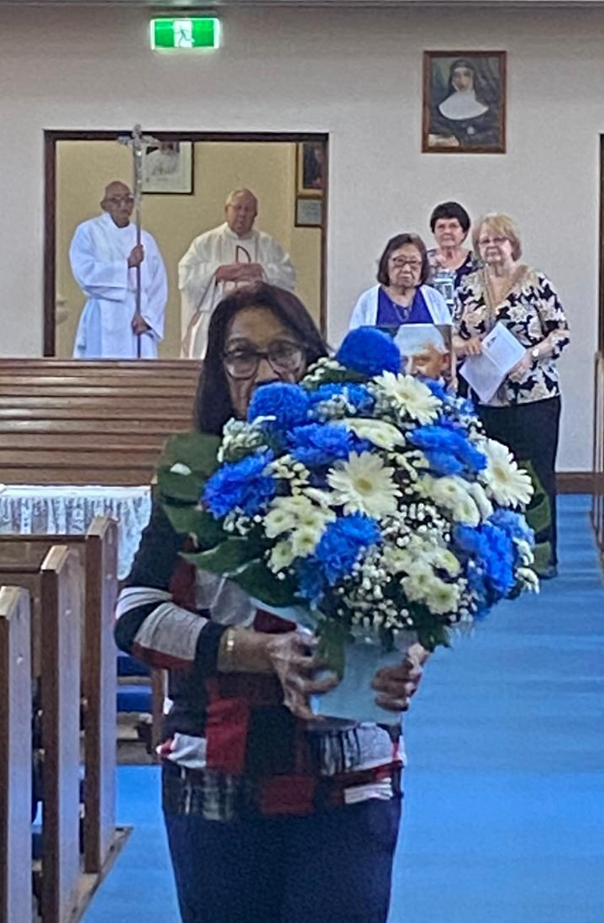
Comitium Annual Mass for Departed Legionaries at St Joachim’s church. Before the Entrance Procession Members carried Legion Symbols to lay around Our Lady’s altar

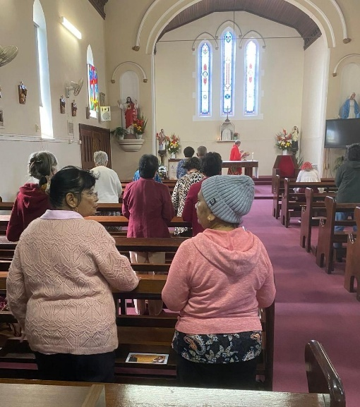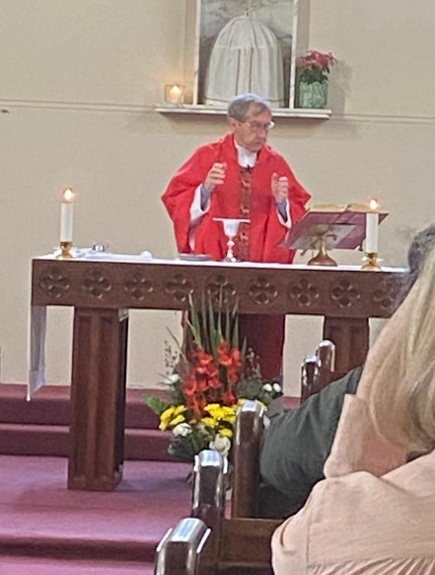
Members at the EDC Annual Mass celebrated by Fr Brian Limbourne.

Visits to distant councils

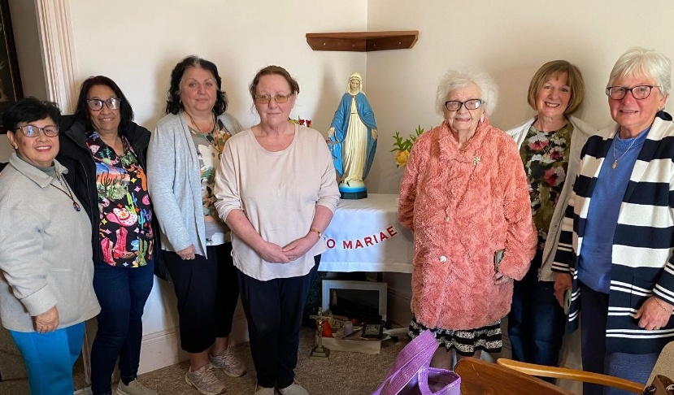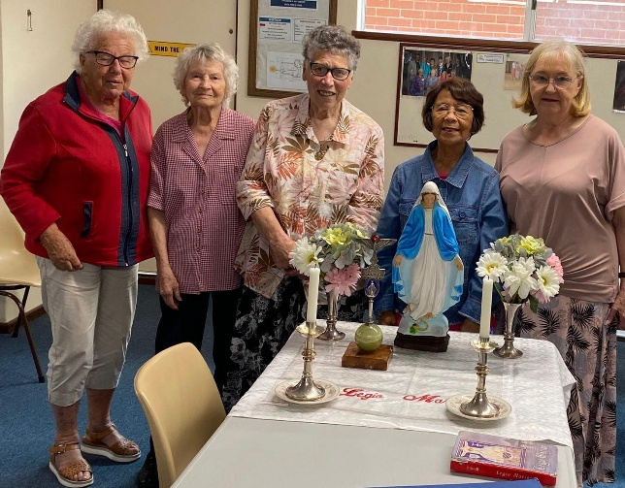
Our Lady of Grace Praesidium, Albany. Star of the Sea Praesidium, Busselton.

New items available from the Piety shop in 2026

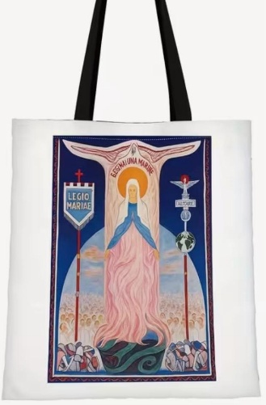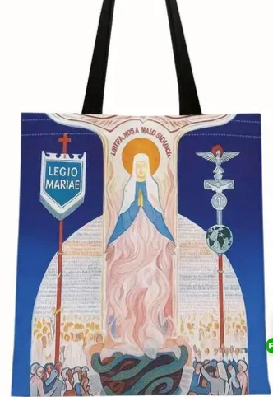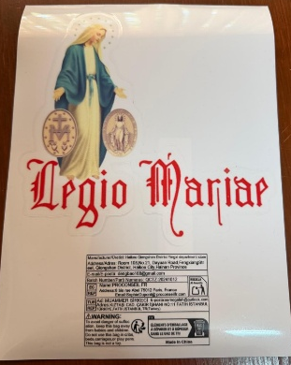
Canvas bags $12.50 Zip pocket $5 Car sticker $4

