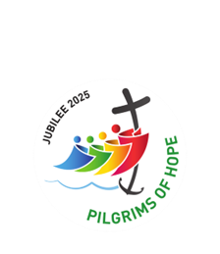
november 2025
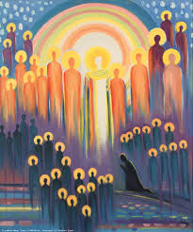

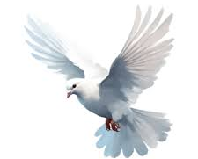

During November we remember our departed Legionaries, and all those who have died and need our prayers to speed them on their journey to everlasting peace in Heaven.

Eternal rest grant unto them, o lord,
And let perpetual light shine upon them,
May they rest in Peace. Amen

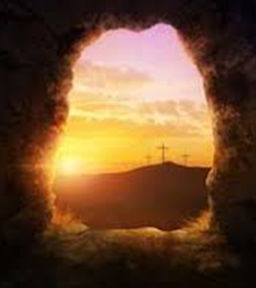
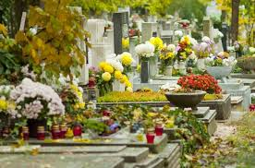

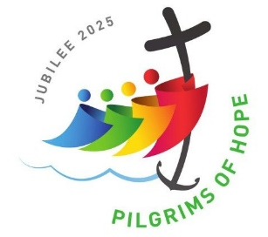
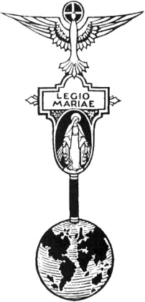
THE LEGION OF MARY
BULLETIN
November 2025
Comitium of Perth (Western Australia) Inc
36 Windsor St, East Perth 6000
Tel 93282726
Email: comitiumofperth@gmail.com
Website: https://www.legion-of-mary-comitium-of-perth-western-australia-inc.org
Facebook: Legion of Mary Perth Western

Australia

Dates to remember.
2nd Monday of the Month
Executive meeting
3rd Monday of the Month Comitium Meeting
2nd Saturday of the Month Rosary Making
EDC meeting 4th Monday
November 24th
NDC meeting 4th Saturday
November 22nd
EVENTS for 2025

Dec 6th AGR 2pm VEQC

EVENTS for 2026
17th Jan 2026
Officers’ Afternoon Tea and Training.
19th Jan Comitium Meeting
ALLOCUTIO: by Fr Doug Harris
Read by: Sr Rosemary Bennett

When Jesus healed ten lepers, only one came back to give Him thanks for the miracle of a clean body.
How deeply the “other nine” wounded His heart.
Jesus said: “Were not all ten made whole, where are the other nine?”
Ten people were healed of leprosy but only one returned to give Him thanks.
Every Sunday Jesus performs a far greater miracle for us. He gives us Himself – the Eucharist.
The Eucharist is the ‘greatest’ gift God gives us because it is Our Lord Himself.
When we receive the gift of the Eucharist, we receive everything. There is no more God can give.
All His Love, all His Life, etc…

The Eucharist, therefore, is a much greater gift than being healed of leprosy. Therefore, we need to thank Our Lord for the Eucharist even more than those ten who needed to thank Him for being healed of leprosy.
The Eucharist meant thanksgiving. The Eucharist only came about through Our Lord’s Sacrifice on the Cross. He gave all of Himself on Calvary so that we may receive all of Himself in Holy Communion.
And yet how often are we like the “other nine” who failed to be thankful for this
Sacrament of Love.
One way we can give thanks to Him is by coming back during the week to visit Him
in the Blessed Sacrament.
When we do this, we not only give Him thanks, but we also make up for the
“other nine” who never think of visiting Him at all.
After the Last Supper Jesus went to the Garden to pray. When He began to pray, He started to sweat blood because He realized that the gift of the Holy Eucharist that He had just given mankind on Holy Thursday night, would
be appreciated by so few and rejected by so many.
He saw down through the ages how many would walk away from His Eucharistic
Love and not even bother to come to Mass. He saw where in the many tabernacles of the world He would be left alone and forgotten.
He saw how few would believe in His Real Presence and fewer still would respond to His appeal to be loved day and night in the Blessed Sacrament.
He saw how much people would live their lives as if He were not here.

In the Garden, Scripture says that:
“His heart was filled with sorrow to the point of death” (Mt 26:38).
He called on His Apostles to comfort Him, but they preferred to sleep because it was in the middle of the night. Today Jesus calls out to you, “Could you not watch one hour with Me?” (Mt 26:40).
In my parish, St. Bernadette’s, Glendalough, we have perpetual adoration. I
encourage this in every parish. One parish could combine with a number of
neighbouring parishes. For Perpetual Adoration, all that is needed is for each one of us to give Our Lord just one hour a week.
At St. Bernadette’s, of particular note, are those who get up in the middle of the night to be with Jesus. There are 4 people who each do at least 3 hours a week in the middle of the night. There are 7 people who each do 2 hours a week in the middle of the night. Some of those have been doing that since the beginning – over 17 years. One young woman does at least 2 Holy Hours, 6 nights a week.
Every week we should give time to thank God for giving us Himself in the Eucharist which the Church calls, “the Sacrament of Love.”
If we were to thank God for the Eucharist, at every moment, with all our heart,
we would need longer than eternity to thank Him sufficiently.

MESSAGE FROM THE PRESIDENT
November 2025

Dear Brothers and Sisters,
It was wonderful to celebrate our Annual Mass for Departed Legionaries, and commemoration of Frank Duff, at St Joachim’s again this year. We thank Monsignor McDonald for being our celebrant and welcoming us to his parish, and Michael Duncan and Soul Purpose choir for their beautiful musical accompaniment. Thanks also to all members who attended and stayed afterwards for the fellowship. There are photographs of the occasion later in this bulletin.

Since the October Comitium meeting we have learned that Sr Christyne Williams is unable to stand for re-election as Vice President due to family demands, so her position is now vacant until we have other nominations and can vote in a new officer. I would like to thank Christyne most sincerely on behalf of the Executive and the whole of Comitium for her dedication and hard work over the past several years. We wish her well in her future and look forward to her return to us when her life permits.

We have two other positions coming up for election, and it is vital for the health and development of the Legion of Mary that we have new members volunteering to take on executive roles. From my own recent experience, I know how daunting it can be to consider stepping up, but I can assure you that with the role comes Our Lady’s strength and guidance. It is a serious step and comes with some time commitments as well as the responsibilities, but the whole Executive supports each other so you are never alone. It is imperative that new blood is introduced, so that we do not become an entity which does not grow because the same people simply rotate roles. Please consider seriously, “Is Mary calling you?” and if she is, please nominate for one of the three positions, or let a member of the Executive know that you would like to learn, with a view to nominating later.
The Officer Afternoon Tea and Training on January 17th will be a very valuable opportunity for any of you who are in, or willing to take on, positions of leadership, to learn and clarify what each leadership role entails, whether at Praesidium, Curia or Comitium level. I hope that we will have a strong response and a very positive workshop.

God bless and Mary guide you
Sr Sheelagh Tillotson

EXECUTIVE OFFICER ELECTIONS

*The office of Vice President is currently vacant and open to nominations.
*Sr Rosemary Bennett completes her first term as Assistant Treasurer in November. Any member wishing to nominate for this position please see Sr Sheelagh at the Comitium meeting to complete the necessary formalities. Elections will take place at the November meeting.
*Sr Bianca Casalengo completes her first term as Secretary in December.
Any member wishing to nominate for this position please see Sr Sheelagh to complete the necessary formalities. Elections will take place at the December meeting.
OCTOBER REPORTS:

To Jesus through Mary
Name of Praesidium: | Maria Annunciata
Location (suburb) | Thornlie
Meeting place and time: | Sacred Heart Church ~ Foley Centre  Wednesday 9.45 am

Spiritual Director: | Nil
President: | Sr Joy Stoddart | Vice President: | Vacant
Secretary: | Sr Jennifer Farrugia | Treasurer: | Sr Bernadette Aitken
Active Membership: | 3 | Praetorian: | nil
Auxiliary Membership: | 36 | Adjutorian: | Nil
Probationary: | Nil
Report from: | 11th Nov 2024 | To: | 15th Oct 2025

Extension:
Frequent efforts are made to recruit new members. A weekly advert is placed in the parish bulletin, giving day, time and contact person. Pamphlets about the Legion of Mary are placed in the Church Foyer.

Works undertaken by members:
- Our Leion work is still mostly by phone contact with occasional visiting if requested. Some Funeral Masses have been attended by members.
- One Legionary is a Parish Catechist and another member made 346 rosaries for the year, with an auxiliary member was also making them for part of the year.
- The Legion provided Jubilee Prayer cards and Divine Mercy Novena Leaflets in the tow parishes.
- Twenty Miraculous Medals and leaflets were given to the Parish Youth Group
- On the feast of the Miraculous Medal Fr James blessed medals and leaflets and over 2 days 120 were taken by parishioners.
- 2 Legionaries attended the ACIES, with our other member making her pledge at the weekly meeting.
Works undertaken that are not Legionary work:
- One Legionary leads a weekly Parish Cenacle.
- The Legion also organisers the “the 48hr Rosary Bouquet” roster in 2 parishes.
Other Items:
- Auxiliary membership has dropped due to age and deaths.

VISITING LEGIONARY FROM ZAMBIA

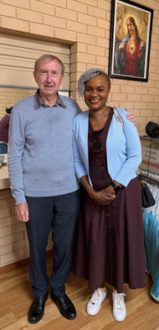
We were delighted to receive a visit from Sr Monica Chisela, a Legionary from Lusaka, Zambia. Sr Monica is currently visiting her daughter in Perth and was able to join us at Comitium and at the EDC meeting. She is a dynamic and inspiring lady who told us many details and stories about the Legion’s work in that part of Africa. Due to the particular needs of the people, the Legion members give a lot of practical as well as spiritual support to many areas of the community. They attend patients in The Cancer Hospital in Lusaka. This is the only one in the country and people often arrive from long distances without the basic needs or even clothes. These needs are supplied and then the spiritual support can begin. This is vital work, as the legionaries may be the only visitors these people have, and the only ones they can pray with at this challenging time. We gave Sr Monica some handmade rosaries which she said will be given to the cancer patients. The members also visit a Correctional Centre where they interact with residents, and an orphanage. There they help supply crayons and other necessities for the children, as well as being always ready to give love and hugs to these children who have no parents to cuddle them.
We wish Sister a safe journey back and hope that she will visit us again on her next trip to Perth.


SPECIALS PRAYERS:

Prayers for the Sick: Louise Allen, Robert Walker, Marie Neale, Albert Codilla, Mimia Gee, Jasmin West. Kaye Ramshaw, Veronica Bogoni, Tony Spiccia.

Repose of the Souls: Yolanda Rayney, Sr Joan Evans PBVM,
Rev Fr Brian Ahearn, Monica Ahern, Ada Grinell (anniversary)

Special Intentions: Peggy Knowles on the occasion of her 90th birthday, Rev Fr Brian Limbourne’s 70th birthday, Sr Christyne for her years of service on the Comitium executive.

Healing Intentions of Servant of God Frank Duff: Sr Penny Fernandez, Rev Sr Teresa Tran, Sr Karen Daly.
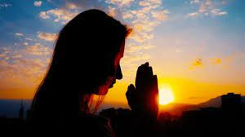
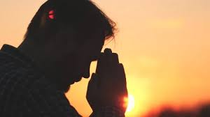

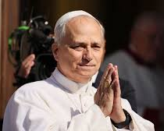
HOLY FATHER’S PRAYER INTENTION

During November, the Holy Father wants us to pray for parents who are grieving the loss of a child.
He asks that these parents find consolation within their communities and receive peace of heart from the Holy Spirit.

Reports to Comitium:
November | December
WILLETTON: OUR LADY OF THE MISSIONS | EASTERN DISTRICTS CURIA: OUR LADY OF CHRISTIANS

Visits to Praesidia:
October | November
EAST VICTORIA PARK: OUR LADY HELP OF CHRISTIANS  QUEENS PARK: MARY IMMACULATE | THORNLIE: MARIA ANNUNCIATA  BUSSELLTON: STAR OF THE SEA

COMITIUM CONTACT DETAILS

Web address:
https://www.legion-of-mary-comitium-of-perth-western-australia-inc.org

comitiumofperth@gmail.com

Spiritual Director | Fr Doug Harris | glendaloug@perthcatholic.org.au
President | Sheelagh Tillotson | 0468 928 319
Vice President
Secretary | Bianca-Maria Casalengo | 0415 405 368
Treasurer | Katie Bennett | 0488 547 817
Assistant Secretary | Cynthia Gauci | 0430 776 648
Assistant  Treasurer | Rosemary Bennett | 0421 580 783

At our Annual Mass at St Joachim’s Church in Victoria Park, we recalled those who have gone before us, and we also celebrated the life and legacy of our founder Frank Duff on the anniversary of his death.

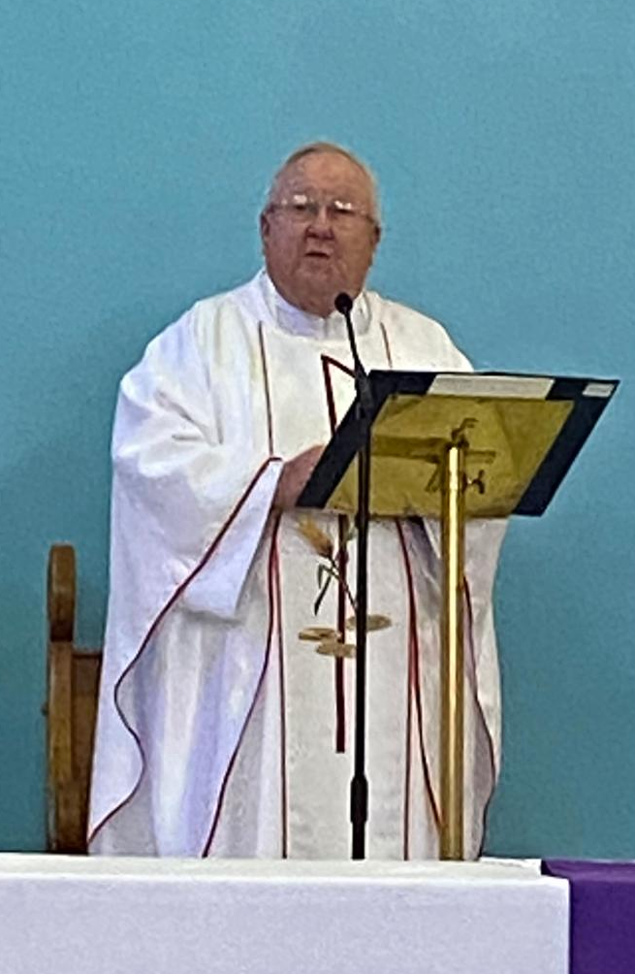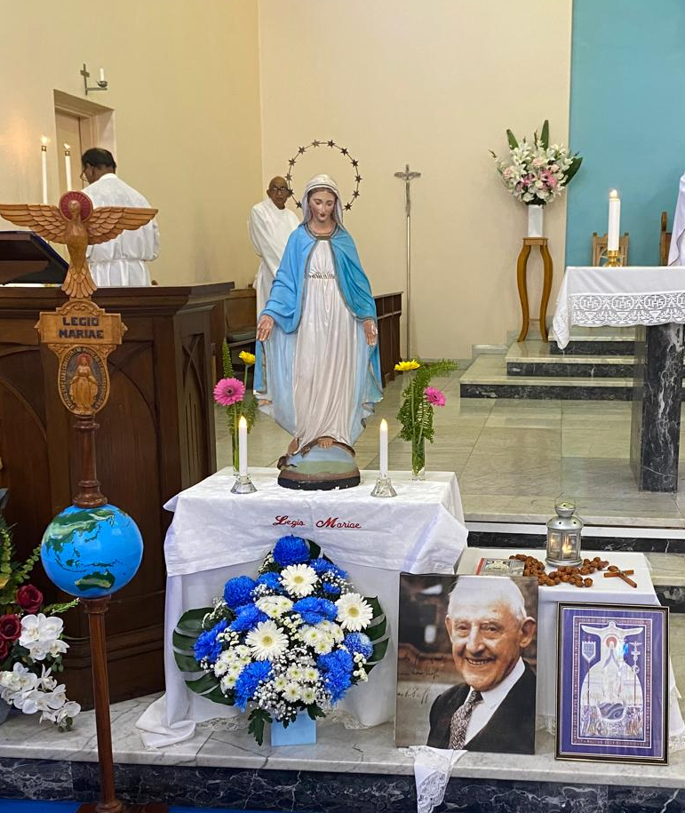
Mass was celebrated by Rev Monsignor McDonald who preached with great insight on the Mariology of St Louis Marie de Montford.

The major symbols of the Legion of Mary were placed by Legionaries around Our Lady’s altar on the Sanctuary.

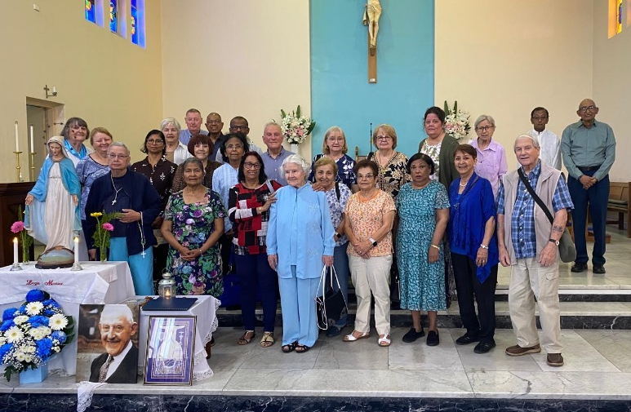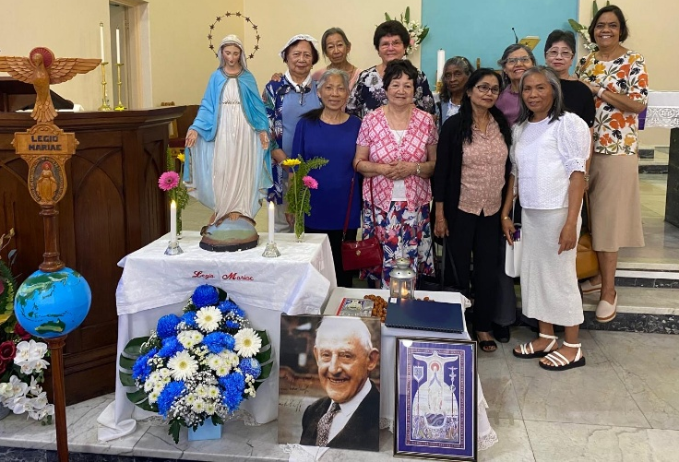
Comitium members Eastern Districts Curia members
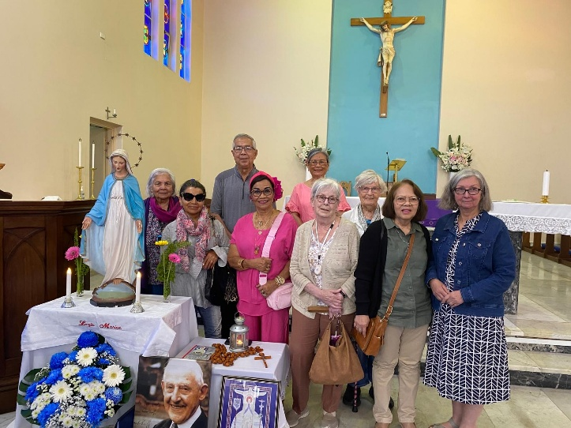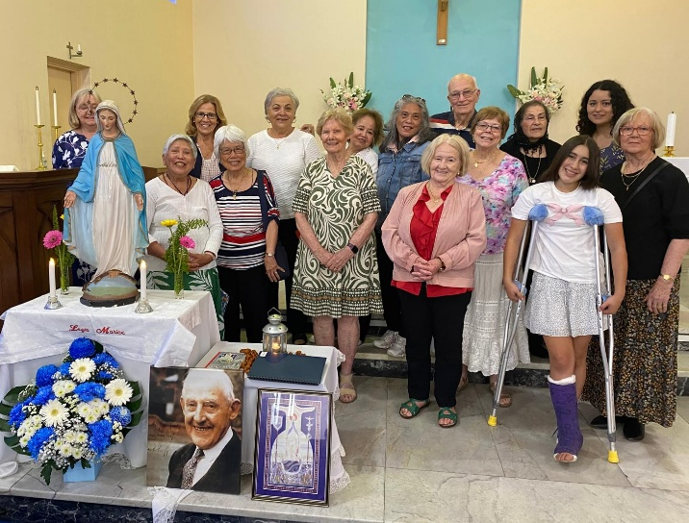
Fremantle Curia members Northern Districts Curia members

