january 2026

A happy, holy New Year to you all



A Wish for the New Year
Dear Lord, please give me...
A few friends who understand me and remain my friends;
A work to do which has real value, without which the world would be the poorer;
A mind unafraid to travel, even though the trail be not be blazed;
An understanding heart;
A sense of humour;
Time for quiet, silent meditation;
A feeling of the presence of God;
The patience to wait for the coming of these things,
With the wisdom to recognize them when they come.
- Author Unknown

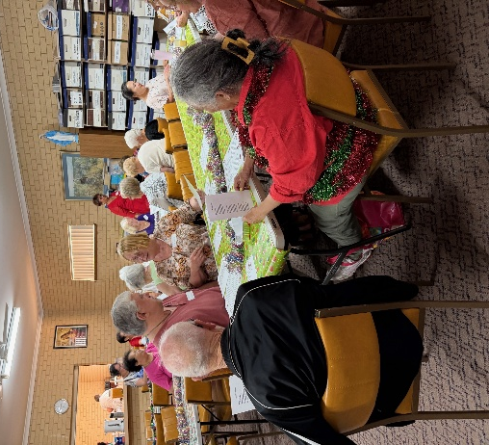
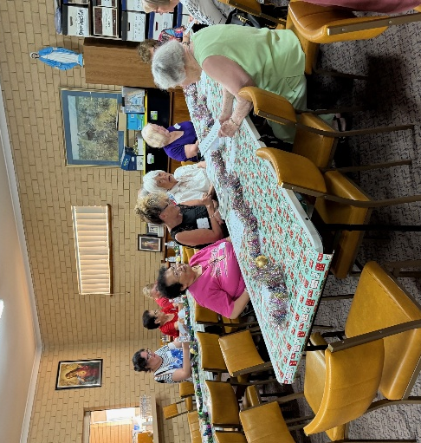
Farewelling 2025 at the AGR
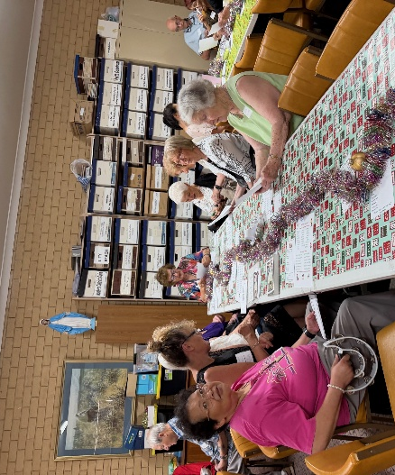
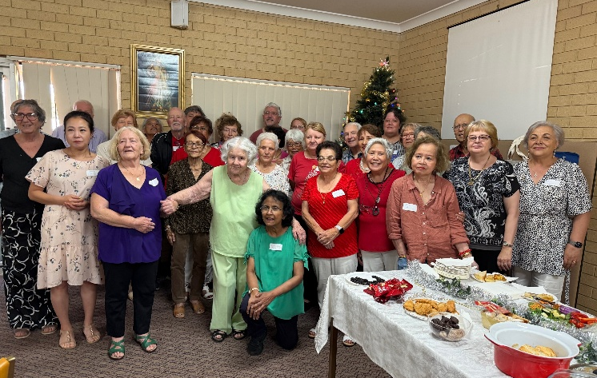
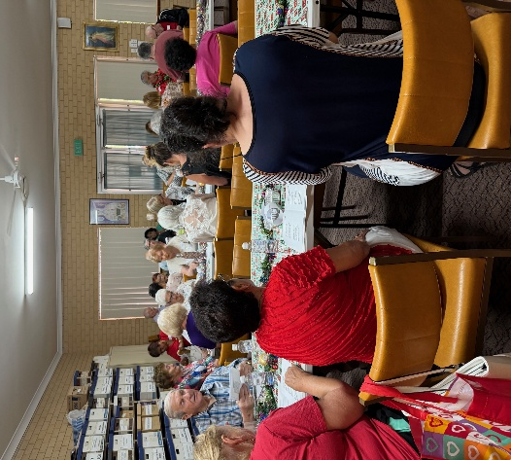

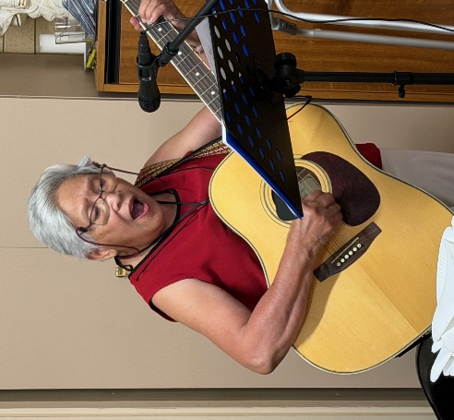
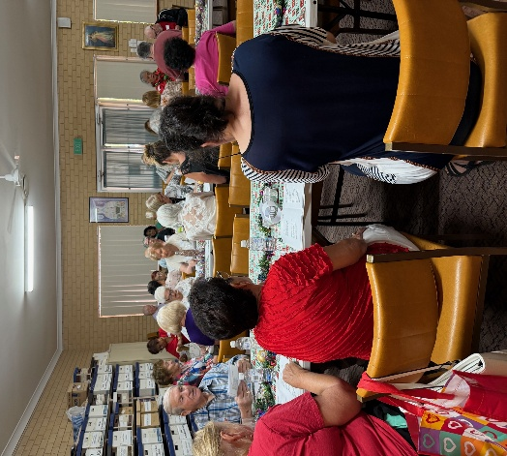
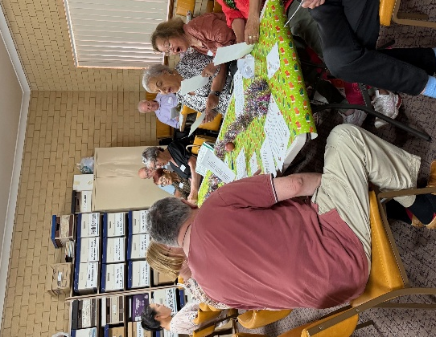

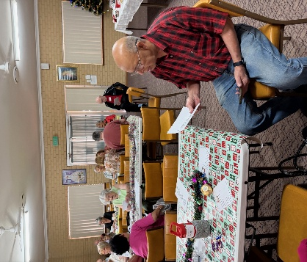
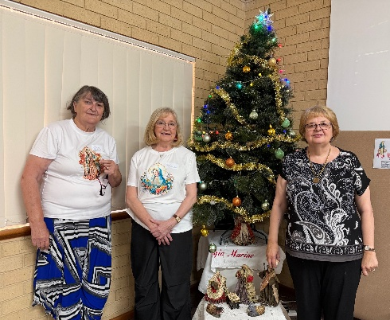
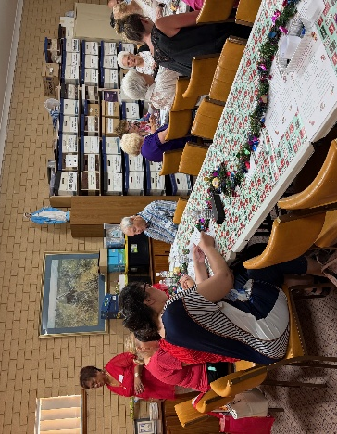

THE LEGION OF MARY
BULLETIN
January 2026
Comitium of Perth (Western Australia) Inc
36 Windsor St, East Perth 6000
Tel 93282726
Email: comitiumofperth@gmail.com
Website: https://www.legion-of-mary-comitium-of-perth-western-australia-inc.org
Facebook: Legion of Mary Perth Western

Australia

Dates to remember.
2nd Monday of the Month
Executive meeting
3rd Monday of the Month Comitium Meeting
2nd Saturday of the Month Rosary Making
4th Monday EDC meeting
4th Saturday NDC meeting

EVENTS for 2026
12th VEQC opens
19th Jan Comitium Meeting
22nd March ACIES
16th May 1-Day Retreat
16th July Pilgrimage (TBC)
5-7th Sept Rosary Bouquet
8th Sept Nativity Mass
16th Oct Procession (TBC)
ALLOCUTIO: by Fr Doug Harris
Read by: Sr Rosemary Bennett
Sacrament of Reconciliation
During Advent we make a special effort to go to the Sacrament of Reconciliation (Confession). Today’s homily is a brief catechism of the Sacrament of Reconciliation. Why should a person go to a Priest to have his sins forgiven? (why not go to God direct?).
Jesus gave His Apostles the authority to forgive sins when He said to His Apostles: “What the Father has given Me I now give to you.” He then breathed on them and said: “Receive the Holy Spirit, if you forgive the sins of any they are forgiven.” (John 20:22,23). From these words from Our Lord, the Apostles understood that they were given the authority to forgive sins. Hence, St Paul said: “What I have pardoned ‘for your sakes I have done it in the person of Christ.’” (2Corinthians 2:10). Meaning that the gift to forgive sin was given by Christ to the Apostles.
Today, priests have this gift. Therefore, when we leave the confessional, we know for certain, 100% guaranteed, that all of our sins have been forgiven. Even if we are the greatest sinner of all time.
Conditions: 1. Genuine sorrow/contrition 2. Firm desire to sin no more.
How often should we go to the Sacrament of Reconciliation? Our Lady of Fatima in 1917 asked us to go once a month. Some of you are familiar with Our Lady’s requests for the First Saturday devotion. To fulfill that devotion, it is a requirement to go to Confession once a month. But if we have committed a serious sin then we must go to Confession as soon as possible (and we should not receive Holy Communion until we have).
We should go to Confession on a regular or frequent basis for two reasons. One is to have our sins forgiven. The other is to receive ‘Sanctifying Grace.’ Sanctifying Grace gives us the power or strength not to sin again and also the power or strength to achieve the highest virtue. Sin always leads to spiritual sickness, which can lead to physical sickness. In the Sacrament of Reconciliation, because a person is healed of spiritual sickness, he or she may also be healed of physical sickness.
Fr John Rea was giving a parish mission in New Zealand. The penitent, Clare, had slipped a disc in her back ten years previously. Since then, she had suffered from severe back trouble and had been unable to kneel. After Clare went to Confession, without thinking, she knelt down to do her penance. She later discovered she was completely healed; she has had no back problem since.
Another reason why we should go to Reconciliation often is because we don’t know when we will die. In the country town of Northam in West Australia where I spent 6 months as a Deacon, there was a man about 50 years of age who had excellent health; he hardly had a sick day in his life. One Saturday morning he said to his wife that he was thinking about going to Confession that afternoon. That was unusual because he hadn’t been to Confession for months, nor had the desire to go. In the afternoon he changed his mind, saying to his wife that he hadn’t been to Confession for such a long time and maybe there was no point. With encouragement from his wife, however, he went to Confession. That very night the man died (as a result of a burst blood vessel in his brain).
Another reason to go to Reconciliation, according to an Exorcist, is because Reconciliation is the most powerful prayer of Exorcism. If we are struggling to stop a bad thought or we cannot overcome a vice, for example, then try the Sacrament of Reconciliation.
What sins should a person confess in the Sacrament of Reconciliation? A person must confess all their mortal sins, in this Sacrament. There are 3 conditions for a sin to be mortal.
1. Serious matter. For example, one of the Ten Commandments. “You shall not steal”. “You shall not commit adultery”, etc. 2. Full knowledge that the act is a mortal sin. 3. Free Will. That means we freely did the act without coercion or force.
If a person doesn’t have any mortal sins, they don’t need to go to the Sacrament of Reconciliation. However, a person should still go to this Sacrament once a month to receive the Sanctifying Grace which will help them overcome all sins and achieve the highest virtue.
Our Lord said to St Faustina before she died in 1933: ‘I desire trust from My creatures. Encourage souls to place great trust in My fathomless mercy. Let the weak, sinful soul have no fear to approach Me, for even if it had more sins than the grains of sand in the world, all would be drowned in the unmeasurable depths of My Mercy (1059). Tell souls where they are to look for peace; that is in the tribunal of My Mercy (the Sacrament of Reconciliation). There, the greatest miracles take place.’
Mr. Marino Restrepo’s life highlights the importance of the Sacrament of Reconciliation. Marino was a well-known actor in Columbia, South America and like many actors, his life was far from pleasing to God. In the 1990’s he was kidnapped and held for ransom. For several months he lived in a dark cave with almost no food. During this time, he had an ‘after life experience’. His soul left his body but returned sometime later. During his death he saw his sins like watching a film. At the same time, he was aware of Our Lord’s Love and Mercy for him. Marino said it was unimaginably painful to hurt Our Lord through sin because He is all love and all compassion and all mercy. When he came back to life his greatest desire was to go to the Sacrament of Reconciliation. On top of that he made a prayer to God that he would never sin again. The thought of offending Our Lord, in the least, was too painful.
Of course, God desires that we do more than overcome sin in our lives. He wants us to have the greatest possible virtue. I will finish with a quote from Bl Mother Cecile of Rome. She died in Canada in 1929. She was beatified by Pope John Paul II. ‘I wish to practice interior silence and recollection and to that end suppress every useless thought and every useless movement. I committed myself under pain of sin to do constantly and in every circumstance, what was most perfect in my thoughts, my desires. This vow affects every second, every moment of my life.’
In Confession we re-commit our lives to Jesus Christ. When we go to confession, we make a commitment not to sin again and we make a commitment to give God everything we have. We also know that the Grace of the Sacrament is sufficient for us to achieve that commitment.

MESSAGE FROM THE PRESIDENT
January 2026

Dear Brothers and Sisters,
I wish you a Holy and Happy New Year filled with many blessings. May Mary continue to guide you in your work for her throughout the coming months.
On January 6th, feast of the Epiphany, Pope Leo X1V ended the Jubilee Year of Hope with the closing of the Holy Door. It has been a memorable time, especially for those who were able to go on pilgrimages both at home and around the world. Pope Francis had opened the year with these words: “You are Pilgrims of Hope, pressing forward toward a better future for the Earth and her people, and committing at every step to bring it about.”
As we move beyond this Jubilee and into 2026, let us take the theme of Hope with us and ask ourselves two questions:
- Who blesses and gives me hope through their words and actions?
- Who may need me to bless them, and needs my hope for them?
May these remain in our minds to both console and inspire us.

We have several events planned, in which we hope many of you will participate. The ACIES will be held at St Joachim’s church in Victoria Park in March; in May we hope to hold a full-day Retreat at the Venerable Edel Quinn Centre; in July there will be a pilgrimage to a local shrine, and September will see the Annual Rosary Bouquet and Mass. We plan to have the Torchlight Procession in October, the Annual Mass at St Joachim’s in November and the AGR in December to round off the year. Dates are detailed earlier in this bulletin and will be repeated monthly, and I urge you to enter them into your diaries and plan to join these valuable and enjoyable opportunities to be with Legionaries outside of your immediate groups. May 2026 be a wonderful year for you.

God bless and Mary guide you
Sr Sheelagh Tillotson

EXECUTIVE OFFICER ELECTIONS

*The office of Vice President is currently vacant and open to nominations. Any member wishing to nominate for this position should see Sr Sheelagh to complete the necessary formalities.
*Sr Rosemary Bennett has been re-elected for her second term as Assistant Treasurer.
*Sr Bianca Casalengo has been re-elected for her second term as Secretary.


SPECIALS PRAYERS:
Prayers for the Sick: Fr Doug Harris, Sr Betty Flynn, Br Binh,
Kay Jones, Michael Travalski
Repose of the Souls: All victims of the Bondi attack, Clarissa Gomez and Susan Murray (anniversary)
Special Intentions: Cummins family, Bernadette Aitkin’s family, Br John, Gary Addison, Ivy Monique.
Healing Intentions of Servant of God Frank Duff: Sr Penny Fernandez, Rev Sr Teresa Tran.
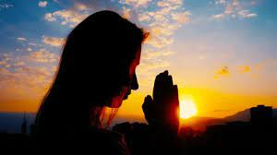
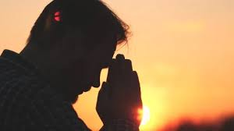

HOLY FATHER’S PRAYER INTENTION for January 2026
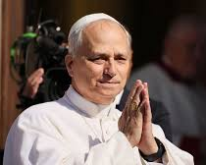
Let us pray that praying with the Word of God be nourishment for our lives and a source of hope in our communities, helping us to build a more fraternal and missionary Church.

Reports to Comitium:
January | February
VIETNAMESE CURIA: OUR LADY of LAVANG | N.D.C.- MARY ASSUMED INTO HEAVEN

Visits to Praesidia:
January | February
No visits | WILLETON - OUR LADY OF THE MISSIONS

COMITIUM CONTACT DETAILS

Web address:
https://www.legion-of-mary-comitium-of-perth-western-australia-inc.org

comitiumofperth@gmail.com

Spiritual Director | Fr Doug Harris | glendaloug@perthcatholic.org.au
President | Sheelagh Tillotson | 0468 928 319
Vice President
Secretary | Bianca-Maria Casalengo | 0415 405 368
Treasurer | Katie Bennett | 0488 547 817
Assistant Secretary | Cynthia Gauci | 0430 776 648
Assistant  Treasurer | Rosemary Bennett | 0421 580 783

New Items in the Piety Shop

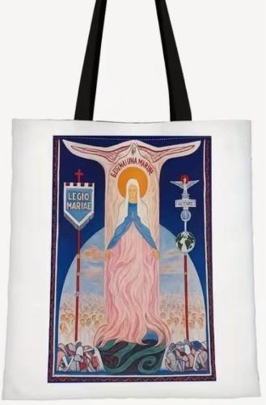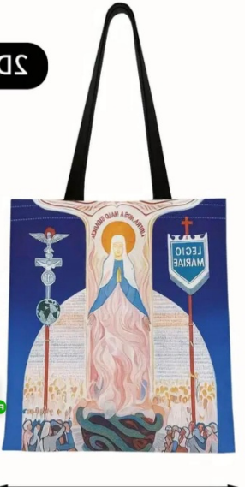

Canvas Tote Bags
$12.50

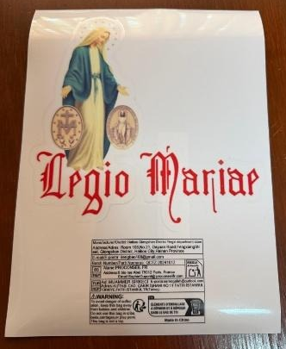


Zippered Canvas Pouch
$5
Car Sticker $4
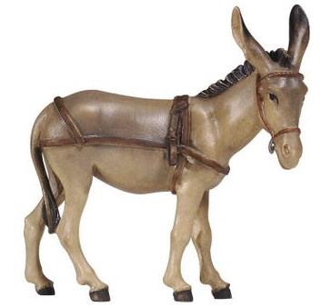
The Donkey of the Crib

I am that silent donkey
Who plodded through the snow

To the little town of Bethlehem
Two thousand years ago.

And though the world condemns me
To trudge with burdens great
Upon the bye-ways of the earth
Is my destined fate.

To be beaten and derided
By the careless and uncouth,
But never a word of censure
Is uttered from my mouth.

Though I am dumb to beatings
I hold my private joy;
That on that Holy Silent Night
I carried Mary’s boy.

Before the dawn I saw him
With angels hovering near,
The king of kings asleep on straw
Since then, I know no fear.

Since man’s opinion counts but nought,
I thwarted Herod’s hand,

And I carried the Holy Child
On the flight to Egypt’s Land.

But more than this, my finest hour,
My back, the Saviour’s seat,
Many cheered him with Hosannas
And spread palms before my feet.

