april 2026

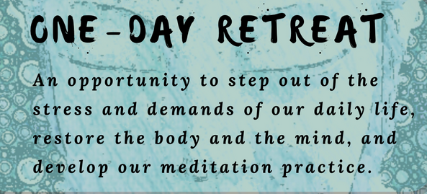

May 16th - Day of Retreat at St Joachim’s Parish
Mark the day in your diary and join Mons Thomas McDonald and Rev Fr Peter Porteous OP for a day of prayer, talks and reflection.
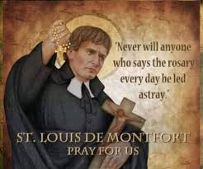
The day will begin with Registration followed by Legion Prayers and Holy Mass.
We will then move to the Parish Hall for morning tea and a talk by Mons. Thomas McDonald.
After reflecting on his words, we will enjoy a lunch of soup (provided) and other plates brought by participants. Please bring your own mug for soup. Plates must be of Finger Food only as we do not have cutlery etc for eating more complex dishes.
In the afternoon, following recitation of the Catena, Fr Peter will give the second talk.
To complete the day, we will return to the church for Benediction and the Concluding Legion Prayers.

We hope that there will be a strong participation of Legionaries for this event, and we ask that you contact Comitium to notify us of your intention to participate, so that preparations can be made for the correct numbers. There is no set fee for the Retreat but there will be a Secret Bag for you to contribute to the costs and stipends of the day.
For Registration of interest, and queries, please call: Sr Sheelagh on 0468 928 319
or email comitiumofperth@gmail.com leaving your name, contact number and the number of participants you will be bringing.
ACIES CEREMONIES at Perth Comitium and curia

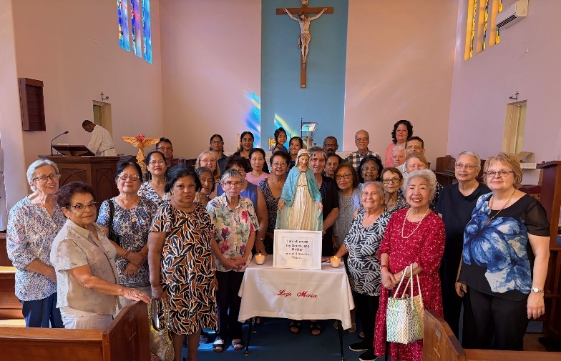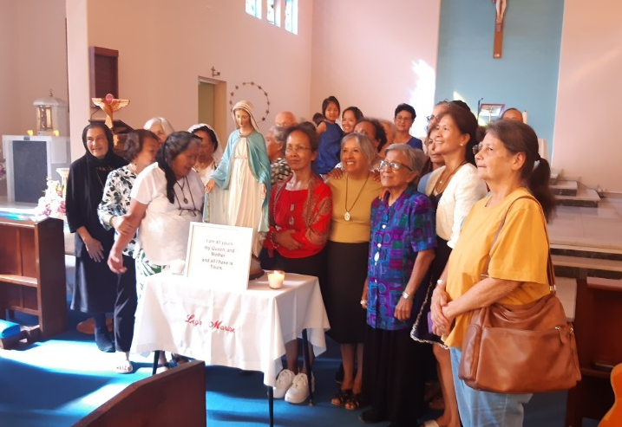
Members of Comitium attached praesidia celebrated Members of Northern Districts Curia gathered at St Joachim’s Parish church in Victoria Park around Our Lady’s altar.

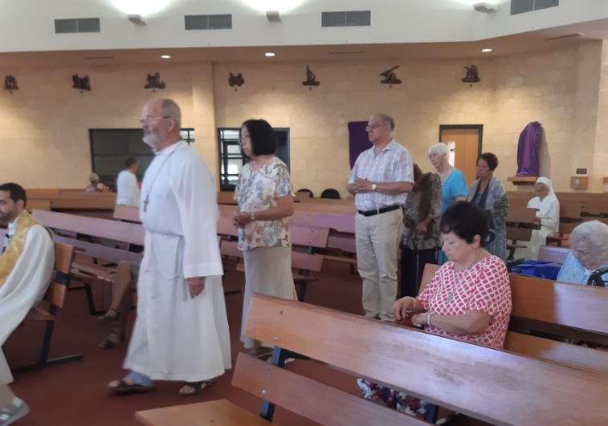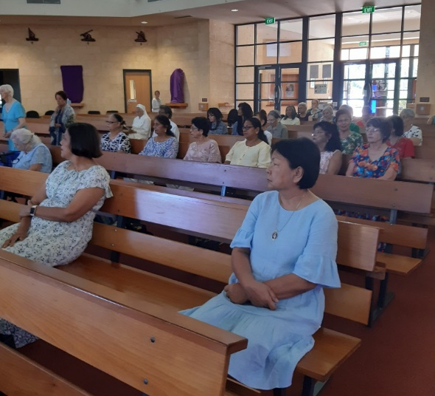
Members gathered for the Eastern Districts Curia ACIES at St Francis Church, Armadale

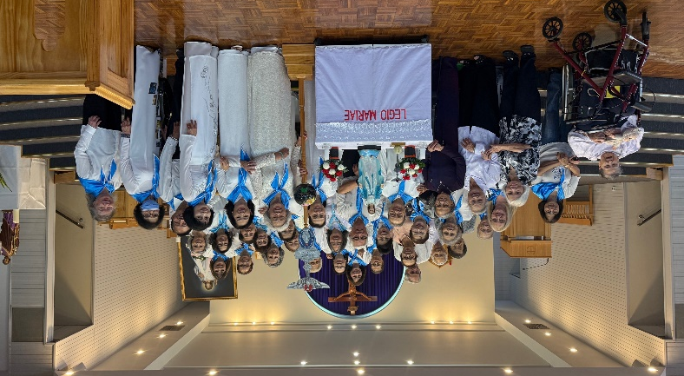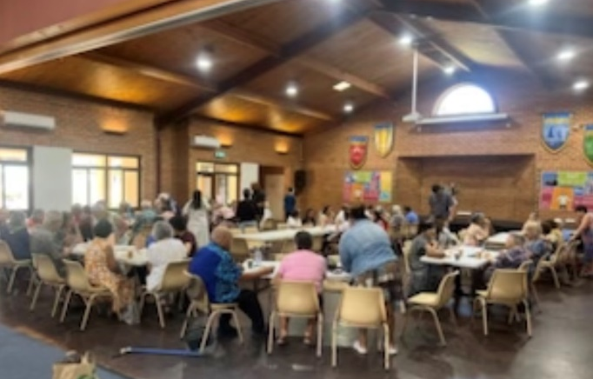
Members of the Vietnamese Curia, in traditional dress, Members enjoyed fellowship after Fremantle Curia at the Vietnamese Centre in Westminster. ACIES at Our Lady of Lourdes, Rockingham

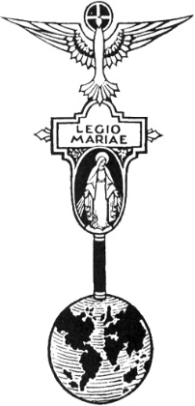
THE LEGION OF MARY
BULLETIN
APRIL 2026
Comitium of Perth (Western Australia) Inc
36 Windsor St, East Perth 6000
Tel 93282726
Email: comitiumofperth@gmail.com
Website: https://www.legion-of-mary-comitium-of-perth-western-australia-inc.org
Facebook: Legion of Mary Perth Western

Australia

ALLOCUTIO: Fr Doug Harris Allocutio on last Sunday’s Gospel LENT 4A, 15th March, 2026.
Dates to remember.
Recurring:
2nd Monday of the Month
Executive meeting
3rd Monday of the Month Comitium Meeting
2nd Saturday of the Month Rosary Making
4th Monday EDC meeting
4^{t;lh} Saturday NDC meeting

EVENTS for 2026
16th May 1-Day Retreat at St Joachim’s 9.30-2.30pm.
16th July Pilgrimage
7-9th Sept Rosary Bouquet
8th Sept Nativity Mass
23rd Oct Procession (TBC)
7th Nov Annual Mass
In the Gospel, John 9: 1-41, Jesus uses soil and His spittle to heal blindness. The soil represents the earth or humanity and the spittle represents God’s Life or the Holy Spirit. God sometimes brings about healing or miracles through ordinary elements of nature. In the first reading from the book of Samuel, David is anointed with oil and this oil causes the Spirit of God to work powerfully upon David from that day until his death. Today, God continues to use ordinary elements from nature to give His Life to us – in the Sacraments for example.
In the Sacrament of Baptism, for example, God taught us to use water. (Jn 3:5 “Unless one is born of ‘water’ and the Spirit one cannot enter the Kingdom of God”). Sometimes God wants us to use the natural elements. Through water a baptized person receives Our Lord’s Spirit. In the Sacrament of the Eucharist the ordinary elements of bread and wine become Our Saviour Jesus Christ. By becoming our Food, Our Lord gives Himself, His Spirit, to us.
In the Sacrament of Anointing of the Sick, oil is used. This gives Our Lord’s Spirit to us so our sin is forgiven and we may be healed in mind, body and spirit.
We read in the Book of James 5:14-15 “Are there sick people among you?…let the Priests lay their hands on them anointing them with oil…the prayer of faith will save the sick persons, and the Lord will raise them up. If they have committed any sins, they will be forgiven.”
When I was a seminarian in 1998, I was assigned to help the chaplain at Royal Perth Hospital in Perth. There was a 91 year old man in a coma who was expected to die at any moment. His family had gathered around him. After the chaplain gave him the Sacrament of the Sick the 91 year old sat up and said to his oldest son “what am I doing here, there is nothing wrong with me, take me home.” Sacramentals are also powerful.
Holy water: Fr Gabrielle Amorth sprinkled holy water on clothing. A man who was possessed was to put on that clothing. The man was unaware that the clothing had been sprinkled with holy water. The man could not put the clothing on because he said to do so would be “unbearable.”
At a weekend Mass, about 3 years ago, a woman manifested. She howled like an unknown animal. I gave her a plastic cup of Holy Water. She didn’t know that the water was blessed. As soon as the water touched her tongue, she spat it out and crushed the cup in her palm.
The Brown Scapular: In October 1952, an air force officer in Texas, also a non-practicing catholic, testified that after being enrolled in the Brown Scapular he had a conversion almost immediately. He started going to Mass every day and he said, “I kept Lent with a fervour I never had before.”
The Rosary: Through the Rosary, Our Lord does many healings and miracles, but He uses a humble woman, His Mother, as His instrument. The Rosary is powerful, for example; an exorcist heard a devil say: “Every Hail Mary is like a blow to my head. If Christians knew how powerful the Rosary is, it would be my end.”
The Lord sometimes performs His miracles through people and things He has created. Today, God wants to do many healings and miracles through us. Therefore, each of us have a purpose, each of us are significant to His Plan. Every morning we should ask Jesus ‘how do you want to use me today to bring about healings, miracles and to help You accomplish your Plan?’
MESSAGE FROM THE PRESIDENT April 2026

Dear Brothers and Sisters,

I hope that you all enjoyed a Happy Easter, and were able to attend some of the Holy Week services in your parishes.

In his Easter message to the world, Urbi et Orbi, the Holy Father said this:
“On this day of celebration, let us abandon every desire for conflict, domination, and power, and implore the Lord to grant his peace to a world ravaged by wars and marked by a hatred and indifference that make us feel powerless in the face of evil. To the Lord we entrust all hearts that suffer and await the true peace that only he can give. Let us entrust ourselves to Him and open our hearts to Him! He is the only one who makes all things new.”
All people need to heed his words, and for this let us pray.

It was a delight to attend the ACIES and witness the commitment of so many devoted Legionaries. We are very grateful to all the priests who celebrated these services with us, and everyone who helped to make them a success.

On Saturday 16th May, we will be hosting a Day of Reflection at St Joachim’s Church, Shepperton Rd, Victoria Park. During the day we will attend both Mass and Benediction, for which we are very blessed. Monsignor McDonald will speak to us in the morning on the life of St Louis Marie de Montford, about whom he is very knowledgeable. Frank Duff had a particular devotion to this saint because of his love for Our Blessed Mother, and encouraged his Legionaries to study his life and teachings. We will have another inspiring talk in the afternoon from Fr Peter Porteous OP. Full details of the day are on the front cover of this Bulletin.
Such a day is not free to put on, but there will be no set charge for attendance. We ask instead that you make a suitable donation to the Secret Bag to help cover costs, and stipends. Please bring a plate of finger food for a shared lunch, and if you would like a serving from the variety of soups which will be provided, please bring a mug.

You will be pleased to hear that this year’s Pilgrimage has been arranged for Friday 16th July to St Francis of Assisi Parish, Maida Vale. We will have talks from members of the Secular Franciscans, and an opportunity to learn more about St Francis during this Jubilee year. More details will be provided to you closer to the time.

God bless and Mary guide you,
Sr Sheelagh Tillotson

REPORTS


Report of Praesidium to Comitium
Regina Coeli. Cloverdale
February 1st 2025 - March 2nd 2026
To Jesus Through Mary

Location of Meetings: During reconstruction work in the Parish Centre, meetings will take place at 3 Pratt Street Cloverdale, 104 Gardiner Street Belmont, 3/15 Ellard Street Belmont on a monthly rotation.
Time: Tuesday 8.40 am
Name of Praesidium: Regina Coeli Spiritual Director:
President: Sr Jacquelyn Turner Vice President:
Secretary: Sr Sandra Robinson Treasurer: Sr Estelita King
Assistant Treasurer: Sr Rita Saldanha
Active Membership: 5 Auxiliary Membership: 20

Continued to visit some housebound, sick and lonely people of our parish briefly as Special
Ministers
Attended vigils and funeral Masses of deceased parishioners.
Visit seven aged care homes in our parish, six weekly, one monthly, with Special Ministry
and Rosaries, Assistance to our Parish Priest in Masses at the Aged Care homes.
Catechist to children from non-Catholic schools or adults with special needs.
Distributed Blessed Ashes to residents in Aged Care homes and some private homes in
2025
Stations of the Cross were prayed at most of the nursing homes during Holy Week 2025.
Co-sponsored a Mass in the Simbang Gabi Novena at Notre Dame Church Dec 2025
Distributed rosaries to First Holy Communicants and Confirmation candidates at Notre
Dame and St Maria Goretti Primary schools.
Assisted in the preparation of gifts for Mothers’ Day and Fathers’ Day
Offered our Auxiliaries’ Mass and Mass for deceased Legionaries.
Continue to organise and help maintain a roster of adorers for our weekly Friday day of
Adoration of the Blessed Sacrament.
Continue to maintain the two Pilgrim Statue rosters and transfer whenever needed.
Attended Acies, Annual Mass, and Annual Lake Monger procession
Distribute Parish Bulletin to the housebound weekly by internet.

Intentions for 2026:
Continue to seek new members.
Continue to visit the sick and housebound and to expand our visiting base
Continue to visit the nursing homes.
Lenten activity in progress:
Distributed Ashes on Ash Wednesday and will present the Stations of the Cross at intervals
in the nursing homes. Continue to expand our activities in these homes.
The praesidium would like to thank our Parish Priest, Fr Michael Quynh Do for his support
and encouragement and members of the Comitium for their support and advice.

FORTHCOMING REPORTS TO COMITIUM
April | May
FREMANTLE CURIA - IMMACULATE CONCEPTION | EASTERN DISTRICTS CURIA - OUR LADY OF CHRISTIANS  ALBANY: OUR LADY OF GRACE

FORTHCOMING VISITATIONS
April | May
NDC - MARY ASSUMED INTO HEAVEN | CANNING VALE - ARK OF THE COVENANT  CLOVERDALE - REGINA COELI

EXECUTIVE OFFICER ELECTIONS

*The office of Vice President is currently vacant and open to nominations. Any member wishing to nominate for this position should see Sr Sheelagh to complete the necessary formalities.


SPECIALS PRAYERS:

Prayers for the Sick: Lorraine Footman, Claire Fowler, Rev Fr Quynh, Katie Trafalski, Michael Trafalski, Mira, Regina, Tony Armenti, Octavia Duorado, Robert Walker, Justin Khoo, Mark Cambridge, Marie Hegarety, Louise Allen, Stefan, Philip Goes.

Repose of the Souls: Kay and Dickie Duncalfe (anniversary), Jacki Shannon, Katie Trafalski’s mother, KA Anthony, Patrick Wates, Michael Raphael Jnr, Annamma Anthony, Patricia, Aurelia Armenti.

Special Intentions: All RCIA Elect, World Peace, Jaimie Morris, Fr Nelson Po, Ellen James, Agnes Shinn, Brent and Patricia, all those dead or suffering in the Middle East war.

Healing Intentions of Servant of God Frank Duff: Sr Penny Fernandez, Rev Sr Teresa Tran, Christopher Cameron, Mel Nerva, Robert Walker and Crissia Baufond.




HOLY FATHER’S PRAYER INTENTION for April 2026

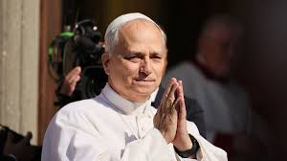
For priests in crisis
Let us pray for priests going through moments of crisis in their vocation, that they may find the accompaniment they need and that communities may support them with understanding and prayer.

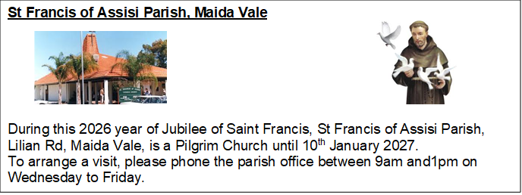

COMITIUM CONTACT DETAILS
Web address:
https://www.legion-of-mary-comitium-of-perth-western-australia-inc.org

email: comitiumofperth@gmail.com

Spiritual Director | Fr Doug Harris | glendaloug@perthcatholic.org.au
President | Sheelagh Tillotson | 0468 928 319
Vice President
Secretary | Bianca-Maria Casalengo | 0415 405 368
Treasurer | Katie Bennett | 0488 547 817
Assistant Secretary | Cynthia Gauci | 0430 776 648
Assistant  Treasurer | Rosemary Bennett | 0421 580 783

