june 2026



LEGION OF MARY ANNUAL PILGRIMAGE 2026

This year’s Pilgrimage will be to the Parish Church of St Francis of Assisi,
Lilian Road, Maida Vale on Thursday July 16th.

In this Jubilee Year of St Francis, this is the only designated Pilgrim Church
in the Archdiocese of Perth, and we are privileged to have four members of
the Secular Franciscans to speak to us about the charism of St Francis.

The day will run from Registration at 9.30 to approximately 3pm, and will
include Morning tea, Mass, Lunch (please bring your own), an Activity and
Benediction.

There will be a charge of $15 per person, payable at Registration, to defray costs
of facilitating the day.

Morning tea will be provided but each attendee should bring their own lunch.

For more information contact Legion of Mary on 9328 2726 or 0468 928 319
or at comitiumofperth@gmail.com
Reflections for a Legionary of Mary
Duties Toward Mary
(From: Queen of All Heaven magazine, with Ecclesiastical Permission)

Do I ever thank Mary for having called me to this apostolate while others, far more worthy, have not been so privileged?
Do I ask for graces for my fellow members, for our Spiritual Director, for the President, in problems which arise in our praesidium, instead of criticizing them and complaining?
Although the Handbook reads, “Legionaries should undertake De Montfort’s True Devotion to Mary,” have I neglected to learn more about this, even knowing that some of my fellow members practice it?
At the ACIES, when I make my individual renewal of consecration, saying “I am all yours, my Queen and my Mother, and all that I have is yours,” do I forget that my Legion membership is all hers, and that nothing short of the best is good enough for her?


SPECIAL PRAYERS:

Prayers for the Sick: Claire Fowler, Gary Bacon, Alecia Hamilton
Norm Carter, Annette Nicholson, Ferny Sales, Justin Khoo, Mary and Vic, Agnes Shinn, Greer Dunsford, John Veluta.
Repose of the Souls: Rev Fr John Winson, Steven, Graem, Jane Murphy, Vivienne Perira, Rev Sr Rebecca (Schoenstatt sister), Mary Thi Nguyen.

Special Intentions: World Peace, Families of our Legionaries.

Healing Intentions of Servant of God Frank Duff: Sr Penny Fernandez, Rev Sr Teresa Tran, Christopher Cameron, Mel Nerva, Robert Walker, Crissia Beaufond and Rachel Kaciuba.
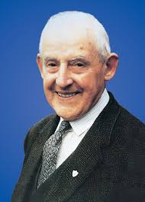




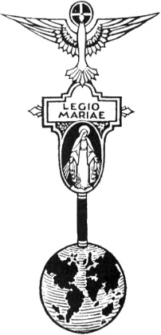
THE LEGION OF MARY
BULLETIN
June 2026
Comitium of Perth (Western Australia) Inc
36 Windsor St, East Perth 6000
Tel 93282726
Email: comitiumofperth@gmail.com
Website: https://www.legion-of-mary-comitium-of-perth-western-australia-inc.org
Facebook: Legion of Mary Perth Western

Australia

ALLOCUTIO: Sr Rosemary Bennett.
Dates to remember.
Recurring:
2nd Monday of the Month
Executive meeting
3rd Monday of the Month Comitium Meeting
2nd Saturday of the Month Rosary Making
4th Monday EDC meeting
4^{t;lh} Saturday NDC meeting
EVENTS for 2026
16th July Pilgrimage
5-7th Sept Rosary Bouquet
8th Sept Nativity Mass
23rd Oct Procession (TBC)
7th Nov Annual Mass
5th Dec Comitium AGR
Story about the power of saying the Rosary, posted on Facebook.

WORLD WAR II SQUADRON PROTECTED BY THE ROSARY

As a meditation on the protection of the Rosary, here is the account of a World War II Canadian Air Force veteran:

“No, I am not a Catholic," he says, "but a lot of us owe our lives to Our Lady, and I promised Her I would always keep my Rosary with me and say it every day." Here follows the reason why...

It was May, 1940, and we had joined the Air Force in late September. At Halifax, we were given an intensive training course, because they needed us overseas, and to us young lads, the whole program was exciting.

We were grouped into squadrons, each of which consisted of six to ten planes, and each was trained to maneuver as a unit. Therefore, about thirty to fifty men made up a squadron, along with the squadron leader who gave all the orders and

kept the group functioning in unity.

In May, our squadron was told we were going overseas and would be in action at once. We would work on nightly missions over enemy territory until the war was over. We were waiting for our new squadron leader, due to arrive in two days on a 9:00 p.m. air-force flight. Being an officer, he would, we thought, go at once to the officers' quarters.

We watched the plane, glimpsed him from the distance, and resigned ourselves to waiting until the next day to "size him up." A couple of hours later, this squadron leader, Stan Fulton, in full uniform, entered our bunk house.

“Well men, we're going to spend some dangerous hours together, but let's hope we all meet back here when it's over. Ah, there's a free bunk and I am tired! I'll meet each of you tomorrow.” With that, he threw his bag on an upper bunk. Our squadron leader, an officer, sleeping here with us! We liked him at once and our liking and our admiration grew each day.

That first night he knelt on the floor and prayed his Rosary in silence. Astounded, we were struck dumb. When he finished, he looked at us with his friendly smile and said, “I hope you guys don't mind a fellow saying some prayers because where we're going, we're going to need them.”

The next day our maneuver practice, under his command, assured us that Fulton was not just our military leader, but our friend. He was one of us; he never tried to intimidate us with his rank.

That night, he repeated his prayer session. Although our group had trained together for six months at least, I had never seen anyone kneel in prayer, and had no idea that any of our group was Catholic; but the third night three of our companions joined Fulton in saying the Rosary. The rest of us did not understand but we kept a respectful silence.

A few nights later—we were quick learners—we all answered the Hail Marys and Our Fathers. Fulton looked pleased, and thus we ended each day in prayer.

On June 1, 1940, we were to leave Halifax to begin a series of night raids from England over Germany. The evening before, Fulton gave each of us a Rosary, saying: “We shall be in some tight situations, but then, if you agree, we'll say the Rosary. If you will promise to keep the Rosary with you always throughout your life and to say it, I can promise you that Our Lady will bring you all back safe to Canada.”

We answered, “Sure thing.” Little did we dream that we would be in action for four years, many times in dreadful danger, with fire all around us. At such times, Fulton's voice would ring through each plane, “Hail Mary...” How reverently and sincerely did we respond! How many hundreds of Rosaries we must have said!

After two years, it was noted that ours was the only squadron that had not lost a plane, nor a single life. We said nothing, but we knew.

Finally, the terrible war was over. During those years, we lost all sense of excitement and adventure. All that concerned us was survival! We did survive, too. All returned to Canada in 1945, fully convinced that Our Lady had taken care of us.

So I never forget to keep my Rosary with me and say it every day although I am not a Catholic. When I change my trousers, the first thing I transfer, even before my wallet, is my Rosary.

MESSAGE FROM THE PRESIDENT June 2026
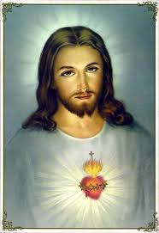
Dear Brothers and Sisters,
The Month of June is dedicated to the Sacred Heart. The Church celebrates the Solemnity of the Sacred Heart of Jesus on the Friday following the second Sunday after Pentecost.
The "Sacred Heart" is Christ, the Word Incarnate, Saviour, intrinsically containing, in the Spirit, an infinite divine-human love for the Father and for his brothers. Devotion to the Sacred Heart was an essential element of Pope John Paul II's hopes for the "new evangelization" called for by the Church.
As those 80+ people who attended the Day of Reflection will know, it was a very uplifting and positive experience. Monsignor McDonald celebrated a beautiful Mass for us and preached on importance of the Legion. We recited the Rosary in 5 languages and we thank Br Binh Nguyen and the Vietnamese group, Sr Franka Delprete, Sr Linda Westwood and SrCatherine Hwang for each leading a Glorious Mystery. And, despite not having any accompaniment, we sang the hymns with full voices to honour Our Lady.
In the hall we were treated to a wonderful talk on St Louis Marie de Montfort. Monsignor spoke with great insight and understanding, and revealed to us so much information about the spiritual mentor who so inspired Frank Duff.
Lunch was a veritable banquet! Thank you to everyone who brought a delicious contribution.
After lunch Fr Peter Porteous related to us his incredible visionary experiences of Mary. It is wonderful to have evidence so near at hand, that Our Blessed Mother is still communicating so closely with her children.
It was a memorable day and I want to sincerely thank the small group of Legionaries who helped make the day run well.
Unfortunately, it was not so satisfying to be at Comitium two days later, where the attendance was disappointing. Admittedly, the weather was bad that day, but the Executive and others who had worked long hours over the weekend were still able to be there. It is important to remind ourselves of the commitment we have made as officers, to attend the monthly meeting unless there is a genuine reason of ill health or crisis. The Legion will only flourish, and be there for you, if there is enthusiasm and a willingness to show up in all the ways Mary asks of us.

Our next event will be the Legion Pilgrimage on Thursday July 16th. This will be to the parish church of St Francis of Assisi, Lillian Rd, Maida Vale. This is the only pilgrim church in the Archdiocese of Perth for the Jubilee Year of St Francis, so it is particularly significant as our venue. A group of Secular Franciscans will present four short talks on the charism of St Francis, which will be really interesting and deepen our understanding of this remarkable saint.
The day will begin with Registration at 9.30am, then morning tea and Legion Prayers. This will be followed by the presentations, and at midday we will have Mass, celebrated by Franciscan priest, Rev Fr Tomasz.
Lunch will be a Bring-your-own meal, with tea and coffee provided, and then we will have a practical activity before ending the day with Benediction and Concluding Prayers. If we can arrange it, there will be a priest available to hear confessions during the morning.
I hope that many of you will come and, if you will be attending, please let Comitium know as soon as possible (by email, or call 0468 928 319) so that sufficient kits are prepared for the afternoon activity.

There will be a $15 fee per person to cover the costs of facilitating the pilgrimage.

God bless and Mary guide you,
Sr Sheelagh Tillotson
REPORTS
ANNUAL REPORT OF
OUR LADY OF GRACE PRAESIDIUM – ALBANY

Location of meeting: New Camfield, 154 Aberdeen St, Albany
Time of meeting: Each Thursday at 1pm
Name of Praesidium: Our Lady of Grace
Place of meeting: New Camfield Office
Active Members: 7 members
Auxiliary Members: 10 members
Spiritual Director: Fr. Marvin Gomaz
President: Sr. Anne Letter
Vice President: Sr. Rosa La Rosa
Secretary: Sr. Kath Trafalski
Treasurer: Sr. Wilma Ward
Members: Sr. Cirila Adams
Sr. Christina Cameron
Sr. Liana Giorgi

Albany has two resident Priests who are very supportive of the Legion.
Rev. Fr. Vince Comple OSJ and Rev Fr. Marvin Gomez OSJ are our Parish Priests. God’s blessing for our
Parish.
On Sunday the 15 March, Our Lady of Grace Preasidium Albany, Legion of Mary held our annual ACIES at
2pm in St. Joseph’s Church. Fr. Marvin was our spiritual director for the afternoon as we made our annual
commitment to the Legion of Mary. We said the Rosary of the Blessed Virgin of Mary followed by quiet
time and concluded with Benediction. 15 people attended. We then enjoyed afternoon tea over at New
Camfield. Thank you, Fr. Marvin, we appreciate your guidance.
Two of our members continue to make chain rosaries each week and we give them to missionaries.
Rosary is said by Legion and axillary members every day in St. Joseph’s Church, either before or after
Mass.
In October we pray the Rosary before all Sunday Masses in both Churches. That is 4 Masses each week.
An Annual Mass for deceased Legionaries is offered every November. Many other visitations to the home
bound are made each week by members.
On the first Wednesday of each month 3 of our members go with the priest when he says Mass in Bethel
Aged Care home. On the first Friday of each month 2 members go with priest when Mass is celebrated at Clarence Estate Aged Care home

The piety stall has been very busy selling statues of the Holy Family Church and St Joseph’s Church plus
many rosary beads. The Pilgrim Statue of Our Blessed Mother Mary is still being moved around the
parishioners’ homes usually on a fortnightly roster.
On the 22 April 2026, St. Joseph’s Church Albany was elevated to the Shrine of St Joseph. It is the first
Shrine in the Bunbury Diocese. It is a pilgrim Church now which means on the two Feast days of St Joseph,
19 March and 1 May, you may receive a plenary indulgence if you go to confession, pray for 30 mins in front of the Blessed Eucharist and receive Holy Communion. We are very blessed to have a Shrine in Albany.
Before Christmas and Easter we take mass time tables to Motels, Caravan Parks etc.
Wishing all members of the Legion a happy and healthy year.
May Our Lord and Our Lady be always with you.
May God bless us all.
Anne Letter.
President of Our Lady of Grace, Albany Praesidium

Retreat day May 16th

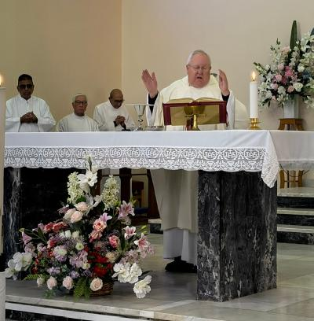
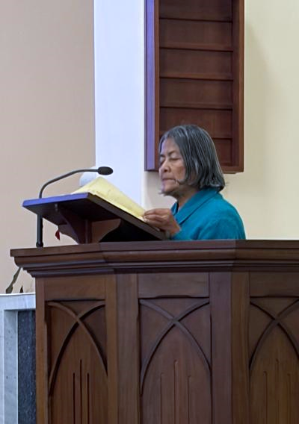

Mons. McDonald celebrated Holy Mass. Sr Teresa Ryan, as Proclaimer of the
Word, represented Auxiliary
Legionaries.
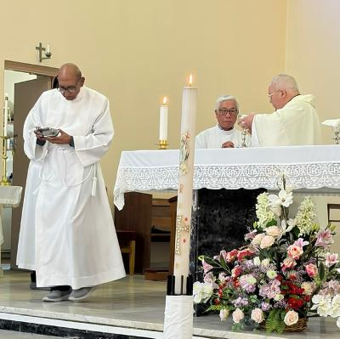
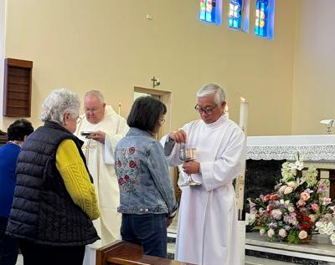

Brs. Philip Mathews and Binh Nguyen
served as Acolytes

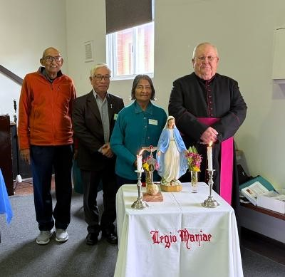
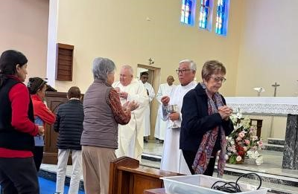

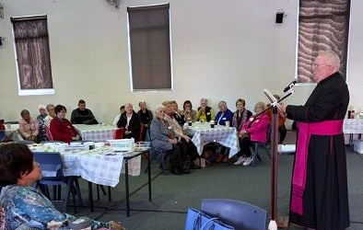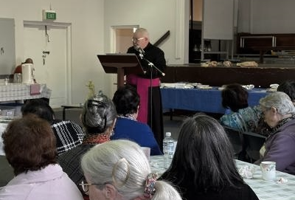

Monsignor McDonald shared his knowledge and insight into the life of St Louis Marie de Montfort, to an audience of over 80 people.
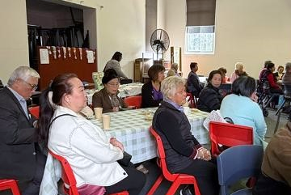
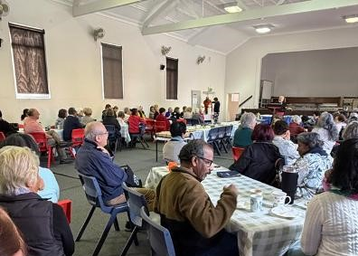
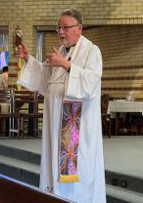
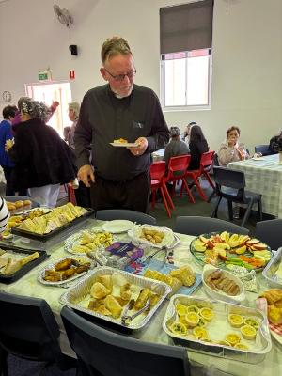

Fr Peter Porteous OSM, National Director of Vocations, gave a moving talk on his personal Visions of the Blessed Virgin. He also celebrated Benediction.
Participants came from Curia and Praesidia all around Perth, and also from local parishes.
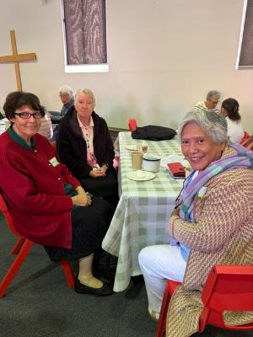
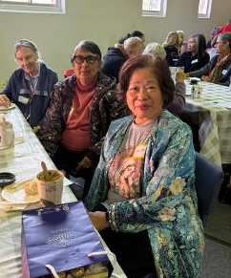
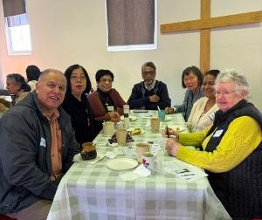
A wonderful gathering of Perth Legionaries
sharing fellowship together
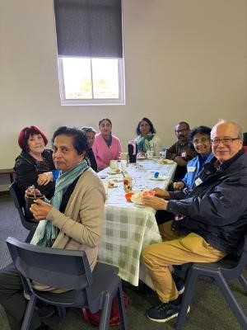
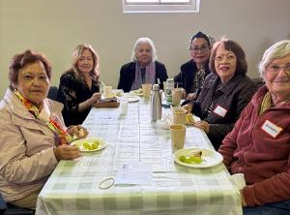
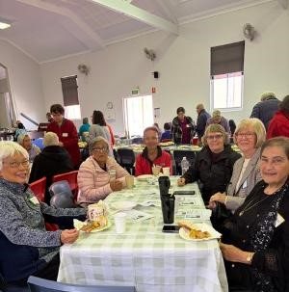

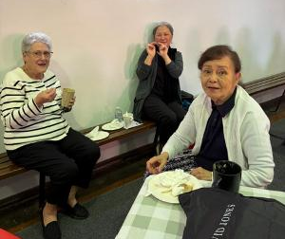
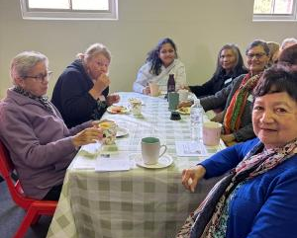
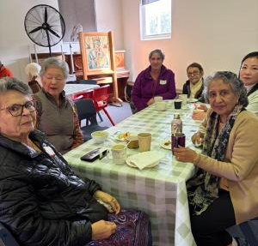

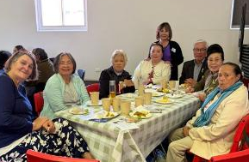
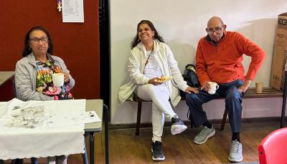

ACIES celebrations in remote praesidia
ACIES ceremonies have taken place in Albany and Busselton. They were both beautiful ceremonies and were well supported.
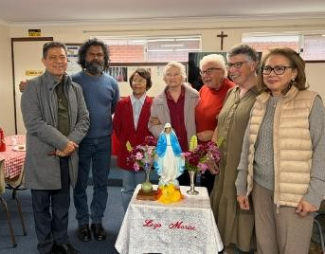

Rev Fr Jess and Rev Fr Jayan with Star of the
Sea praesidium members, Busselton.

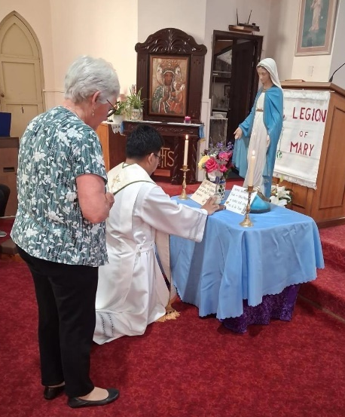

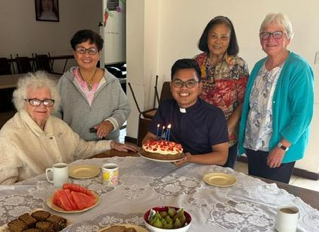

Rev Fr Marvin Gomez with Our Lady of Grace Praesidium members, Albany.

COMITIUM CONTACT DETAILS
Web address:
https://www.legion-of-mary-comitium-of-perth-western-australia-inc.org
email: comitiumofperth@gmail.com

Spiritual Director | Fr Doug Harris | glendaloug@perthcatholic.org.au
President | Sheelagh Tillotson | 0468 928 319
Vice President
Secretary | Bianca-Maria Casalengo | 0415 405 368
Treasurer | Katie Bennett | 0488 547 817
Assistant Secretary | Cynthia Gauci | 0430 776 648
Assistant  Treasurer | Rosemary Bennett | 0421 580 783

WITH OUR DEEPEST SYMPATHY

Comitium and the Legion of Mary, Perth, extend our deepest sympathy
to Sr Pat Nerva and her family on the passing of her beloved husband Mel.
Mel passed peacefully into the arms of the Lord on May 28th after a long
illness. We wish to thank him for his many, many years of musical contribution
to the Blind Concert.

FORTHCOMING REPORTS TO COMITIUM

June | July
EASTERN DISTRICTS CURIA - OUR LADY HELP OF CHRISTIANS  VICTORIA PARK - OUR LADY QUEEN OF PATRIARCHS  COMITIUM TO SENATUS | EAST VICTORIA PARK – OUR LADY HELP OF CHRISTIANS

FORTHCOMING VISITATIONS
June | July
CANNING VALE - ARK OF THE COVENANT | EASTERN DISTRICTS CURIA – OUR LADY HELP OF CHRISTIANS

EXECUTIVE OFFICER ELECTIONS
*The office of Vice President is currently vacant and open to nominations. Any member wishing to nominate for this position should see Sr Sheelagh to complete the necessary formalities.
*The Office of Treasurer will be vacated in July when Sr Katie Bennett reaches the end of her 2nd Term. Nominations were called for in May, and the election will take place at the June meeting.

HOLY FATHER’S PRAYER INTENTION for June 2026

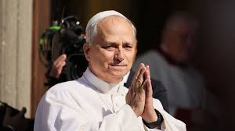
For the Values of Sports
Let us pray that sports be an instrument of peace, encounter, and dialogue among cultures and nations, and that they promote values such as respect, solidarity, and personal growth.

