MAY 2026
“THE MONTH OF MARY”

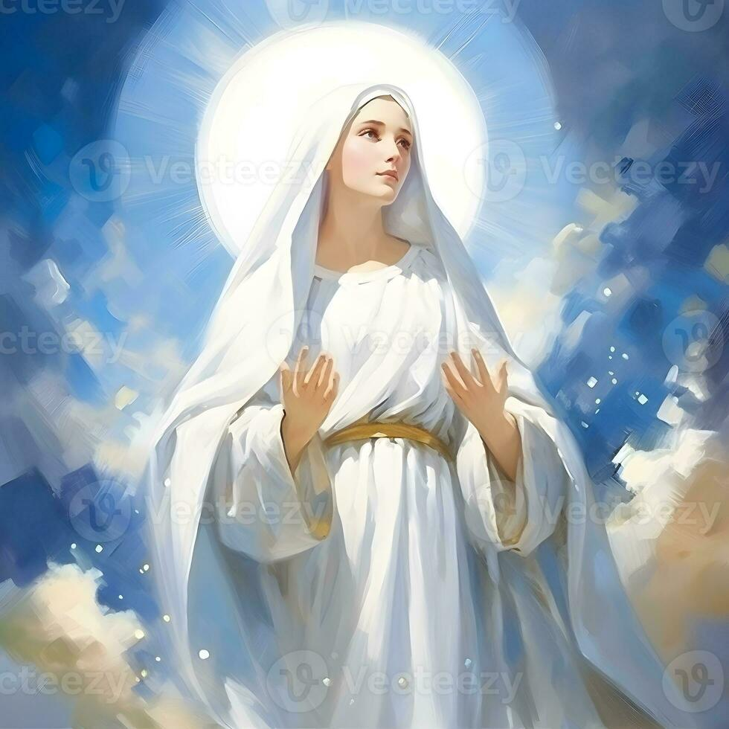

Morning Consecration to Mary

My Queen, my Mother, I offer myself entirely to you.
To show my devotion to you, I offer you this day my eyes, my ears,
my mouth, my heart, my whole being without reserve.
Therefore, good Mother, as I am your own, keep me and guard me as your property and possession.
Amen

Reflections for a Legionary of Mary
On the Duty of Extension
(From: Queen of All Heaven magazine, with Ecclesiastical Permission)

Do I leave all extension effort to a committee or council officer?
Have I ever tried to bring in a new Active Member?
Have I ever asked a priest, deacon or religious sister to become an Adjutorian Member, and thus enrich the apostolate with the added prayer of a consecrated soul?
Do I try to be generous in the Secret Bag Collection, knowing that its ultimate purpose is for extension expenses, the support of envoys, etc worldwide?
Do I ever try to introduce the Legion to a pastor who has not yet tried it, by lending him a Handbook and giving him other Legion literature? Have I offered to call on possible members myself, if he will supply the names?
Have I been guilty of complacency and disregard for the growth of the Legion, even though I know that, without dynamic action on the part of someone, the Legion would never have been established in my own country?


SPECIAL PRAYERS:

Prayers for the Sick: Robert Harding, Tessie McIntyre, Colleen
Le Goice, Justin Khoo, Agnes Shinn.

Repose of the Souls: Mary O’Neale, Roz Hamilton, Sharon Bridger,
Mathew Antony, Patrick McBraida (anniv), Melissa Smith (anniv)

Special Intentions: Leone Blake and family, Georgia and family, Jennet Christy JB,
Kai Jewell, Day family, Ass Bishop Nelson Po, World Peace, Thanksgiving for birth of Clara Gemmy’s 2nd grandchild (April 2, 2006)

Healing Intentions of Servant of God Frank Duff: Sr Penny Fernandez, Rev Sr Teresa Tran, Christopher Cameron, Mel Nerva, Robert Walker and Crissia Beaufond.

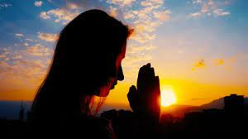

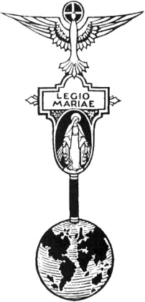
THE LEGION OF MARY
BULLETIN
May 2026
Comitium of Perth (Western Australia) Inc
36 Windsor St, East Perth 6000
Tel 93282726
Email: comitiumofperth@gmail.com
Website: https://www.legion-of-mary-comitium-of-perth-western-australia-inc.org
Facebook: Legion of Mary Perth Western

Australia

Dates to remember.
Recurring:
2nd Monday of the Month
Executive meeting
3rd Monday of the Month Comitium Meeting
2nd Saturday of the Month Rosary Making
4th Monday EDC meeting
4^{t;lh} Saturday NDC meeting

EVENTS for 2026
16th July Pilgrimage
7-9th Sept Rosary Bouquet
8th Sept Nativity Mass
23rd Oct Procession (TBC)
7th Nov Annual Mass
5th Dec Comitium AGR
ALLOCUTIO: Fr Doug Harris
Emmaus
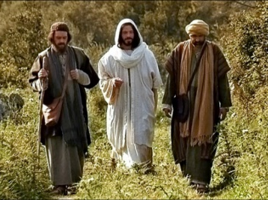
The Gospel last Sunday began with the disciples of Emmaus. Our Lord walks with them from Jerusalem to a village called Emmaus – a distance of 11kms or 7 miles. But the disciples failed to recognize Jesus.
On top of that – their conversation was all about Jesus. Jesus explained to the disciples: “all the passages throughout Scripture that were about Himself,” and yet the disciples still failed to recognize Jesus.
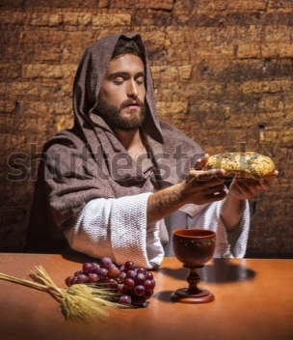
Only when Our Lord made Himself present in the Eucharist did they recognize Him.
The Gospel today said: “He took the bread and said the blessing, then He broke it…and their eyes were opened, and they recognized Him.”
In other words when Jesus was made present in the Eucharist, they were more aware of His Presence – more than if He were present in His human form.
Why is it that they were able to recognize Him in the Eucharist and not in His human form? Because there is a grace which only comes with His Presence in the Eucharist.

Christ established His New Covenant – an eternal Covenant with the institution of the Eucharist – a new Covenant, a new era, a new Grace.

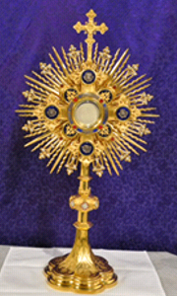
In France, Andre Frossard was a well-known atheist who wrote articles in newspapers claiming that God did not exist. He once followed a friend into a church. The Church had Exposition of the Blessed Sacrament. Within a few moments in the Church, he knew that Jesus was in the Blessed Sacrament.
This man had been educated in Catholic schools. Many people had shared their faith with him, but none of this convinced him of the existence of God. Just a few moments in the presence of Jesus in the Blessed Sacrament and he knew that God existed.

In the United States, a Warlock named Zachary King entered a Perpetual Adoration chapel and he could see Jesus in the Blessed Sacrament. As a result, he was completely converted and spends hours every day in the presence of the Blessed Sacrament.

A Protestant woman at Bluff Pt, Geraldton (St Lawrence’s parish) walked in to the Catholic Church. The Blessed Sacrament was exposed. Within a few moments she knew that Jesus was present in the Blessed Sacrament. She became a Catholic. She said to the parish priest, Fr Brian Ahern, that because the Eucharist is here how can Catholics not adore Him perpetually. How is it that the church is not full all day and all night?
As a result of this experience the parish priest – Fr Brian Ahern, started perpetual adoration (on July 16th, 1988).

Hamish was 6 months old when his family brought him to Mass in Greenwood. He acted like any 6 months old baby, he was restless in his mother’s arms and showed n/o interest at all in the Mass. Then came the Consecration, Hamish was now completely absorbed in what was happening on the altar. His father said he had a joy beyond a human joy. Hamish saw something or someone which completely absorbed his attention. It appears he was given the gift to see beyond the wall which separates God’s Kingdom from this kingdom.

When Pope St John Paul II started perpetual Eucharistic Adoration at St Peter’s in Rome on December 2nd 1981, he prayed to Jesus using the same words that the disciples of Emmaus spoke to Jesus in today’s Gospel: “Stay with us Lord.”
The Pope prayed to Jesus to stay with us in His Eucharistic Presence as He did at Emmaus.

The Pope also spoke of urgency – even desperation. The actual words in today’s Gospel are: “stay with us Lord for evening is approaching and the day is almost over.” Meaning darkness is near. It is upon us. Therefore, stay with us Lord because You are our only hope in these times of trial or desperation. “Stay with us Lord,” in the Eucharist.
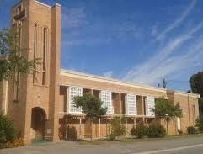
In more recent times there has been a resurgence of Perpetual Eucharistic Adoration. In my parish, St. Bernadette’s, Glendalough, we have perpetual Eucharistic Adoration when the Blessed Sacrament is exposed 24 hours a day, 7 days a week.

Bishop John Magee of Clone diocese Ireland, the only person in history to be secretary to three popes, has established Perpetual Eucharistic Adoration in 33 parishes in the diocese and vocations to the priesthood have tripled as a result.

In the diocese of Lucena, Philippines they averaged 6 murders a day over a 7-year period by communist groups, but since PEA was introduced, there has not been one murder by the communists. The bishop testifies all this in writing. San Marcus parish in Guatemala has PEA. In a civil war not one of its parishioners was harmed, despite in the 4 surrounding parishes all the priests were killed, and the villages destroyed.

At Sacred Heart, Highgate a family was praying for a relative in England who was in a coma and not expected to recover. While they were in Adoration, they received a call on their mobile to say that she had shown signs of recovery.

The graces that come from Jesus in the Blessed Sacrament are astonishing. This is particularly so for the night hours. St Mary’s, Nebraska, has had PEA for over 40 years. Fr Garvey, parish priest, related about an adorer who did his holy night hour, Friday 2-3am, after only 2 hours sleep from shift work. The pastor suggested he change his holy hour, “Listen Fr.” He said, “that is the best hour of my week, and I won’t change it for anyone. I have had more questions answered, more difficulties resolved than in all of the other hours of the week put together.”

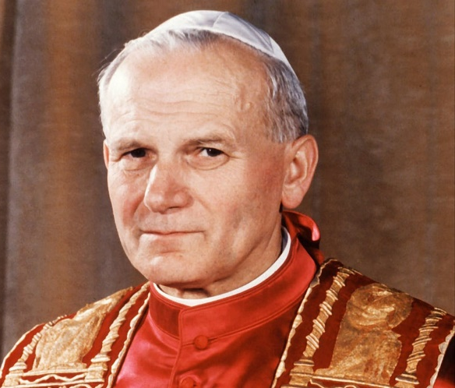
Pope St John Paul II is a wonderful inspiration. He began his day with a Holy Hour before the Blessed Sacrament. He ended his day with a Holy Hour.

He made over 20 visits a day to the Blessed Sacrament, plus one day out of the week he spent the entire night in prayer in the presence of the Blessed Sacrament. In his last encyclical, ‘The Church and the Eucharist’ he wrote: “In our lifetime Christians must be distinguished above all by the art of prayer…in spiritual converse, in silent adoration, in heartfelt love for Christ present in the Most Holy Eucharist. It is pleasant to spend some time with Him, to lie close to His Breast like the beloved disciple and feel the infinite love in His Heart… How often, dear brothers and sisters, have I experienced this and drawn from it strength, consolation and support.”
MESSAGE FROM THE PRESIDENT April 2026

Dear Brothers and Sisters,

We are now celebrating the month of May, Our Lady’s month. In England this falls in the middle of Spring with mild sunny days and flowers blooming everywhere. The Salesian convent school which I attended held a huge procession through grounds filled with vast rhododendron bushes every May 24th. The entire school processed from one to another of about a dozen grottos, singing hymns and crowning each statue in turn. Here we are in Autumn, but none-the-less, the same tradition is followed. Our Lady Queen of Patriarchs praesidium, Victoria Park, organised a Marian Procession after Mass on May 10th, at St Joachim’s, to crown the grotto statue of Our Lady, followed by a Mother’s Day Morning Tea. This was also an opportunity to give a short talk on the Legion and promote membership. I am sure that other praesidia are putting on similar functions, and it would be good to receive your reports and photos to record them.

May 24th is the feast of Our Lady Help of Christians, patron of Australia, of EDC and at least one Praesidium. We must not let this day pass without some special recognition, by each of us, of our Heavenly Mother.

Comitium has just held its Day of Reflection / Retreat at St Joachim’s, and there will be a report on that in the June Bulletin. Grateful thanks are extended to Monsignor Thomas McDonald and Fr Peter Porteous for their inspiring spiritual talks, and to everyone else who helped to make this event happen smoothly.

Preparations for the Pilgrimage are progressing well. This year there will be no transport laid on by Comitium, because the venue is within the metro area. So, members are asked to make their own way to St Francis of Assisi church, Maida Vale. There is plenty of parking and there are also train and bus alternatives.

God bless and Mary guide you,
Sr Sheelagh Tillotson
EXECUTIVE OFFICER ELECTIONS
*The office of Vice President is currently vacant and open to nominations. Any member wishing to nominate for this position should see Sr Sheelagh to complete the necessary formalities.
REPORTS

CURIA REPORT TO COMITIUM

Curia Name | Immaculate Conception Curia, Fremantle
Place of Meeting | Our Lady of Lourdes, Rockingham
Time of Meeting | Second Sunday of month at 2.00 pm
Details of Praesidia attached | See below
Active Members | 43 plus 6 on Probationary
Junior Members | 10 (average attendance)
Auxiliary Members | 145
Praetorian Members | 13
Adjutorian Members | 3
Number of Officers | 23
Number of Vacant Offices | 1
Spiritual Directors vacant | 1
Report Period | 1st April 2025 to 31st March 2026

At the time of reporting there were 6 Senior and 1 Junior Praesidia attached to this Curia.
These are:
Our Lady of Good Counsel, Dawesville
Mary, Queen of Angels, Dawesville Juniors

Mary Mother of the Church, Baldivis
Mater Christi, Yangebup
Our Lady of Lourdes, Rockingham
Our Lady Queen of Peace, Willagee
Salve Regina, Bateman

Curia Officers:
Spiritual Director Fr Vijay D’Sousa
President Sr Mary Glen
Vice President Sr Bev O’Brien
Secretary Br Kevin Autagavaia
Treasurer Br Andrew Khoo

During this period 6 senior praesidia and 1 junior presidium reported to Curia.

Works undertaken by senior praesidia:

Visitation of people in 12 Nursing Homes where they support Masses and the praying of the rosary.
- Eight Special Ministers are taking Holy Communion to the sick and housebound and nursing homes.
- Five praesidia make home visits to elderly, sick and house bound. 1 praesidium carried out door to door to 14 homes and contacted one catholic family from Brazil.
- 5 Praesidia circulate 9 Pilgrim Statues to families in their parishes.
- Praesidia promoted the Rosary. The rosary is taught in pre-primary to year 6 at St Damiens Catholic School, Dawesville. Rosary packs are given to Year 6 students on their graduation. First Holy Communicants received rosaries in Baldivis. 3 praesidia leave rosary packs in the church foyer. All praesidia promote the 48-hour rosary.
- 1 member facilitates the running of a drop-in centre for vulnerable women.
- Two praesidia assist with children’s liturgy weekly and monthly.
- 1 praesidia promoted the Brown Scapular. 80 people were enrolled.
- Four piety stalls operate weekly and monthly, two book barrows operate after weekend Masses. One book barrow held monthly on parish grounds at Bateman.
- Children of Mary operate during the school terms in Yangebup with an average of 25 children.
- Two parish libraries are maintained by two praesidia.
- Members attend funeral services and rosaries.
- Various praesidia undertake Curia visitation monthly. These visits are always well received.

Extension and Recruitment for the period
- Regular notices are placed in Parish bulletins and ministry sheets. The Spiritual Director Fr Vijay D’Sousa speaks regularly on the need for a personal approach to potential new members.
- Annual Mass for deceased Legionaries.
- AGR was held in Rockingham on 27th November. A lively and enjoyable event.
- ACIES was well attended with over 70 attendees with several people attending for the first time.
- The Officers’ Training Day, held at the VEQC on the 17th January 2026, was attended by 7 members of two praesidia. 1 praesidium has since amended the Treasure’s book, the secret bag collections have increased, and the minutes are now signed by both the president and the secretary. They have begun to use the Praesidium Self-assessment checklist as a guide to handbook study and have had some very deep conversations as a result. They appreciated the opportunity provided by the Comitium in hosting this event.

Plans for the future:
- Training of new officers and recruitment of active and auxiliary members and keeping in touch regularly with auxiliaries.
- Mater Christi Yangebup are planning a pilgrimage to Divine Mercy Chittering in May.

Acknowledgements
We gratefully acknowledge the spiritual guidance and encouragement offered from our Spiritual Director Father Vijay D’Sousa. Our grateful thanks also go to Comitium for their support.
- 500 parish visiting cards have been distributed in letter boxes.

Highlights
- On the feast of Our Lady Help of Christians, the rosary was prayed after Mass in 7 different languages.
- 50 people went on Pilgrimage to the Carmelite Monastery for the Jubilee Year.
- Annual Frank Duff Mass was attended by one praesidium. All praesidia celebrated the

FORTHCOMING REPORTS TO COMITIUM

May | June
EASTERN DISTRICTS CURIA - OUR LADY OF CHRISTIANS  ALBANY: OUR LADY OF GRACE | VICTORIA PARK, OUR LADY QUEEN OF PATRIARCHS  COMITIUM TO SENATUS

FORTHCOMING VISITATIONS
May | June
CLOVERDALE - REGINA COELI | CANNING VALE - ARK OF THE COVENANT

HOLY FATHER’S PRAYER INTENTION for May 2026

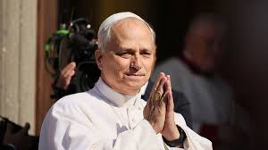
That everyone might have food.
Let us pray that everyone, from large producers to small consumers, be committed to avoid wasting food, and to ensure that everyone has access to quality food.

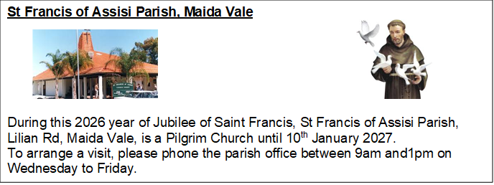

COMITIUM CONTACT DETAILS
Web address:
https://www.legion-of-mary-comitium-of-perth-western-australia-inc.org

email: comitiumofperth@gmail.com

Spiritual Director | Fr Doug Harris | glendaloug@perthcatholic.org.au
President | Sheelagh Tillotson | 0468 928 319
Vice President
Secretary | Bianca-Maria Casalengo | 0415 405 368
Treasurer | Katie Bennett | 0488 547 817
Assistant Secretary | Cynthia Gauci | 0430 776 648
Assistant  Treasurer | Rosemary Bennett | 0421 580 783

episcopal Ordination of Auxiliary Bishop Nelson Po

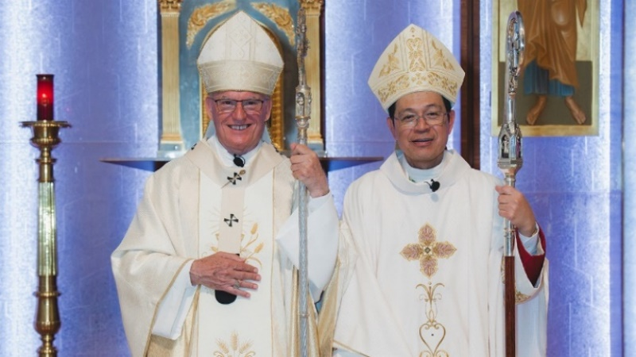
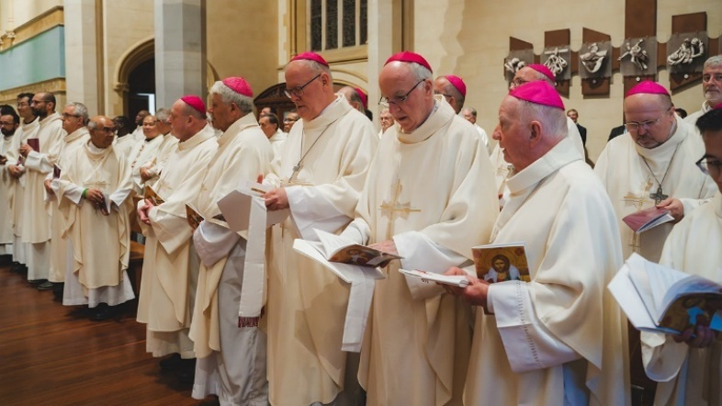
On April 16th Rev Fr Nelson Po was ordained Auxiliary Bishop of Perth at St Mary’s Cathedral. It was a wonderful celebration attended by more than 20 Bishops and scores of priests, as well as hundreds of Perth Catholics who congregated both inside and outside the Cathedral. This was the first Episcopal Ordination in more than twenty years and Bishop Po is the first Asian Bishop in Western Australia.
Archbishop Timothy Costelloe with About twenty Bishops supported their
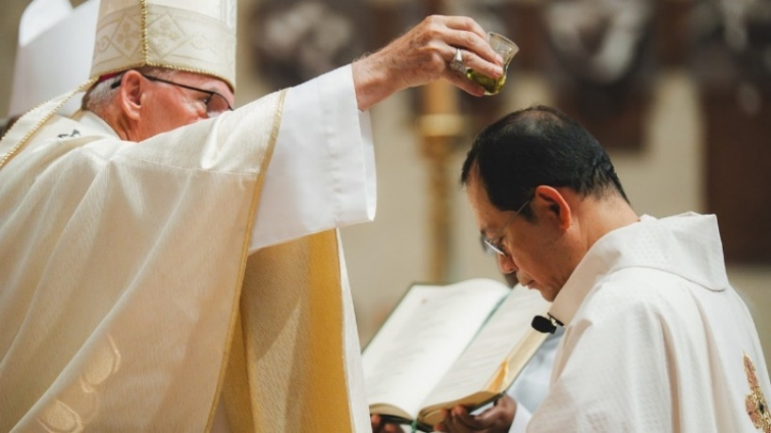
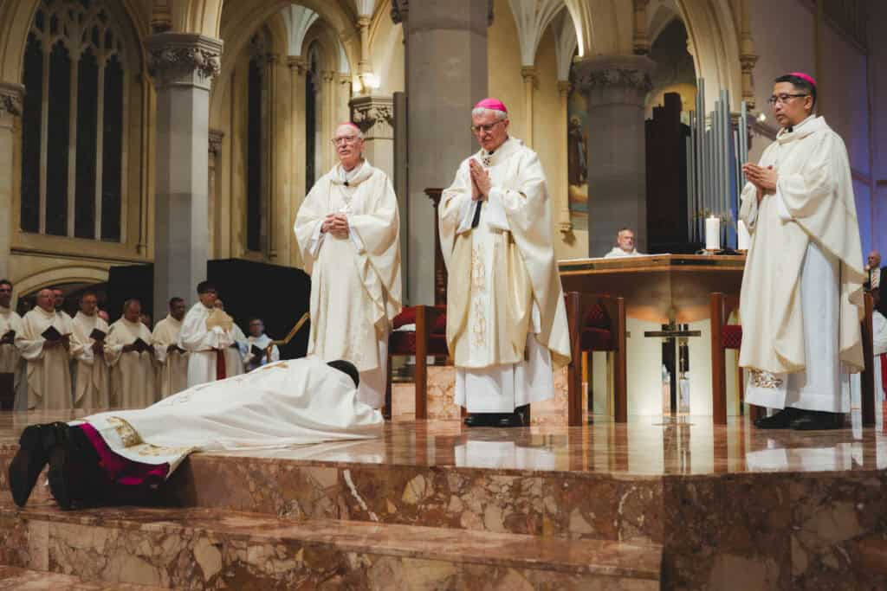
Auxiliary Bishop Nelson Po. brother.
Bishop Nelson prostrates himself in Archbishop Costello anoints the new
front of the Archbishop. Auxiliary Bishop.

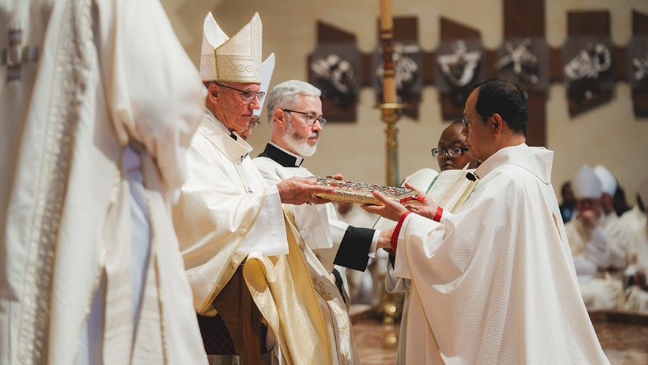
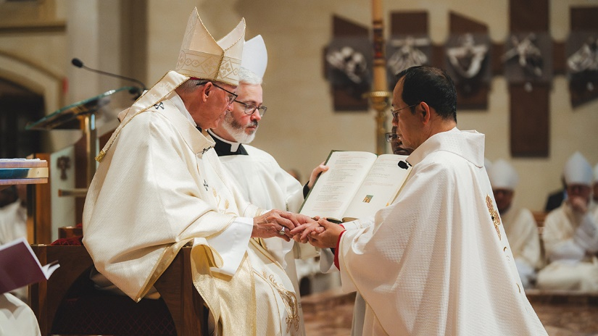
Auxiliary Bishop Nelson receives his ring and Book of Gospels.

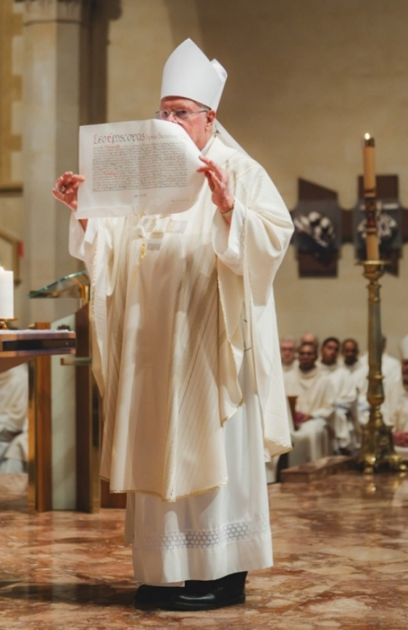
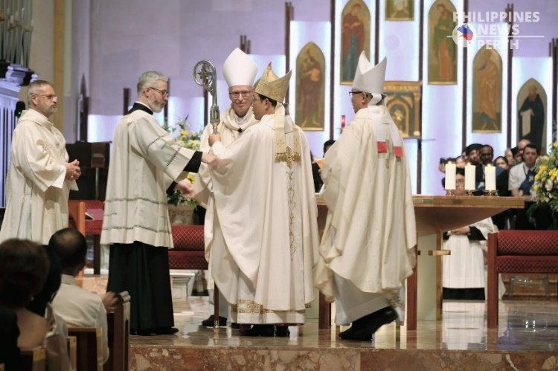
Then finally, his Crosier.

Papal Nuncio Archbishop
Charles Balvo attended to
witness the consecration in
place of His Holiness
Pope Leo XIV.

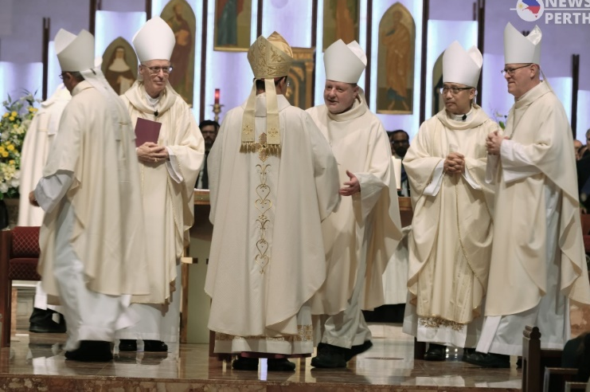
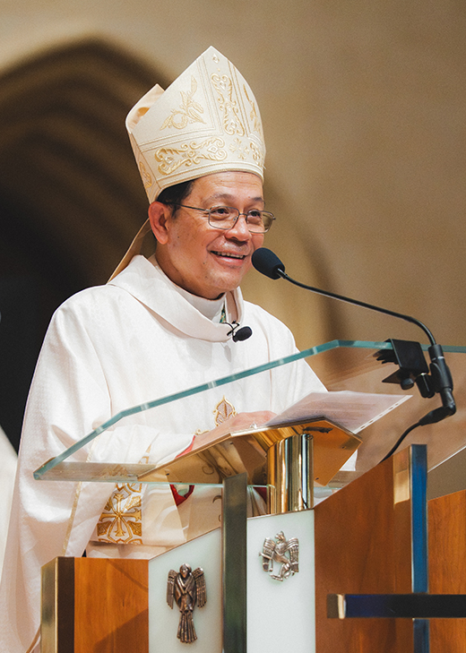

The Bishops individually congratulate
their newly consecrated brother.

In his homily for Bishop Nelson’s ordination on, and in official statements, Archbishop Costelloe SDB of Perth praised newly appointed Auxiliary Bishop Nelson Po, describing him as a "dynamic shepherd" with a deep commitment to the Church and its people, bringing valuable pastoral leadership to the Archdiocese of Perth.

The Legionaries of Mary send our congratulations to Auxiliary Bishop Nelson, and offer our prayers for him as he takes on his new role in the Archdiocese.

