march 2026

wishing you all a happy and blessed easter

he is risen


Because of Him – An Easter Poem
Because of Christ, we know a love that fills the earth and sky–
a selfless and redeeming love the world cannot deny.
Because of Him, what’s wrong on earth will, one day, be made right.
His path is ours to understand: the Way, the Truth, the Light.
Forever cleansed and grateful, we draw comfort from His grace,
surrender tears and sorrow to the One who took our place.
Gladly, He laid His body down to raise our bodies up.
He sank beneath all men and chose to drink the bitter cup.
On Easter, we remember what He bought, and what He paid.
Because of Him, mankind can live unblemished, unafraid.
His blessings are eternal ones, His promises are real.
What promise will we offer Him? What will our lives reveal?
By Susan Noyes Anderson
New members make their Promise
We congratulate them as they join us in serving Our Blessed Mother
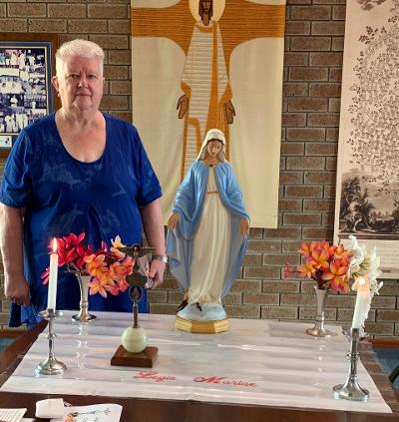
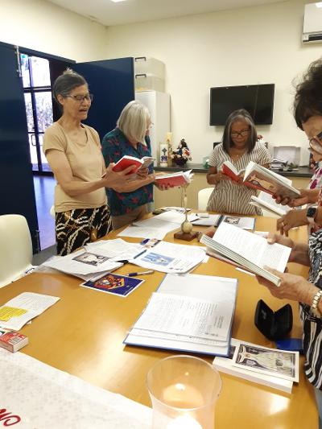
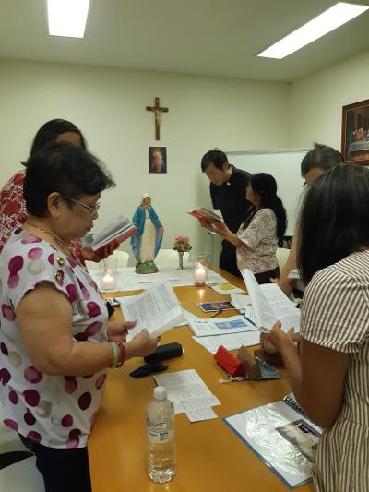
Members of Mary Queen of Peace, Armadale, supported the members at Gosnells as they took their Promise.
3 members of the newly opened Mother of the Most Blessed Sacrament praesidium, took their Promise at Gosnells.
Sr Margaret Collins took her promise at Mary Immaculate praesidium, Queens Park.

News from Our Lady of LaVang Vietnamese Curia

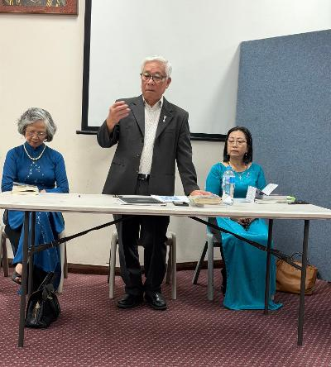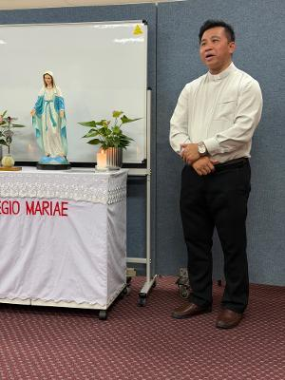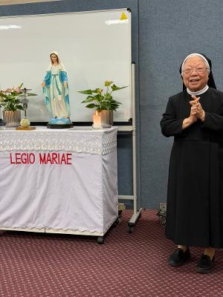
Br Binh chairs the newly Fr Tu Van Hguyan was Sr Theresa Tranh, who elected Executive at their visiting from Viet Nam founded the Vietnamese February Curia meeting. and spoke of his work. Legion in Perth joined us.
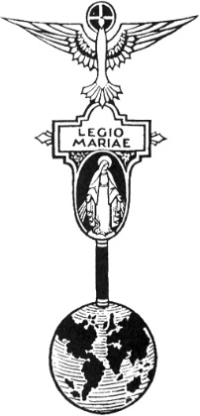
THE LEGION OF MARY
BULLETIN
MARCH 2026
Comitium of Perth (Western Australia) Inc
36 Windsor St, East Perth 6000
Tel 93282726
Email: comitiumofperth@gmail.com
Website: https://www.legion-of-mary-comitium-of-perth-western-australia-inc.org
Facebook: Legion of Mary Perth Western

Australia

ALLOCUTIO: Fr Doug Harris
Dates to remember.
Recurring:
2nd Monday of the Month
Executive meeting
3rd Monday of the Month Comitium Meeting
2nd Saturday of the Month Rosary Making
4th Monday EDC meeting
4th Saturday NDC meeting

EVENTS for 2026
22nd March ACIES
16th May 1-Day Retreat
16th July Pilgrimage (TBC)
7-9th Sept Rosary Bouquet
8th Sept Nativity Mass
23rd Oct Procession (TBC)
7th Nov Annual Mass
(Gospel Matthew 5: 17-37)
Our Lord didn’t come to change or “abolish” the law (the Old Testament Law) but He came to complete or fulfil it. The Old Testament Law is You shall not… i.e. You shall ‘not’ kill. You shall ‘not’ commit adultery. You shall ‘not’ bear false witness, etc.
Jesus now teaches it is not enough to try not to break the law, we must try to achieve its perfection. Hence, Jesus said (Mt 5:48): “You must be perfect as your heavenly Father is perfect and be holy as I am holy.” For example, in today’s Gospel Jesus says: “You have learnt how it was said to our ancestors you shall not kill but I say to you anyone who is ‘angry’ with his brother will answer for it.”
Also in the Jewish Law, God commanded: “Love your neighbours but hate your enemies. But I tell you, love your enemies and pray for those who persecute you.” On the Cross Jesus loved His enemies. He died for the ones who nailed Him. Our Lord’s Love went all the way. Another example in today’s Gospel: Jesus said: “You have learnt how it was said: “You shall not commit adultery,” but, Jesus said: “If a man looks at a woman lustfully, he has already committed

adultery.” Our minds are called to be as chaste as Out Lord’s mind. Perfectly chaste! The widow’s mite is another example. The Old Testament Law says give ten percent of one’s income to the Temple treasury, but Jesus honoured a widow who gave all she had to the Temple treasury. And to the rich young man Jesus didn’t say give ten percent, He said: “sell everything you have…then come follow Me.”
Our Lord was not a minimalist. He didn’t just give the minimum. He gave everything. He went all the way. A Jew once asked Jesus: “What sign will you give to show us that we should believe in You? Our Fathers had manna bread to eat in the desert.” Jesus answered: “I am the Bread of Life. He who eats my Flesh and drinks my Blood has life everlasting.”
In the Old Covenant God was content to feed the people with nourishment that lasted finitely or temporarily. The manna bread in the desert. In the New Covenant God feeds us with Himself (in Holy Communion). For love of us, Our Lord’s Love goes all the way.
Bl Dina Belanger is an inspiration. She died in Canada in 1929. She became a Religious Sister – Sr Mary Cecile. She wrote: “I committed myself under pain of sin to do constantly what was not perfect. I promised not to entertain any useless thought not to allow myself any useless physical movement. This vow affects every second, every moment of my life. Yes, I am happy, because my happiness lies not in the events that take place, but in God alone. I live in the heart of God.
The Pharisees accused Jesus of abolishing the law. Jesus didn’t abolish or change the Law, He fulfilled the law by becoming the law, As St John the Apostle wrote, Jesus is the Word made flesh. Jesus is the living Word. The Law or Word became the Person of Our Lord Jesus Christ. In this way, Our Lord taught us how the Law should be lived.

EXECUTIVE OFFICER ELECTIONS

*The office of Vice President is currently vacant and open to nominations. Any member wishing to nominate for this position should see Sr Sheelagh to complete the necessary formalities.
MESSAGE FROM THE PRESIDENT
March 2026

Dear Brothers and Sisters,

The season of Lent is a time when we are called upon to make sacrifices for the benefit of our own souls, but also, in order to benefit others. As we deny ourselves, so we can give to other people; as we redouble our efforts to do things which we perhaps do not enjoy, we can offer that discomfort in prayer or action for someone else’s intension. Jesus purified himself in the desert for 40 days, and that is what the Church is asking us to mimic in our own way, in order to prepare for the death and resurrection of Jesus at Easter. As Legionaries, we can take this opportunity to direct some of our efforts in ways which enhance the work that we do for Our Lady.

On February 14th Sr Rosemary and I had the pleasure of attending a half-day retreat arranged by the Ocean Reef praesidium, Mary Queen of the Family. It was a spiritual and inspiring morning with talks by Fr Peter Porteous on his personal experiences of Marian visions, and another on ‘Mary in Scripture, Song and Art’ by Steven Harris. The Retreat opened with Mass, there was a shared morning tea, and we finished with Benediction. About 75 people attended, which was wonderful. I would like to extend congratulations to the praesidium for doing such a great job, and gratitude to the parish priest, Fr Leonard Macionczyk SDS, for his strong support of the Legion.

Please let Comitium know whenever you are holding events so that we can notify the wider Legion community and increase participation.
Please make note also of the Comitium Retreat which will be held on May 16th and will be a whole-day event this year.

I wish you all a very happy Easter.

God bless and Mary guide you,
Sr Sheelagh Tillotson

St Francis of Assisi Parish, Maida Vale
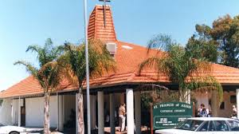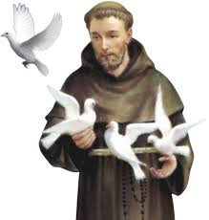

During this 2026 year of Jubilee of Saint Francis, St Francis of Assisi Parish, Lilian Rd, Maida Vale, is a Pilgrim Church until 10th January 2027.
To arrange a visit, please phone the parish office between 9am and1pm on Wednesday to Friday.

REPORTS

Report of Curia to Comitium

To Jesus through Mary

Council: Our Lady Assumed into Heaven – Northern District Curia

Meeting No: 813 - 822 From January 2025 to December 2025

Spiritual Director: Father Peter Porteous President: Sr Giulia di Carlantonio
Vice President: Sr Linda Westwood Secretary: Sr Lorraine Allen
Asst. Secretary: Sr Celia Salinas Treasurer: Sr Wilma Hedzik
Asst. Treasurer: -
Meetings Time: 4th Saturday of the Month, at 10.30 am
Place of Meeting: Venerable Edel Quinn Centre, Windsor Street, East Perth

No. of Praesidia: 7 Members Number at Praesidium reporting period:

Spouse of the Holy Spirit Junior, City Beach 33 (to October 2025)
(3 Seniors 30 Juniors)
Our Lady of All Nations, Glendalough 7 (to September 2025)
Our Lady of Perpetual Succour, Mirrabooka 3 (to April 2025)
(2 probationary members)
Our Lady of Grace, North Beach 10 (to March 2025)
Our Lady of Missions, Whitfords 11 (to August 2025)
Immaculate Heart of Mary, Balcatta 4 (to May 2025)
Mary Queen of the Family, Ocean Reef 2 (to January 2026)
(4 probationary members)

Positions vacant: 6 (to December 2025)
Officers: 32 (to December 2025)
Active Members:76 (includes 30 Junior Members and 6 Probationary members (to December 2025)
Auxilliary: 145 approximate Adjutorian: 4 Praetorian: 3

Works Undertaken by Praesidia during the months of January to December 2025:
Every Praesidium has supported the Curia and Comitium through regular attendance at meetings and active participation in spiritual and social events organised during the past 12 months, including ACIES, Nativity Mass, Rosary Bouquet and Annual Mass, and have participated in many varied and numerous active good works.

Some praesidia notify the Parish Priests of Sick parishioners and those admitted to hospital; many transport those in need of assistance to Mass, and those health-challenged or in aged care to their appointments, and also help the aged and housebound in their homes. They visit Nursing Homes and the St Francis Hostel in Balcatta, and welcome new parishioners to the parish by phone call or visit.
One praesidium delivers God Start Birthday cards to children baptised in the parish until they are 4 years old, they also provide Baptism informkkation letters to inform parents of the God Start programme. Some praesidia circulate Pilgrim Statues, assist with Adoration and assist the Parish Priest as needed.

The Junior praesidium assists with altar serving and collections at Masses. Help with Bible study and say their prayers reverently, as well as other good works of helpfulness at school and at home.
They enjoyed a joint gathering at Immaculate Heart of Mary’s Church, Scarborough to celebrate All Hallows Eve.

The Curia organized a Retreat to New Norcia, and one praesidium facilitated a Half-Day Retreat in their parish which was very well attended.

Other Works Undertaken
Rosary making in several praesidia, providing a good deal of the stock for the Comitium Piety Shop. One praesidium organised a Holy Hour of Grace, monthly rosaries, participate in church choirs, attend prayer meetings in parishioners’ homes, and one is an acolyte. Members are at hand in the Church helping with Mass preparation, washing altar cloths, count candle collections and take Communion to the sick. They also sing in the Church choir, some hand out Miraculous Medals after Mass on Sundays and some are involved in church cleaning. Others man the Venerable Edel Quinn Centre twice a month.

All Members have carried out their Legionary duties with fervour and dedication in the many layers of work within their Legionary Membership.

Plan for the Year 2026: We encourage Legionaries to continue their efforts in recruiting active and auxiliary members.

Sr Giulia di Carlantonio
President

REPORTS TO COMITIUM in the coming month

February | March
N.D.C.- MARY ASSUMED INTO HEAVEN | CLOVERDALE – REGINA COELI

VISITATIONS
February | March
WILLETON - OUR LADY OF THE MISSION | VIETNAMESE CURIA – OUR LADY OF LAVANG


SPECIALS PRAYERS:

Prayers for the Sick: Ros Hamilton, John Sherry, Michael and Peter Hollows, Sandra Robinson, Michael (Mona’s husband – Busselton), Sr Kim, Rev Fr Dominic Son, Linda Westwood, Louise Allen, Mark Cambrige, Norm Carter, Octavia Durado, Rae Morris, Johny Anthony, Theresa, Gary Addison, Rocky Dunsford.

Repose of the Souls: Winston Bristow, Keith Collins, Arnold Shinn, Margaret Fernandes, Tom Mahardy, Curt Jones, Arello Devita, Alana King, Lisa Crofts; and Alfio Peci and Patricia O’Dea (anniversaries).

Special Intentions: Bishop elect Fr Nelson Po. Ivy Sequira, Jannet, Jennifer, Daniel and Simone. Safe travel for Sr Bianca and Regine.

Healing Intentions of Servant of God Frank Duff: Sr Penny Fernandez, Rev Sr Teresa Tran, Christopher Cameron, Mel Nerva, Robert Walker and Crissia Baufond.


HOLY FATHER’S PRAYER INTENTION for March 2026
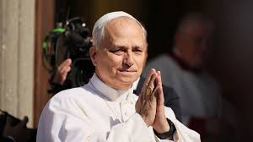
For disarmament and peace
Let us pray that nations move toward effective
disarmament, particularly nuclear disarmament, and
that world leaders choose the path of dialogue and
diplomacy instead of violence.

Retirement of Rev Monsignor Thomas McDonald

The Legion of Mary would like to offer our congratulations and prayers to Monsignor Thomas McDonald on the occasion of his retirement as Parish Priest of St Joachim’s, Victoria Park, after more than 50 years of faithful service in the Archdiocese of Perth.
Monsignor has been extremely supportive of the Legion and we are grateful that he will continue to make himself available to us in the future.
We hope that he will enjoy a well-earned change of pace and the opportunities which that will bring.

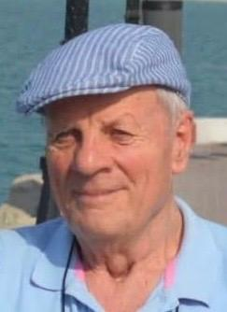
Vale Winston Bristow

“It was with great sadness and heaviness of heart that I learned this week about the passing of Winston Bristow. Winston was a daily mass goer, adorer, prayer of the Rosary and member of the Legion of Mary. Winston always pulled up in his trusty car, unloaded his walking frame, and then proceeded into the church every day — to pray and to present himself to Christ. He was a true gentleman and exhibited what I could only describe as splendid behaviour in all weathers! I pray in thanks for such a wonderful example to inspire us all. Rest in peace, Winston.” — Fr John Daly

So aptly and authentically did Fr John, our Parish Priest, capture Winston in our weekly parish bulletin. We, the members of the Legion of Mary, wholeheartedly echo those sentiments. Br. Winston — as we affectionately call one another brother and sister in the Legion — was organised and systematic, especially during his time as President three years ago. It was always a pleasure to work alongside him. He was enthusiastic and experienced — a true leader — yet never bossy or demanding. Rather, he was thoughtful, patient and kind.

Br. Winston generously shared his knowledge and actively participated in all Legion prayer meetings and activities, including visits to homes and nursing homes. He was always punctual and ever ready to offer a lift to anyone in need — whether for hospital visits, doctor’s appointments, or Mass. He quietly encouraged younger parishioners to strive for growth in their studies, personal development, and service within their committees. And in true Winston fashion, he even shared his gardening tips with us Legionaries!

After joining the Legion of Mary, Br. Winston grew ever closer to God. He rarely missed a meeting. In 2024, after suffering a fall that required hospitalisation, he faced his recovery with determination. Within three months, he was back at daily Mass and attending regular Legion meetings.
We will deeply miss his resonant voice, his kind spirit, and his cheerful daily greetings.

Br. Winston passed away peacefully at his home, No. 9 The Pinnacle, on 22nd January 2026

May he rest in eternal peace.

The members of Our Lady of the Mission praesidium, Willetton.
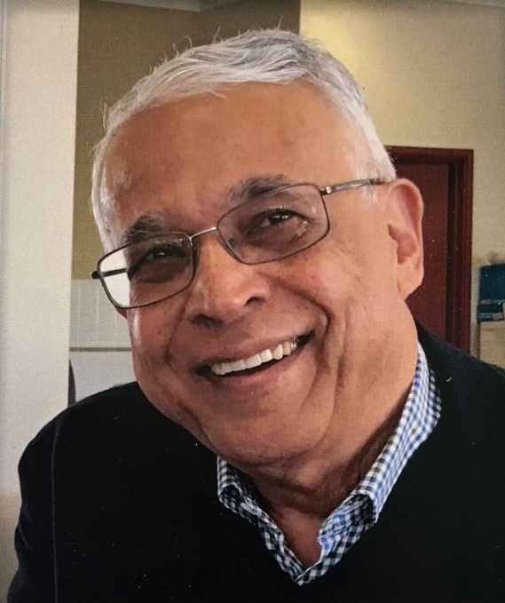
Vale Keith Collins 1949-2026

Keith was a man of great faith. Born in Malasia and educated at Wesley College, in South Perth, he gained a degree in Engineering at UWA.

He was raised in the Methodist faith and journeyed through o the Catholic faith, spreading hid love of Jesus, the Alpha Program and Alan Ames ministry.

Keith had a gift which he shared, about the goodness of God, through music, and it was through this that I first met him about 15 years ago, when Fr Hugh Thomas CssR asked me to invite him to lead the singing at our Annual One-Day Retreat at the Redemptorist Monastery in North Perth. This led to a wonderful association with Keith, of sharing his talents with us at our functions which required music.

At one retreat where Archbishop Costello was our Keynote speaker, Keith approached His Grace about sharing his knowledge of engineering with the boys at the Salesian College in East Timor. He subsequently spent 6 months working with the boys, but unfortunately his health saw his return to Perth sooner than he’d wished.

Although Keith had a fondness for the Legion of Mary, he was never an active member, but always supported us by attending our Annual Mass, Rosary Procession and Nativity mass. His quiet presence will be remembered and we will always be grateful for his sharing of his gifts.

Keith, may your beautiful soul Rest in the Peace of our Lord and Saviour.

Sr Rosemary Bennett

ACIES ceremonies will be held on March 21st: Eastern Districts Curia
and March 22nd: Fremantle Curi, Comitium and Northern Districts Curia.

I am all yours, my Queen, my Mother,
And all that I have is yours.

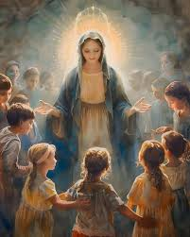


Half-Day Retreat at Ocean Reef

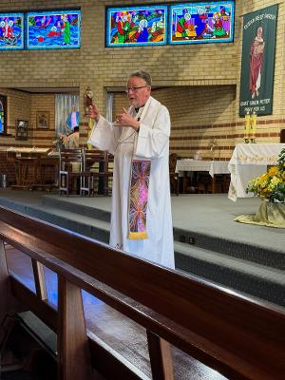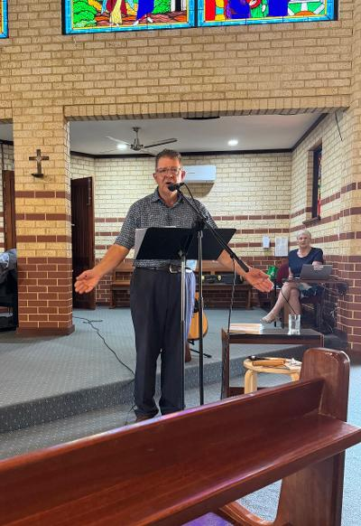

Fr Peter Porteous was inspiring as Steve Harris described in detail he related his personal experiences the various depictions of Our Lady of visions of Our Blessed Lady. in the Bible, in Art and in Music.
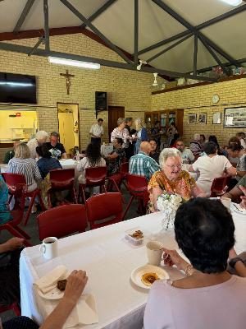
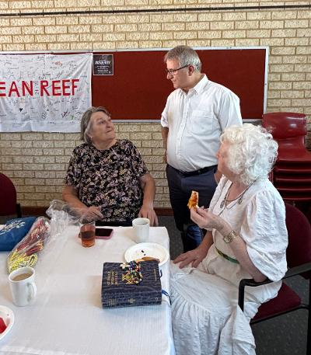

Parish Priest Fr Leonard Macionczyk During the morning tea
celebrated Mass and Benediction and fellowship, members enjoyed spent the entire morning with us. He sharing and catching up with was very welcoming of visiting Legionaries. those from other districts.
Mary in different forms of Art

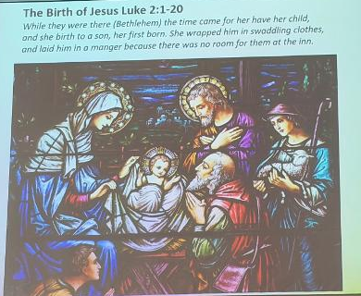
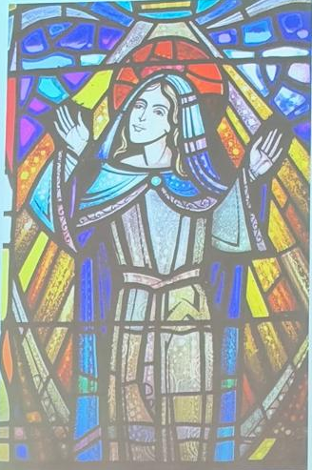
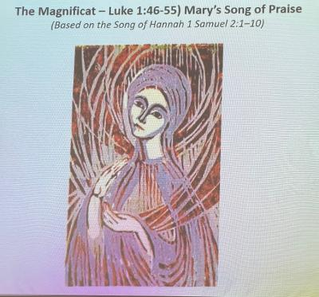

The Nativity
The Magnificat

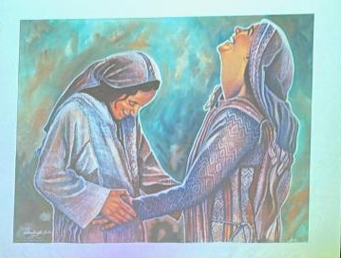
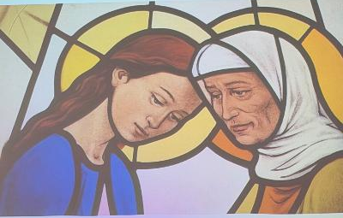
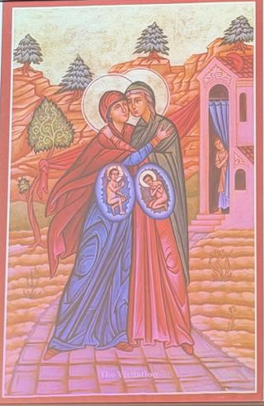

The Visitation

COMITIUM CONTACT DETAILS
Web address:
https://www.legion-of-mary-comitium-of-perth-western-australia-inc.org

email: comitiumofperth@gmail.com

Spiritual Director | Fr Doug Harris | glendaloug@perthcatholic.org.au
President | Sheelagh Tillotson | 0468 928 319
Vice President
Secretary | Bianca-Maria Casalengo | 0415 405 368
Treasurer | Katie Bennett | 0488 547 817
Assistant Secretary | Cynthia Gauci | 0430 776 648
Assistant  Treasurer | Rosemary Bennett | 0421 580 783

