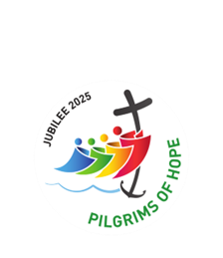

October 2025

November Annual Mass
Commemorating the life of Servant of God,
Frank Duff and all departed Legionaries

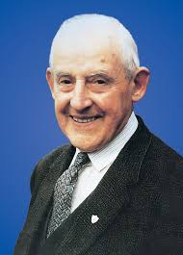
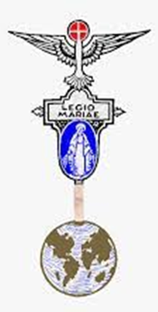

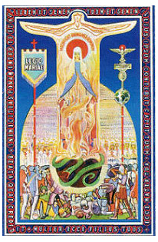

SATURDAY NOVEMBER 8TH
ST. JOACHIM’S PARISH, VICTORIA PARK

ROSARY at 10.30am with MASS at 11.00am.
THIS WILL BE FOLLOWED BY FELLOWSHIP IN THE PARISH HALL

Rosary Bouquet Mass - St Mary’s Cathedral, Sept 8th
This was a beautiful occasion and an opportunity for Legionaries from different Curia to honour Mary on her birthday.
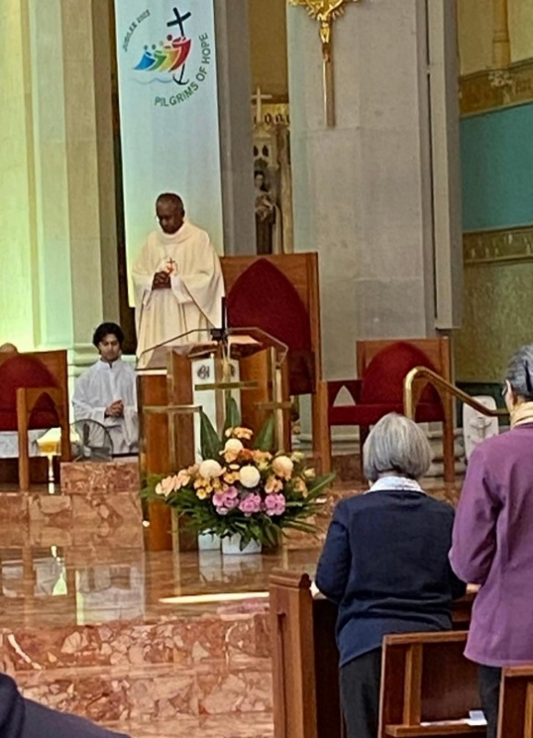
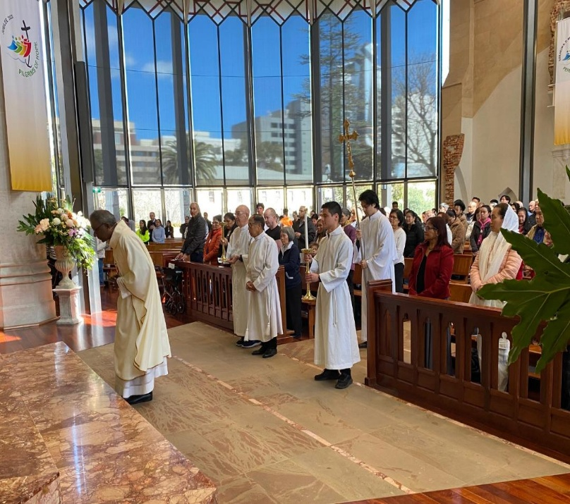

Mass was celebrated by Dean of Cathedral, Fr Sean Fernandez.
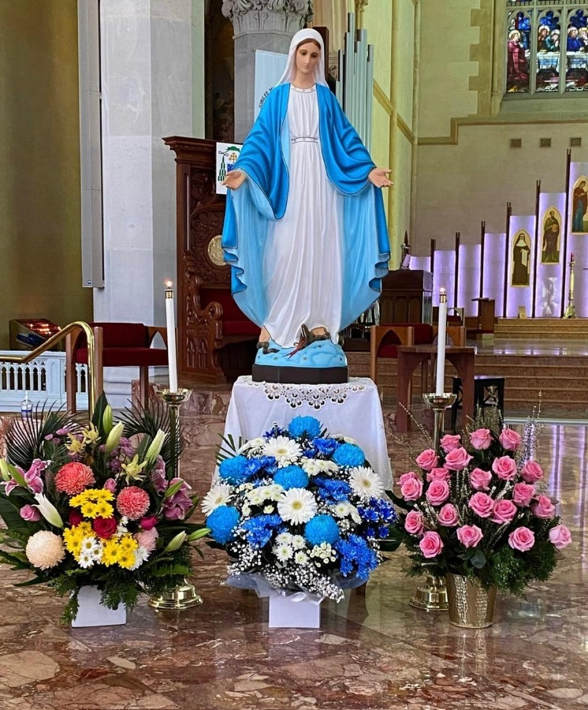
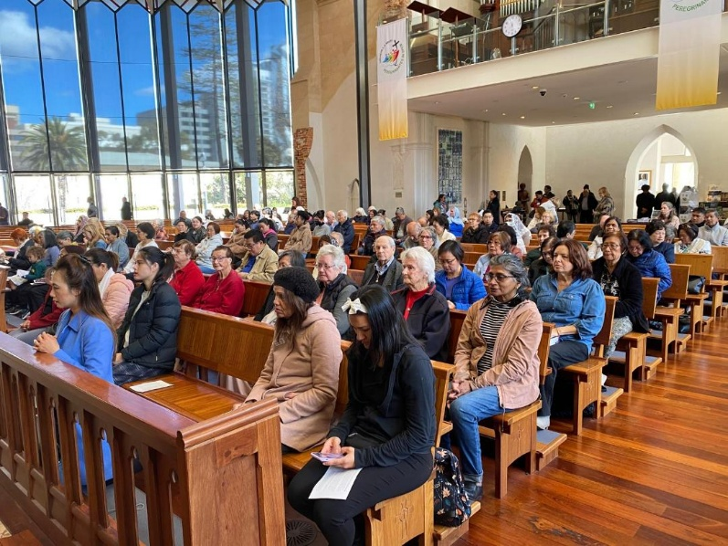

There was a large congregation to
honour Mary’s birthday.


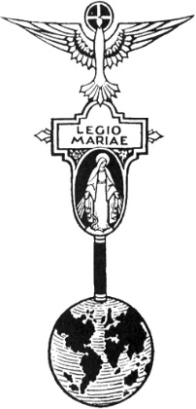
THE LEGION OF MARY
BULLETIN
October 2025
Comitium of Perth (Western Australia) Inc
36 Windsor St, East Perth 6000
Tel 93282726
Email: comitiumofperth@gmail.com
Website: https://www.legion-of-mary-comitium-of-perth-western-australia-inc.org
Facebook: Legion of Mary Perth Western

Australia

Dates to remember.
2nd Monday of the Month
Executive meeting
3rd Monday of the Month Comitium Meeting
2nd Saturday of the Month Rosary Making
EDC meeting 4th Monday
Oct 27th, November 24th
NDC meeting 4th Saturday
Oct 25th, November 22nd
EVENTS for 2025

Oct 20th AGM

Nov 8th Annual Mass
St Joachim’s Parish, Victoria Pk 10.30am

Dec 6th AGR 2pm VEQC
Jan 2026 Officers’ Afternoon Tea
ALLOCUTIO: by Fr Doug Harris Humility

Pride is a deadly sin. It is the sin of Lucifer who wanted to be greater than God. Humility is the exact opposite. It is a virtue of Christ who St Paul said (Philippians 2:6-8):
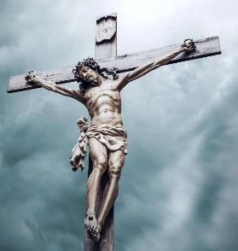
“Although he was in the form of God, he did not regard equality with God as something to be exploited but emptied himself taking the form of a slave being born human and being found in human form, he humbled himself even more, and became obedient to the point of death, even death on a cross.”
Psalm 22:6 describes the Messiah “but I am a worm and not human;” (scorned by others and despised by the people). He could not have become littler/smaller, humbler: On at least one occasion He called Himself a slave. (The Greek word ‘dulos’). He freely chose to become the littlest of the littlest, the least of the least, the slave of slaves. A radical infinite littleness. His littleness, His humility is too much, too radical for us to grasp with our minds. Although He was God, He chose for mere humans to treat Him cruelly, even to crucify Him. So that the punishment due to us because of our sins would be paid for by Him, who is innocent.
God’s humility goes so far that, although He is God, He reduced Himself to mere bread, so that He may be eaten so that we, the ones who crucified Him, may become One with Him and He may become One with us. God becomes lower than human, mere bread, only so that we by eating Him, can share in His divinity.

There is a story of our Blessed mother’s humility. (this brings me to my knees, so to speak, when I talk about it). Karen, a young lady, was invited to speak about our Blessed Mother in a large church in New York in 1996. Karen gave a wonderful description of our Blessed Mother. Karen said one point which stood out. She said, “Our Blessed Mother is the most powerful of all creatures against Satan because she is the humblest. The evil one didn’t like Karen stating that. As Karen said the word “humble”, the church had a blackout. All the lights went out as did the microphone. Outside, near the church, an enormous tree was struck by lightning even though there was no rain or storm. Humility is very powerful. A humble person defeats Satan and changes the world. (A humble person is an ‘afront’ to Satan who is all pride).

St Bernadette

After the 18 apparitions of Lourdes in 1858 Bernadette entered the convent and became Sister Bernard and led a very retired life, doing the lowliest work in the convent. A visitor was surprised that Bernadette was doing the humblest chores in the Convent.
“What do you do with brooms?” asked Bernadette simply.
“Why we sweep with them of course,” answered the visitor.
“And when we have finished sweeping?”
“Why we put the broom back in its place.”
“Where is its place?” asked Bernadette.
“In the corner, behind the door.”
“Good!” said Bernadette with decision. “Now you have my story in a few lines. Our Blessed Mother made use of me, and then she put me in a corner. It is my proper place. I am very happy in it, and here I will remain.”
Sister Marie Terese Vauzou, Bernadette’s novice mistress and future Superior General of the order, was heard to say, “If Our Lady wanted to appear on earth why did she choose such an ignorant, uneducated little peasant.” Bernadette would not have disagreed with the nun’s assessment of her. In fact, she went far beyond the sister’s opinion by describing herself as a ‘good for nothing.’ She couldn’t grasp the difficult formulas of the catechism or lessons at school. She remained ignorant and illiterate peasant. Sickness added to that experience of her own uselessness.
St Paul replied that God ‘chose those who count for nothing to reduce to nothing all those who do count for something.’ (1 Cor 1:28-29)
Perhaps what we fear most in life if this – to be considered as good for nothing, useless, inefficient, ignored, rejected, without value.

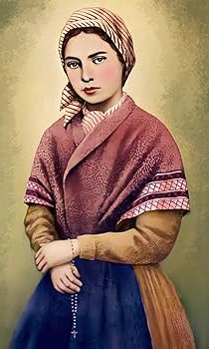
In 1858, life for Bernadette Soubirous and her family was far from easy. A family of six lived in one room, the Cachot, an old prison unfit for human habitation. They had no money, no bread, and almost no hope. Death and disease were never far from their door. So hungry were they that Bernadette’s little brother was found eating candle wax. Bernadette had her own sorrows. At school she had to suffer all kinds of humiliation as the dunce of the ‘paupers’ class. Her life was often very difficult, a situation that the apparitions did not change. In fact, the apparitions brought an ever greater martyrdom. They caused mockery, incomprehension, threats, interrogations and opposition. She had to make the sacrifice of leaving Lourdes and her family for exile in the convent of Nevers.

In the face of trials and suffering we wither run or rebel. We become bitter and resentful, venting our anger upon God for all the misfortune that come our way. But this is not Bernadette’s way. No complaining, no anger, no bitterness. But she followed the Way of the Cross right to the end as Mary herself has done.
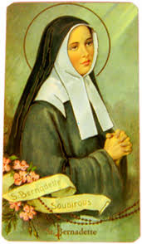
St Bernadette had the virtue of humility. She was at peace being the discarded broom, being considered without value.
She also was at peace with her physical sickness which included chronic asthma which at times were particularly severe. Also, tuberculosis of the bone which caused her significant pain and ultimately contributed to her early death at age 35.
St Bernadette wrote: “O Jesus and Mary, grant that my only joy may be to love You, serve You and suffer for sinners.” She also wrote: “O Mother Mary, come to my help, give me the grace of dying to myself, so that I no longer live, but in Jesus and for Jesus.”
Our Lord Jesus calls all of us to strive to have the same level of humility as Himself. But in order to have this level of humility we need to spend time with Him. The best place to spend time with Him is in His Presence in the Blessed Sacrament where He is seen as a humble piece of bread.

Let us pray:
‘The Litany of Humility.’ (just 6 lines of the Litany)
The response is “Jesus grant me the grace to desire it.”

Response is “Jesus grant me the grace to desire it.”

That others may be loved more than I.
That others may be esteemed more than I.
That others may be chosen, and I set aside.
That others may be praised and I unnoticed.
That others may be preferred to me in everything.
That others become holier than I, provided that I may become as holy as I should be.

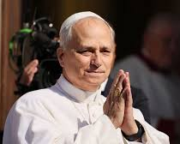
HOLY FATHER’S PRAYER INTENTION
During October, the Holy Father wants us to pray:

“Let us pray that believers in different religious traditions might work together to defend and promote peace, justice and human fraternity.”

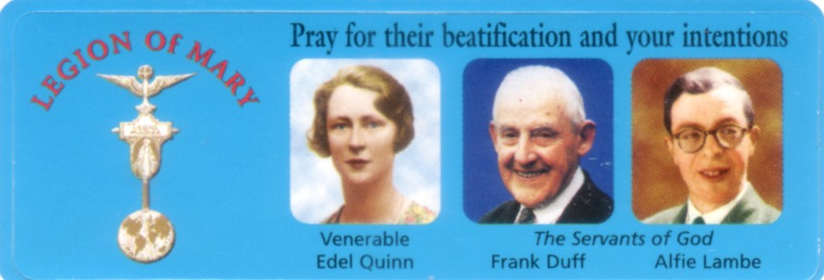

MESSAGE FROM THE PRESIDENT
October 2025

Dear Brothers and Sisters,
It was with heavy hearts that the Executive had to make the decision to postpone the Torchlight Procession this year, but we were up against too much bureaucratic red tape to get the legalities processed in time. Balcatta Parish held a public Rosary on October 11th and hopefully many other parishes have held Rosary gatherings in its place.
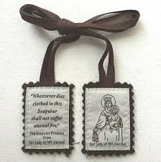
Sr Rosemary Bennett and Sr Ann Mathews travelled to Albany during September to visit Our Lady of Grace Praesidium, and their report is included on page11. Their generosity of time and their willingness to do this work are greatly appreciated, as our remote praesidia can feel very distanced from the heart of the Legion, and this personal contact helps to keep them feeling connected and supported.
At the office we have received deliveries of Brown Scapulars, Handbooks and Rosary centres and crosses (for the rosary making group). We have also been preparing more Auxiliary Packs and other resources for the piety shop. If you have particular requests for other stock or holy artefacts please let us know and we will try to accommodate you. We have also updated the name badges and they will be set out for you to wear during meetings.

Our next major event will be the Annual Mass on November 8th, in commemoration of the life of Frank Duff, and all departed Legionaries. It will again be held at St Joachim’s in Victoria Park, with the praying of the Rosary at 11.30am, followed by Mass at 12pm, celebrated by Monsignor Thomas McDonald. We look forward to a high attendance at this celebration, which is always a really enjoyable occasion. Please feel free to invite your Auxiliary members to attend if they wish. There will be Fellowship afterwards in the Parish Hall and, as always, please bring a plate to share.

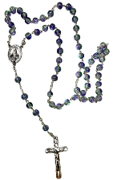
During this month of the Holy Rosary, I would like to encourage you to combine your prayers with the Holy Father’s intention for the month, which is “that religious leaders of all faiths may work together to promote peace, justice and fraternity throughout the world.”

You will notice that there are few small additions to this Bulletin: the Dates to Remember on P3 now include the dates of the up[coming EDC and NDC meetings and, on P9, reminders of the Reports and Visits which are due in the coming month. Hopefully you will find these useful.
We are planning to hold a special afternoon tea during January for Praesidia and Curia officers. Please keep this in mind as attendance will be very helpful to you in carrying out the responsibilities of your position. A firm date will be set shortly.

God bless you all and may Mary guide you,
Sr Sheelagh Tillotson, President.

SEPTEMBER REPORTS:
Report of Praesidium to Comitium

Name of Praesidium Our Lady Help Of Christians
Location East Victoria Park Parish Centre
Meeting Place and Time Friday Morning at 10.00 am at Parish Centre at Our Lady Help of Christians

Spiritual Director: We did not have a Spiritual Director from until March 2025. On 21 March 2025 Fr Arulraj Mulaguri agreed to be our Spiritual Director (he was previously a parish priest at Our Lady Help of Christians). He attends our meetings once a month.
President: Sr Penny Fernandez Secretary: Sr Bianca Maria Casalengo
Vice President: Sr Franka Del Prete Treasurer: Br Gary Fernandez
Active Membership 8 Praetorian: Nil
Auxillary Membership: 8

Two members have resigned as they are now living in nursing homes.

Report from 1 September 2024 to 31 August 2025
Extension: we have tried to encourage parishioners to joining the Legion by providing information on the notice board and newsletter Our Lady Help of Christians and word of mouth. We have asked our Parish Priest for information on joining The Legion to be included in the Parish Bulletin.
Report on Works undertaken during the past year; (only Legion Work):**
Members visited the homebound and elderly (at nursing homes)
as well as visiting parishioners who live alone in their homes.
One Member mans Edel Quinn Centre once a month.
Specific tasks carried out by individual members:
One member is on the Liturgy Committee at Our Lady Help Of Christians.
One member is on the executive of Perth Comitium
Members attended funeral masses for deceased legionaries, auxiliaries and parishioners.
One member is in the music ministry playing the piano on Sundays at Mass.
One member is an extraordinary minister of the eucharist
Other relevant information: Events attended by members:
Rosary Bouquet and Mass for our Lady’s Nativity held at St Joachim’s Church on 7 September 2024
Our Praesidium’s annual retreat to New Norcia from 8 to 10 September 2024
Annual Mass at St Joachim’s on 9 November 2024
Annual General Reunion 7 December 2024
ACIES March 2025
Retreat held on 17 May 2025 at Edel Quinn Centre.
Pilgrimage at Schoenstatt at Mt Richon on 16 July 2025
Other Information:
We have been approached by a young woman who was visiting our Parish. She said she wanted to set up a Legion of Mary Praesidium in Myaree. She asked if she could come to our meetings for six months to learn all she can to set up a Praesidium. She is a member of a prayer group in Myaree all members are Korean and would want to conduct meeting in Korean.

EXECUTIVE OFFICER ELECTIONS
Sr Rosemary Bennett completes her first term as Assistant Treasurer in November. Any member wishing to nominate for this position please see Sr Sheelagh at the October Comitium meeting to complete the necessary formalities. Elections will take place at the November meeting.
Sr Bianca Casalengo completes her first term as Secretary in December.
Any member wishing to nominate for this position please see Sr Sheelagh to complete the necessary formalities. Elections will take place at the December meeting.

Vale Father Brian Ahearn
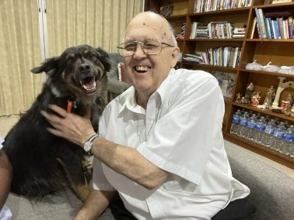
Father Brian Ahearn passed away peacefully on Thursday 2nd October 2025, the Feast of the Guardian Angels, in Geraldton after a long battle with Cancer. Father was a powerful supporter of the Legion of Mary in Geraldton and Dongara bringing several pilgrimages to Our Lady of Revelations Church in Bullsbrook and welcoming many Legionaries who journeyed through Geraldton. Although the Legion is no longer active in Geraldton Father will be sadly missed by those who shared his love of Mary and his work in the Diocese
May his beautiful soul rest peacefully in the Arms of Mother Mary and her Son, Jesus

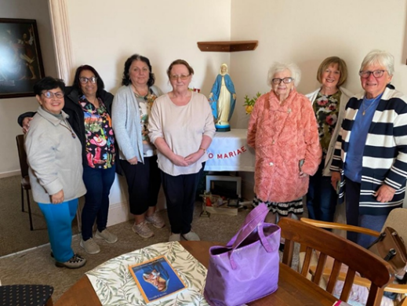
Comitium Visit to Albany
Sr Rosemary Bennett and Sr Ann Mathews, representing Comitium, visited Our Lady of Grace Praesidium Albany during the month of September. They were warmly welcomed by Sr Ann Letter, President, and all Legionaries who had a special afternoon tea and celebration of birthdays. Unfortunately, their Spiritual Director, Fr Joel, was unable to attend the meeting. Father, in the near future, will be transferring to Bunbury and we wish him all the best in his new position there.

To Jesus through Mary
Name of Praesidium: | Our Lady Star of the Sea
Location (suburb) | Busselton
Meeting place and time: | Ned Kenny Centre, St Joseph’s Church  Kent Street Busselton
Meeting number

Spiritual Director: | Fr Nathan
President: | Sr Pauline Cornelius | Vice President: | Vacant
Secretary: | Sr Mona Dranijanerch | Treasurer: | Sr Lollita Scott
Active Members: | 5 | Praetorian: | 3
Auxiliary Members: | 14 | Adjutorian: | Nil
Probationary:
Report from: | 17th Sept 2024 | To: | Sept 2025

Extension:
Personal contact is made to parishioners inviting them to “Come and See” in the past year. We have a new member joining us in September.

Works undertaken by members:
- Visitation of the Elderly, sick, lonely in their homes and in the 3 Aged Care facilities:- Ellenvale, Capecare, William Carey Court and the hospital.
- Holy Communion is taken to residence in the Nursing Homes.
- The Pilgrim Statue of Our Lady is taken to homes monthly and we pray the Rosary with the family.
Works undertaken that are not Legionary work:
- We undertake any duties that the Parish Priest requires of us.
- Members assist with the parish morning tea when required.
Other Items:
- The ACIES Ceremony was held with about 10 Parishioners and Fr Jess in attendance.
- Attended the Rosary Rally at Bove Farm held in May. Mass, Benediction and Procession were held
- Attend Cenacle at Bove Farm monthly on the 1st Sunday is attended.
- We organised the saying of the Rosary for Our Lady’s birthday.
- Sr Rosemary Bennett visited us when she was in Busselton on holidays.
- We thank Fr Nathan for his support and Sr Ann Mathews for monthly correspondence.

More Memories of the Rosary Bouquet Mass
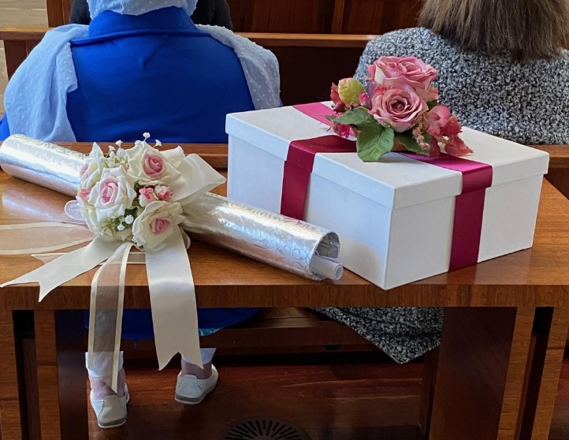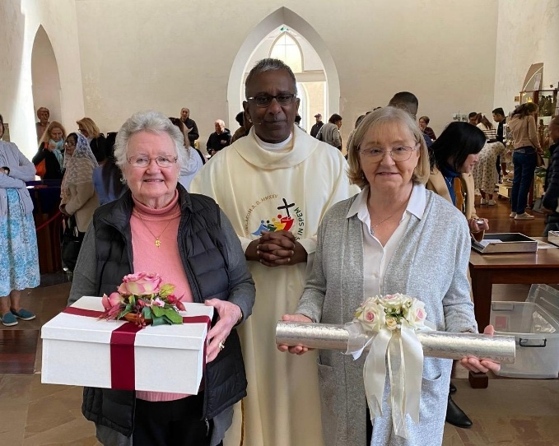
Birthday gifts of Rosaries recited and pledged were presented by Sr Betty Flynn and
Sr Sheelagh Tillotson
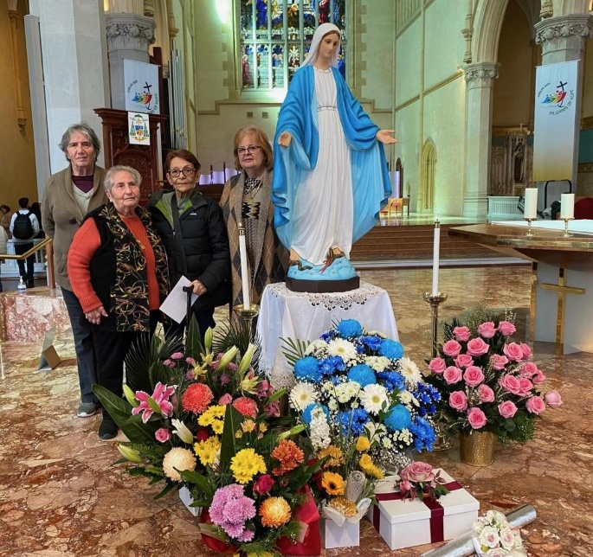
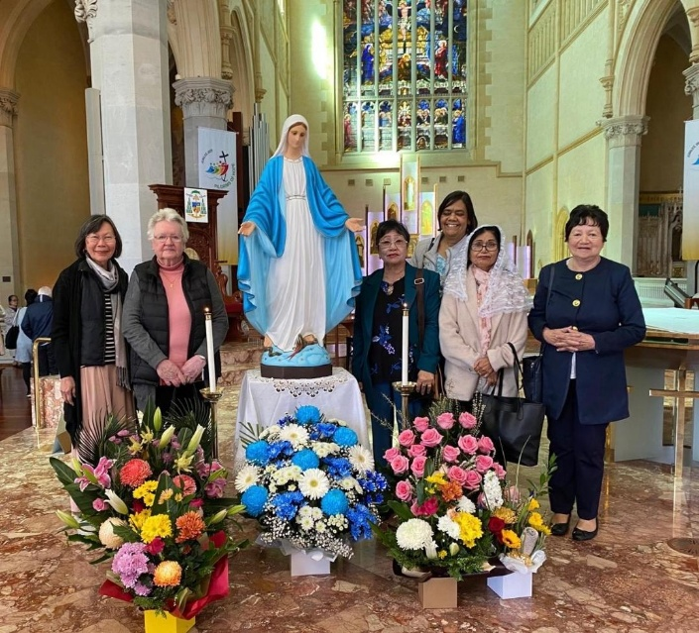

Members of Mary Help of Christians Praesidium Members of Eastern Districts Curia
East Victoria Park


SPECIALS PRAYERS:

Prayers for the Sick: Arlene Garrad, Neil Blake, John and Marie Norfor, Fr Steven Trustcott, Ken, Jan Hudson, Silvia Arnold, Marie Neale, Robert Walker, Mary McDermott, Sr Maureen Burrows, Sr Daphne Jewel, Lloyd Burrows, Tessie Burrows.
Repose of the Souls: Marion Kennelly and her brother, Tom Glynn, Ashley Burrows, Rev Fr Brian Ahearn.
Special Intentions: Karen, Priests’ retreat, Kennelly family, Pope Leo for his birthday.
Healing Intentions of Servant of God Frank Duff: Sr Penny Fernandez, Rev Sr Teresa Tran, Rick Tillotson, Sr Karen Daly.

Reports to Comitium:
November | December
WILLETTON: OUR LADY OF THE MISSIONS | EASTERN DISTRICTS CURIA: OUR LADY OF CHRISTIANS

Visits to Praesidia:
October | November
EAST VICTORIA PARK: OUR LADY HELP OF CHRISTIANS  QUEENS PARK: MARY IMMACULATE | THORNLIE: MARIA ANNUNCIATA  BUSSELLTON: STAR OF THE SEA

Web address
https://www.legion-of-mary-comitium-of-perth-western-australia-inc.org

comitiumofperth@gmail.com
Spiritual Director | Fr Doug Harris | glendaloug@perthcatholic.org.au
President | Sheelagh Tillotson | 0468 928 319
Vice President | Christyne Williams | 0410 269 518
Secretary | Bianca-Maria Casalengo | 0415 405 368
Treasurer | Katie Bennett | 0488 547 817
Assistant Secretary | Cynthia Gauci | 0430 776 648
Assistant  Treasurer | Rosemary Bennett | 0421 580 783

