FEBRuary 2026

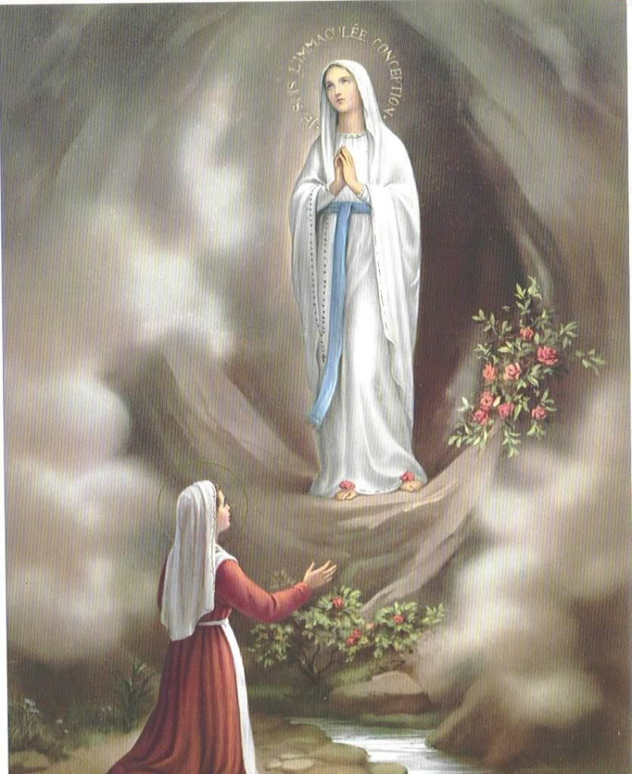

The Apparition of
Our Blessed Lady
to St Bernadette
at Lourdes
11th February 1858

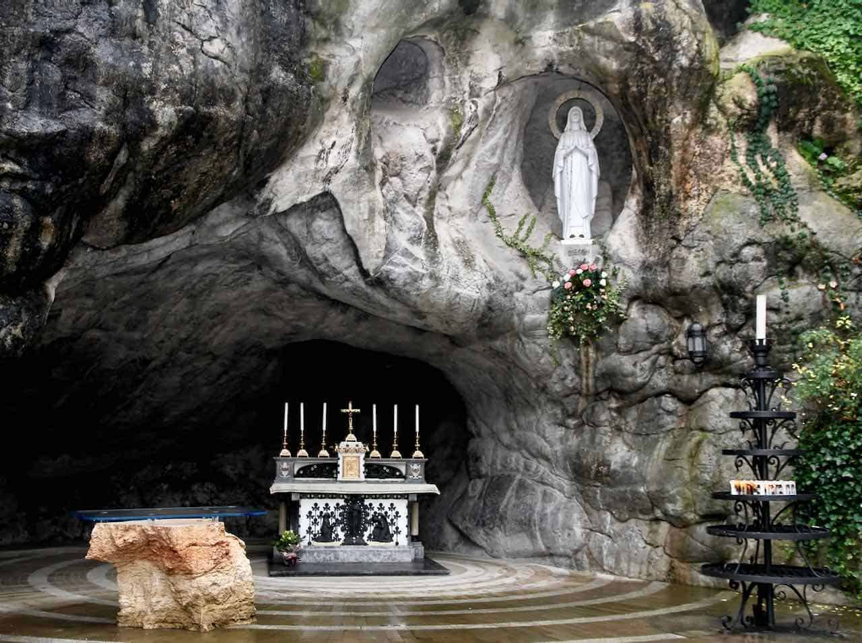

The Grotto of Massabielle at the Sanctuary of Our Lady of Lourdes
(present day)

Perth Comitium Promise of Commitment to Our Lady, the ACIES, will take on March 22nd at 2pm at St Joachim’s Parish Church, Victoria Park.

Fruitful Interaction at the Training Workshop
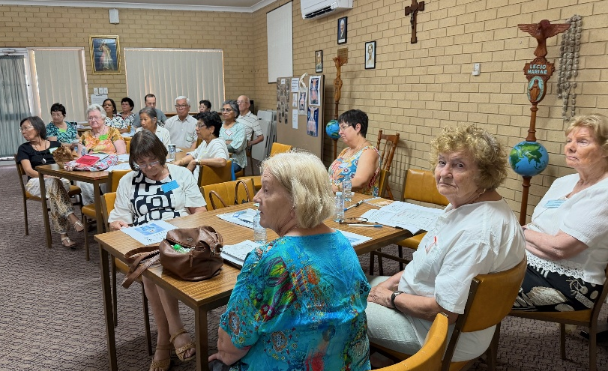
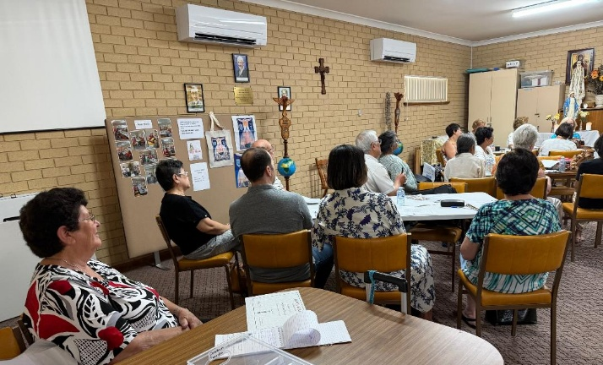
The attendees focussed attentively on the many points raised.
Members from NDC, FC, EDC and the Vietnamese Curia mingled together.

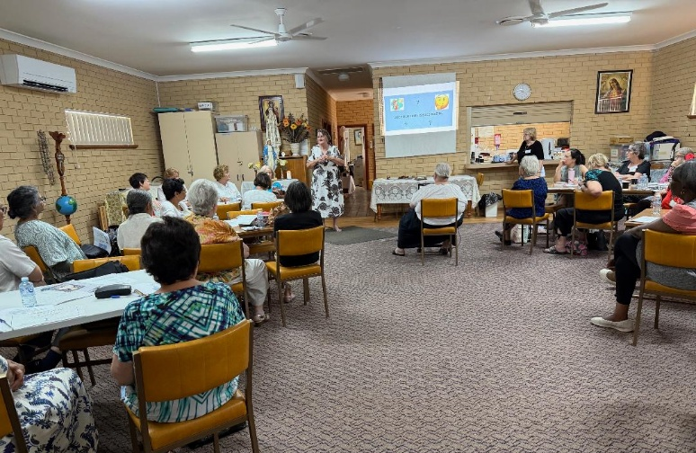

Sr Cynthia handled the PowerPoint presentation while Sr Rosemary and Sr Sheelagh facilitated the discussions.

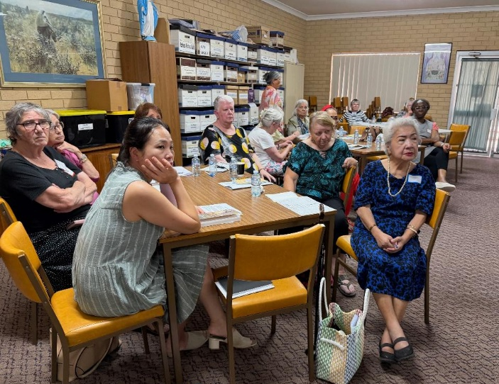
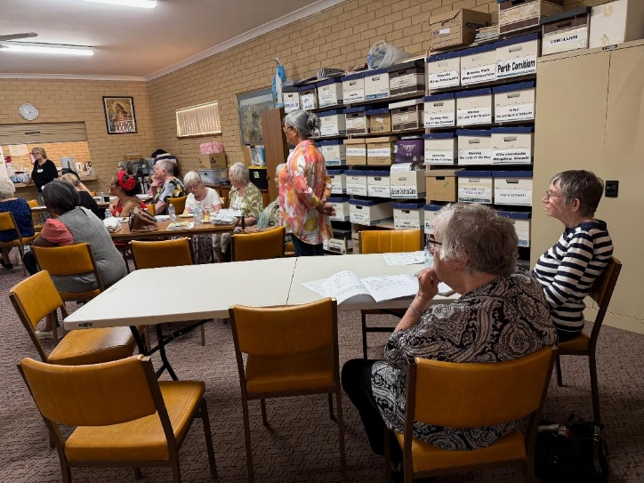
Members from most of the Comitium praesidia supported the event.

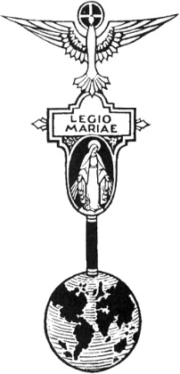
THE LEGION OF MARY
BULLETIN
February 2026
Comitium of Perth (Western Australia) Inc
36 Windsor St, East Perth 6000
Tel 93282726
Email: comitiumofperth@gmail.com
Website: https://www.legion-of-mary-comitium-of-perth-western-australia-inc.org
Facebook: Legion of Mary Perth Western

Australia

ALLOCUTIO: by Fr Doug Harris
Dates to remember.
Recurring:
2nd Monday of the Month
Executive meeting
3rd Monday of the Month Comitium Meeting
2nd Saturday of the Month Rosary Making
4th Monday EDC meeting
4th Saturday NDC meeting

EVENTS for 2026
22nd March ACIES
16th May 1-Day Retreat
16th July Pilgrimage (TBC)
7-9th Sept Rosary Bouquet
8th Sept Nativity Mass
23rd Oct Procession (TBC)
7th Nov Annual Mass
Read by: Sr Rosemary Bennett
BAPTISM
Today’s homily is a little catechism on Baptism. Why is there the Sacrament of Baptism? The first reason is that Jesus Himself was baptised. Jesus did not need to be baptised. He is without sin. One reason why Our Lord was baptised was to sanctify all baptisms.
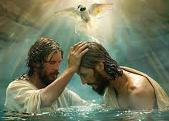
In the Bible, Jesus Himself commanded us to baptize. In the Gospel of Matthew Jesus said to His disciples: “Make disciples of all the nations and baptise them in the Name of the Father and of the Son and of the Holy Spirit.” Baptism was taught by Our Lord.
In the bible there are many examples of baptisms. In the Book of Acts, chapter 8, the disciple Philip baptised a eunuch. In Acts, chapter 9, when Paul received his conversion, the bible says, “he got up and was baptised.” In Acts, chapter 16, a woman named Lydia, who was a dealer in purple cloth, was converted and “she and her entire household were baptised.” There are other examples as well.
Why is baptism necessary? Jesus answered this question when He said to Nicodemus in John Chapter 3: “I tell you very solemnly, unless a man is born through water and the Holy Spirit, he cannot enter the kingdom of God. What is born of the flesh is flesh and what is born of the Spirit is Spirit.” Therefore, baptism is necessary for salvation.


What are the fruits of baptism? In the Bible, St Peter gives us the answer. On Pentecost day St Peter began to preach to a large crowd of people. He said: “Repent and be BAPTISED so that your sins will be forgiven, and you will receive the Holy Spirit.”
There are two major reasons for Baptism: Firstly, “so that our sins will be forgiven;” and secondly, so that we will receive the Holy Spirit. The first fruit of baptism is that our sins are forgiven. All sins are forgiven, including the ORIGINAL SIN (the sin of THE FALL, the sin of ADAM AND EVE).
Also, in Baptism the punishment due to sin doesn’t have to be paid for. In the Sacrament of Reconciliation, sin is forgiven but the effects of that sin, or the damage caused by that sin, still needs to be paid for. Whenever we sin, that sin causes damage to creation. Every sin adversely or negatively effects creation, like the Original Sin did. Therefore, that damage has to be paid for. If the damage done by our sins is not sufficiently paid for in this life, we may have to pay for it in the next – in Purgatory.
If we break someone’s window, for example: The owner might forgive us, but the damage still has to be paid for. In the Sacrament of Baptism, God waivers that payment or punishment.
An example is Hans Frank. In WWII he was the Nazi Officer responsible for the Nazi occupation of Poland. He oversaw the murder of about 2 million Poles and Jews. His crimes compare with the greatest criminals of history. But after the war, a Priest visited him regularly in prison and he was converted and baptised. The Church teaches that all of Frank’s sins were forgiven and the punishment due to sin was forgiven. As he died not long after he was baptised, he almost certainly would have gone straight to heaven, even by-passing purgatory.
The mercy of God may shock us, it may even offend us.
The second fruit of Baptism is that we receive the Holy Spirit. This is God Himself. This is why St Paul describes Christians as ‘Temples of the Holy Spirit’ or ‘Temples of the Living God.’
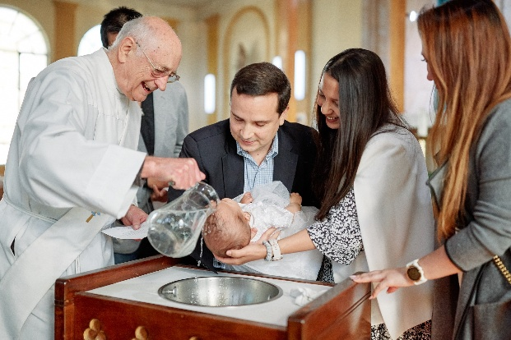
At Baptism the union that takes place between the human soul and the Holy Spirit is among the deepest unions that exist between two things. Like when two individual flames are joined together, the two flames become one. Like a drop of water placed in a glass of water, the drop becomes completely one with the water in the glass. No longer two, but one. For those of us who have received the Grace of Baptism, obviously we need to cooperate with the Holy Spirit. We do this by doing all that God has commanded us. The more we cooperate with the Grace that is given to us at Baptism, the more we overcome the flesh, the world and the evil one and the more we become of the Spirit.
The ideal is Our Blessed Mother whom the Bible says is: “full of Grace,” or full of the Holy Spirit, or full of God. God’s plan is that we all become One with Him, as much as Our Blessed Mother did. Our Lord appeared and said to St Faustina of the Blessed Sacrament that His plan is for us to become ‘living hosts’ or ‘other Christs’.
There is no limit to what God, who is Infinite Love, wants to do in us.
MESSAGE FROM THE PRESIDENT
February 2026

Dear Brothers and Sisters,

On Saturday 17th January, Perth Comitium held an Officers’ Training Workshop at the Venerable Edel Quinn Centre. As this had not been done for some time, we were unsure of how many might attend, but the response was wonderful. Thirty-seven Legionaries came and we spent a very profitable afternoon exploring the duties and responsibilities of the President, Vice-President, Secretary and Treasurer of the Praesidium or Curia. The atmosphere was both serious and convivial as details were explained and questions raised. It was really good to have a number of very experienced members present whose input to the discussions was very valuable. A package has been prepared for each Praesidium, containing the Workbook we used, copies of documents and a USB on which you will find all the documentation needed for maintaining your Praesidium, and communicating essential information to Comitium. These will be distributed to you through Curia.

Two additional points came up which, although they are difficult, I need to include here.

Firstly, is the matter of weekly contributions, and I encourage you to discuss this further with your Curia if you are concerned. The requirement, as can be read in the Handbook, is that monies given by members through the Secret Bag should be more than a very minimal amount, except in cases of hardship. Also, that the funds collected, while belonging to the praesidium, are to be used for the purchase of Spiritual goods or Mass contributions for departed Legionaries only, and all surplus funds should be given monthly to your Higher Council (either Curia or Comitium). They should not be hoarded, or be spent on anything else.
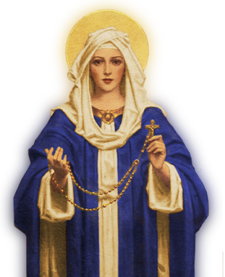
Secondly, is that there should be no holidays from the Legion. This means that there should be a scheduled praesidium meeting 52 weeks of the year, and a Curia meeting 12 months of the year, (if at all possible). It is understood that there will be times when some members will not be able to attend, particularly around Christmas time, but the meeting should not be cancelled. It needs only two to gather together for a meeting to convene. Our commitment to Mary shouldn’t be cancelled because it is inconvenient or we are too busy. It may be necessary to move the meeting to a different day occasionally, if it would clash with a Public Holiday, but it should still be scheduled. With a little flexibility and imagination, we can honour our Promise regularly in deed and word.

Please note that the ACIES will held be at St Joachim’s Church, on Sunday March 22nd at the slightly earlier time of 2pm. followed by tea and biscuits in the parish hall.

God bless and Mary guide you,
Sr Sheelagh Tillotson
EXECUTIVE OFFICER ELECTIONS
*The office of Vice President is currently vacant and open to nominations. Any member wishing to nominate for this position should see Sr Sheelagh to complete the necessary formalities.

REPORTS
To Jesus Through Mary

Name of Curia | Our Lady of La Vang Vietnamese Curia
Location (Suburb): | Westminster
Meeting Place and Time: | Vietnamese Catholic Community Centre  3 Victoria St  Westminster  10.30am 2nd Sunday of the month

Spiritual Director: |  | Fr Dominic Son |  | Vice President: | Sr Mary
President: | Br Binh Nugyen |  |  | Treasurer: | Sr Thuy
Secretary: | Sr Ann |  |  | Asst Secretary
Active Membership: | 39 |  |  | Praetorian: | Tba
Auxiliary Membership: | Tba |  |  | Adjutorian: | tba
Probationary
Number of Praesidia | 3
Report from | January 2025 |  | to | January 2026

Extension:
Father invites parishioners to “come and see” at Sunday Masses regularly.
Members invite parishioners to join the Legion
Legion Works undertaken:
- Members visit the sick and housebound members of their community.
- Members visit members of their community who are in hospital.
- Members attend the funeral Masses of deceased members of their community and pay condolence visits to the bereaved families.
- Members assist Father when called upon.
Works other than Legion Work:
- All praesidia have reported to Curia in the period of this report.
- All Praesidia are well represented at Curia
- Rev Sr Theresa Tran is unwell with cancer, but the doctors have informed her that she is very close to a diagnosis of remission. She offers her thanks for the prayers that are offered for her recovery.
The Curia held elections for new officers in December, with them taking up their roles at the January meeting. Br Binh is very eager to bring the Curia in line with the correct procedures. Br speaks very good English and, as a result, our work with him will be a lot easier. He is very eager to carry out his role correctly. His first request on being ratified was to ask for the Handbook in English as well as all the prayers. He is anxious to understand and follow correctly.
Plans for the future:
Br Binh is working towards bring the Curia records up to date and encouraging the praesidia to follow the guidelines properly.
The Curia will work towards having younger people ‘come and see’ the Legion in the hope of encouraging them to form a younger praesidium.
The Treasurer’s books have been audited and funds passed on to Higher Council.


SPECIALS PRAYERS:

Prayers for the Sick: Mark Lewis, Grace, Des, Kevin Tate, Joe Palmer, John Sherry, Greer Dunsford, Ulla Mullin, Pat Corrigan, Rae Morris, Dorothy D’Souza, Justin Khoo, Margaret Fernandes, Octavia Dourado.

Repose of the Souls: George Penman, Winston Bristow and Keith Collins

Special Intentions: Br Kenneth Todoro becoming a Norbertine Deacon; all those affected by the fires around Australia, safe travel for Sr Ann and Sr Bianca.

Healing Intentions of Servant of God Frank Duff: Sr Penny Fernandez, Rev Sr Teresa Tran, Christopher Cameron, Mel Nerva, Robert Walker and Crissia Baufond.

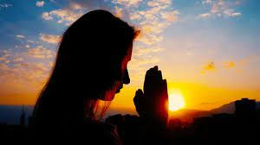

HOLY FATHER’S PRAYER INTENTION for February 2026

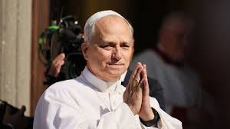

Let us pray that children suffering from incurable diseases, and their families, receive the necessary medical care and support, never losing strength and hope.

Reports to Comitium:
February | March
N.D.C.- MARY ASSUMED INTO HEAVEN | CLOVERDALE – REGINA COELI

Visits to Praesidia:
February | March
WILLETON - OUR LADY OF THE MISSION | VIETNAMESE CURIA – OUR LADY OF LAVANG

COMITIUM CONTACT DETAILS

Web address:
https://www.legion-of-mary-comitium-of-perth-western-australia-inc.org

email: comitiumofperth@gmail.com

Spiritual Director | Fr Doug Harris | glendaloug@perthcatholic.org.au
President | Sheelagh Tillotson | 0468 928 319
Vice President
Secretary | Bianca-Maria Casalengo | 0415 405 368
Treasurer | Katie Bennett | 0488 547 817
Assistant Secretary | Cynthia Gauci | 0430 776 648
Assistant  Treasurer | Rosemary Bennett | 0421 580 783

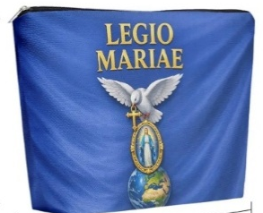
New Items in the Piety Shop
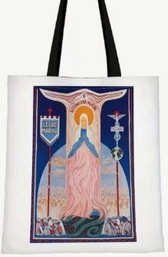

Canvas Tote Bag
$12

Zippered Canvas Pouch $7
(Will fit Handbook, Tessera etc)

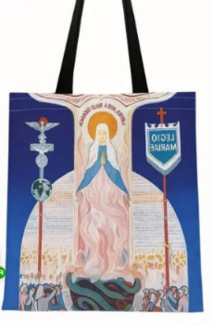
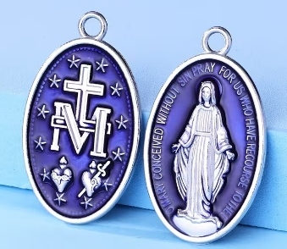
Large Miraculous
Medal $2

