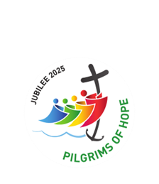

August 2025

Rosary Bouquet for Our Lady’s Birthday

Let Us Pray for Her Intentions





The Rosary Bouquet will be presented on September 8th
at 12.10pm Mass, St Mary’s Cathedral, Perth.
All are encouraged to attend and participate.





THE LEGION OF MARY
BULLETIN
August 2025
Comitium of Perth (Western Australia) Inc
36 Windsor St
Perth 6000
Tel 93282726
Email: comitiumofperth@gmail.com
Facebook: Legion of Mary Perth Western Australia

Dates to remember.

2nd Monday of the Month Executive meeting
3rd Monday of the Month Comitium Meeting
2nd Saturday of the Month Rosary Making

EVENTS for 2025
Sept 5-7th Rosary Bouquet
Sept 8th Mass for Nativity of Mary
Sept 15th AGM
Oct 17th Lake Monger Rosary procession
Nov 8th Annual Mass
Dec 6th AGR
Jan 2026 High tea with Our Lady for Officers

ALLOCUTIO: from Australian Catholics.
Written by Sam Waters, read by Sr. Rosemary Bennett.
Goodbye my friends: How do you comfort friends in times of deep sorrow? One young writer imagines what Jesus might have written before his crucifixion and death.
I must apologise to whoever reads this. The sorrow and grief my chosen path will bring is not lost on me. I know the pain it will cause those who are loved and yet not my will but yours will be done (Luke 22:42).
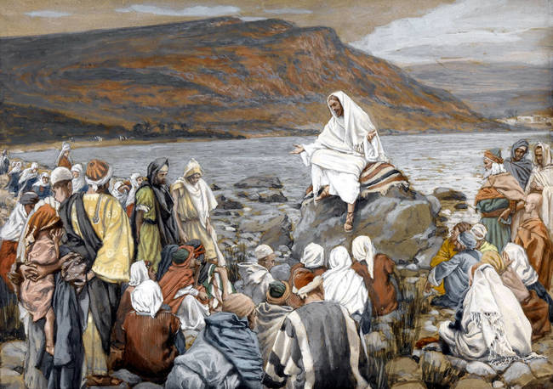
Some may say the sacrifices selfish, to leave such aching hearts behind. But I know this, I give myself up for all. For those who love me and for those who do not. “Greater love has no one then to lay down one’s life for one’s friends - (John 15:13.)
And I have called you friends - all of you. To those who have followed me, who believe in what I have spoken, I say this: do not become what is hateful. By this everyone will know that you are my disciples, if you love one another (John 13:35).
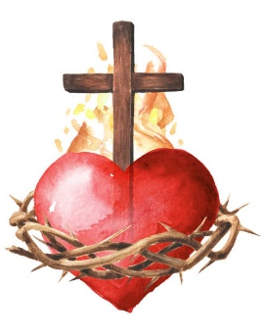
Heavy Heart. I do not go to the cross to deepen darkness, but to bear it, to shoulder what others cannot. Still, my heart is heavy. I have walked among beggars and thieves. I have seen the poor in the streets and the greedy growing fat on their labour. And I know, even after I’m gone, there will still be hunger, cruelty and injustice. The poor you will always have with you (Matt 26:11), but I have hoped to bring more kindness while I could. This is my sorrow - that I could not do more. That when I am taken, evil will remain. I do not regret my travels- the dusty roads of Galilee, the storms my father stilled, the blind who now see. I think of Lazarus’ call from the tomb, and I know my father holds power over death itself and though I stepped into the shadow of death, ‘the Father is with me’ (John 16:32).
When you read this, I will be gone. But let these words remain as proof of the love I hold for you – and more so, the love my Father holds for you. ‘For God so loved the world that he gave his one and only Son, that whoever believes in him, shall not perish but have eternal life’ (John 13:16)

Forgiveness. I have already forgiven those who take me to the cross. ‘Father, forgive them for they know not what they do’ (Luke 23:34) . I bear no hatred towards those who will drive the nails. They too are beloved. Perhaps I will go with a small smile, for the cross will smell of fresh wood and splinters like Joseph’s carpentry. He would say that was the smell of honest work. He would probably critique the cross for its roughness - poor craftsmanship, he might say - and I would laugh as I did when I was a boy at his side. If they ask who I was, what I stood for, tell them this I was of truth, of mercy, of love. I ate with sinners and wept with the grieving. ‘Come to me all you are weary and burdened, and I will give you rest’ (Matthew 11:28).

Love one Another. I do not hate those who are lost in greed or violence. If anyone asked what I believe, tell them to love one another, to feed the hungry, to shelter the homeless.’ Whatever you did for one of the least of these brothers and sisters of mine you did for me’ (Matthew 25:40). So you ask what do I believe? I believe in you. I believe in all of you. And above all, I believe in my Father who has sent me. Hold to faith, even when the night feels endless. Though I go to the cross I will rise again, as my Father has promised. ‘And I will be with you always to the very end of the age’ (Matthew 28:20).
With all my love Jesus.

SPECIALS PRAYERS:
Prayers for the Sick: (For all who have been on previous lists) and Connie, Carmela, Sr Vitalis, Geraldine, Sanchee, Rocky and Freda, Ivy James, Maree Smith, Robert Hardine, Karn Daly and Cynthia Gauchi.
Repose of the Souls: Katie Zaknich, Kay Kennelly, Noel Taggart, Phillipe Payat, Paul Askey, Juliana Addis, Bern Screen (John’s twin), and Alex and Leonora Crasto (anniversary)
Special Intentions:
Our Bible study group; Claudia and Elisha.
Healing Intentions of Servant of God Frank Duff: Sr Penny Fernandez, Rev Sr Teresa Tran, Rick Tillotson.

MESSAGE FROM THE PRESIDENT
August 2025
Dear Brothers and Sisters,
During the month of August, we are making our own pledges and gathering those of other friends and family to say the Rosary for the Birthday gift of the Rosary Bouquet for Our Blessed Mother. Please help this Legion endeavour by ensuring that the Schedule is displayed in your parish church, and that it is brought to the attention of the congregation by the parish priest. It is a unique annual event which Perth Comitium greatly values, and it is being extended across the country and beyond each year. This year the Rosary Bouquet will be presented during the 12.10pm Mass at St Mary’s Cathedral, and all Legionaries are encouraged to attend if they can.

It is wonderful to finally be back in Perth and to take up my duties again. I sincerely thank the members of the Executive for all the hard work they have done in my absence, especially with regards to the Half-day of Reflection and the Pilgrimage. Their willingness to shoulder the responsibilities of my role as well as their own meant that I could focus entirely on helping my son to recover from his strokes, and for that I am so grateful. Through your prayers, and those of the wider community, Rick has made a miraculous return to health, far beyond what his doctors predicted or gave us hope of. He was well enough, and had been declared medically fit, to drive me home across Australia from Melbourne at the beginning of this month. That would have been unthinkable three months ago, and underscores just how powerful God is in our lives if we ask for His help. I thank you all so very much for your part in my family having Rick back.

God bless you all and may Mary guide you,
Sr Sheelagh Tillotson
President.

SPECIALS PRAYERS:
Prayers for the Sick: (For all who have been on previous lists) and Connie, Carmela, Sr Vitalis, Geraldine, Sanchee, Rocky and Freda, Ivy James, Maree Smith, Robert Hardine, Karn Daly and Cynthia Gauchi.
Repose of the Souls: Katie Zaknich, Kay Kennelly, Noel Taggart, Phillipe Payat, Paul Askey, Juliana Addis, Bern Screen (John’s twin), and Alex and Leonora Crasto (anniversary)
Special Intentions:
Our Bible study group; Claudia and Elisha.
Healing Intentions of Servant of God Frank Duff: Sr Penny Fernandez, Rev Sr Teresa Tran, Rick Tillotson.

Reports: Our Lady Queen of Patriarchs, Victoria Park.
To Jesus through Mary
Name of Praesidium: | Our Lady Queen of Patriarchs
Location (suburb) | Victoria Park
Meeting place and time: | 228 Berwick St,  Wednesday 12noon
Meeting number | 4240 (11th June 2025)

Spiritual Director:
President: | Sr. Sheelagh Tillotson | Vice President:
Secretary: | Sr. Ann Mathews | Treasurer: | Sr Peggy Knowles
Active Membership: | 7 | Praetorian: 1
Auxiliary Membership: | 25 | Adjutorian: | Nil
Probationary:
Report from: | June 2024 | To: | May 2025

Extension:
Personal contact is made to parishioners inviting them to “Come and See” in the past year. This approach has not seen us recruit any new active members but we have increased our Auxiliary membership.

Works undertaken by members:
- Contact is made with the elderly, frail and housebound in the parish. This is done by one member who makes a phone call and chats with parishioners. Those who are contacted enjoy the opportunity of a chat with our Legionary.
- Auxiliaries are contacted before the ACIES and the Annual Mass and they are invited to attend. If necessary transport is arranged.
- Members man the Venerable Edel Quinn Centre weekly.
- The funeral Masses of deceased parishioners are attended and condolence visits to the family of Legionaries who are no longer attached to a Praesidium.
- We continue to circulate the Pilgrim Statue of Our Lady of Fatima. Our Blessed Mother spends 2 weeks with the family. One Legionary has taken on the responsibility of transporting Our Lady on her journey. The last 12 months has found a number of parishioners wishing to have her in their home and the help offered by the Legionary ensures that she is at their home on the due date.
- 2 members ensure that there is always a supply of Miraculous Medals and Scapular medals available for a priest who shares them in his chapel. These are put on chain which come in gold and silver. The same members stitch Miraculous Medals into the Scapulars for distribution by Father
- Members make Rosaries for the Piety Shop.
- One member takes Holy Communion to several Parishioners each week.
- We work with the Men Alive group in the parish supporting their functions .

Works undertaken that are not Legionary work:
- Members are Acolytes, Proclaimers of the Word and Extraordinary Ministers of the Eucharist in their parishes.
- The Praesidium has been represented at the following functions: the Annual Mass, Australia Needs Fatima, ACIES, 48 Hour Rosary Bouquet for Our Lady’s birthday.
- One member attended the Senatus Summer School in 2025
- One members undertakes the stocking and sales in the Piety shop on Comitium days.

Other Items:
- Since February 2025 our President Sr Sheelagh Tillotson has been in Melbourne looking after her son who has had several strokes but fortunately Sister was able to prepare our recording sheets for part of this time which has been greatly appreciated by the members. Sr Rosemary Bennett has taken on the role of Acting Vice President during this time.
- One member has had to take extended leave as he has a serious eye problem It is hoped that he will return shortly. Another member has also had to ask for extended leave has she has had a life-threatening illness. She will return as soon as she is strong enough.
- Our Treasurer’s books have been audited and found correct. Our Praesidium passes all funds onto Comitium each month.
- Our Praesidium thanks Monsignor Thomas McDonald for his wonderful support of the Praesidium, often promoting us during his Masses and encouraging people to come and see. He also supports us by encouraging the movement of the Pilgrim Statue.

Reports to Comitium in August 2025

PLEASE EMAIL YOUR REPORT to PERTH COMITIUM one week before the meeting.
JANUARY | FEBRUARY
VIETNAMESE CURIA | MANNING: OUR LADY OF THE WAY  N.D.C. MARY ASSUMED INTO HEAVEN
MARCH | APRIL
CANNING VALE: ARK OF THE COVENANT  CLOVERDALE: REGINA COELI | EASTERN DISTRICTS CURIA: OUR LADY OF CHRISTIANS
MAY | JUNE
FREMANTLE CURIA: IMMACULATE CONCEPTION  ALBANY: OUR LADY OF GRACE | VICTORIA PARK: OUR LADY QUEEN OF PATRIARCHS
JULY | AUGUST
BUSSELTON: STAR OF THE SEA | QUEENS PARK: MARY IMMACULATE
SEPTEMBER | OCTOBER
EAST VICTORIA PARK: OUR LADY HELP OF CHRISTIANS | THORNLIE: MARIA ANNUNCIATA
NOVEMBER | DECEMBER

VISITATIONS for August 2025

JANUARY | FEBRUARY
WILLETON: OUR LADY OF THE MISSIONS | QUEENS PARK: MARY IMMACULATE
MARCH | APRIL
VIETNAMESE CURIA: OUR LADY OF LAVANG | MANNING: OUR LADY OF THE WAY  NDC: MARY ASSUMED INTO HEAVEN
MAY | JUNE
CANNING VALE: ARK OF THE COVENANT  CLOVERDALE: REGINA COELI | FREMANTLE CURIA: IMMACULATE CONCEPTION
JULY | AUGUST
EDC: OUR LADY OF CHRISTIANS  ALBANY: OUR LADY OF GRACE | VICTORIA PARK: OUR LADY QUEEN OF PATRIARCHS
SEPTEMBER | OCTOBER
BUSSELTON: STAR OF THE SEA | EAST VICTORIA PARK: OUR LADY HELP OF CHRISTIANS  QUEENS PARK: MARY IMMACULATE
NOVEMBER | DECEMBER
THORNLIE: MARIA ANNUNCIATA

comitiumofperth@gmail.com
Spiritual Director | Fr Doug Harris | glendalough@perthcatholic.org.au
President | Sheelagh Tillotson | 0468 928 319
Vice President | Christyne Williams | 0410 269 518
Secretary | Bianca-Maria Casalengo | 0415 405 368
Treasurer | Katie Bennett | 0488 547 817
Assistant Secretary | Cynthia Gauci | 0430 776 648
Assistant  Treasurer | Rosemary Bennett | 0421 580 783
`
2025 Pilgrimage to the Schoenstatt Shrine July 16th

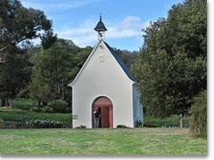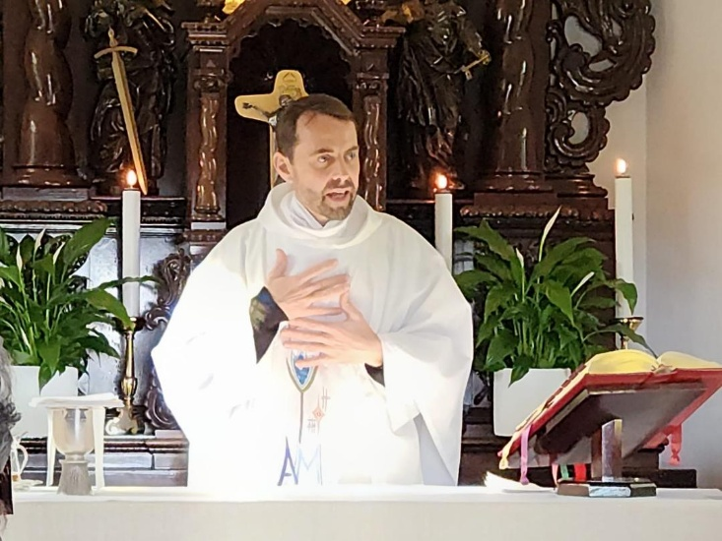
Schoenstatt Shrine, Armadale Rev. Fr Grant Goddard

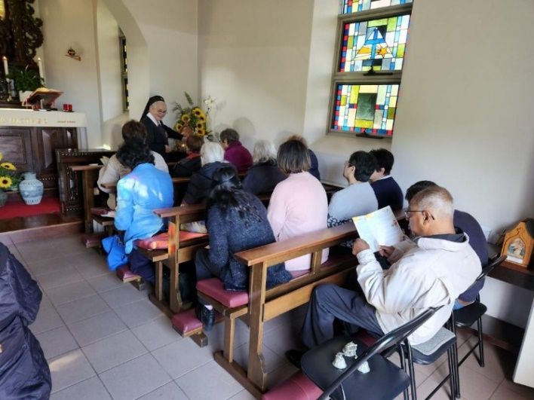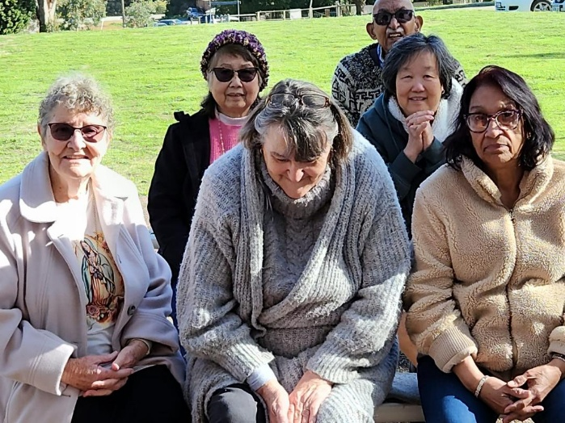
Some pilgrims sat inside the chapel whilst others attended outside in the beautiful grounds.

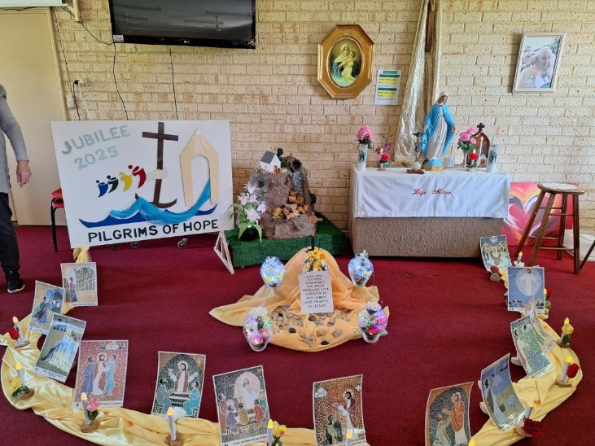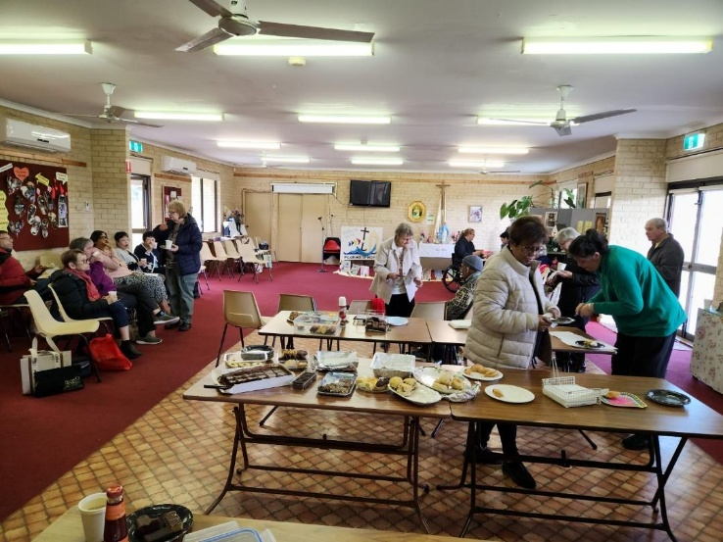
The Pilgrimage of Hope Prayer Focus Sharing and Caring time at the Pilgrimage

